Complete Revision for Mathematics

Applications

Units 3&4

Topic by Topic – Exam Questions

Full Solutions and Marking Guide

Compiled by Bill Purcell & Barry Tognolini

Preface for Students

No subject is more inherently Australian than mathematics!

“ Have a go”, make lots of mistakes, ask about and discuss those mistakes in light of the solutions given, and move on to the next challenge. Remember, learning mathematics comes from doing mathematics.

Use this book to start your revision program from the day you finish your first topic, not the day you finish your last topic. In so doing, you will reduce the stress of exams to micro rather than mega.

INDEX

Chapter | Topic | Page
1 | Collecting & Representing Data | 4
2 | Bivariate Statistics (i) | 15
3 | Number Patterns | 24
4 | Bivariate Statistics (ii) | 33
5 | Eulerian, Hamiltonian and Shortest Path | 57
6 | Recurrence | 71
7 | Applications of Sequences | 84
8 | Financial Mathematics | 99
9 | Time Series | 117
10 | Minimum Spanning Tree | 130
11 | Maximal Flow | 146
12 | Project Networks | 158
13 | Task Allocation | 178
 | Solutions | 181

Chapter 1: Collecting & Representing Data

This chapter includes questions about

Sampling
Organising data into tables and graphs
Drawing and interpreting pi graphs
Drawing and interpreting histograms

Some questions require the use of a calculator.
1. [9 marks: 1, 2, 3, 3]
The pie graph below shows the distribution of birth places of parents of the
720 students at Brown college.
• There were twice as many students with one Australian born parent than
those with no Australian born parent.
• There were three times as many students with two Australian born parents
than those with no Australian born parent.

(a) What percentage of students has two Australian born parents?
(b) Calculate the size of the central angle for the “none” section.
(c) Calculate the number of students with
(i) no Australian born parent.
(ii) at least one Australian born parent.
The area of a pie graph is proportional to the number of students represented by a
pie graph. The area of the pie graph representing students at Brown College is
twice the area of the pie graph representing students at Green College.
The central angle representing students at Green College with no Australian born
parent is 30º.

(d) How many students at Green College have no Australian born parent?

2. [1 mark]

When do we use a Column Graph (Figure 1) and when do we use a Histogram
(Figure 2)? Write a “general rule”.

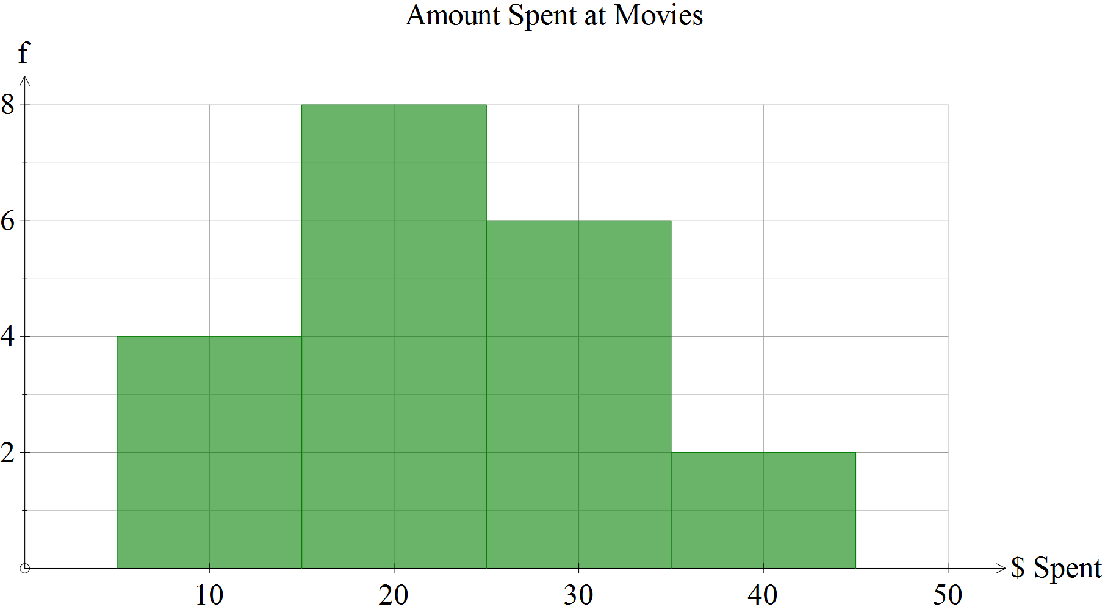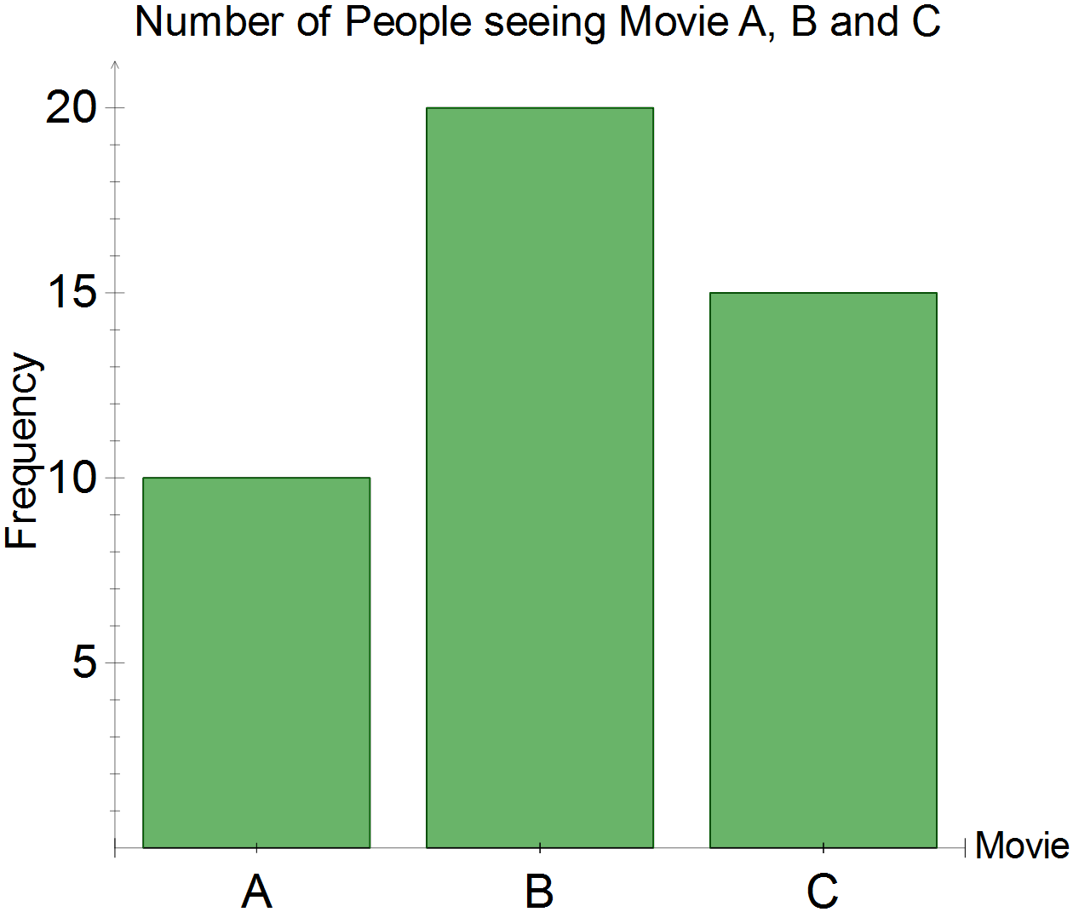

Figure 1 Figure 2

3. [8 marks: 1, 2, 3, 2]

“Just Shoes” has a sale. The results are:

Shoe Size | 7 |  | 8 |  | 9
Number of Pairs Sold | 6 | 8 | 24 | 17 | 5

(a) How many pairs were sold?

(b) Draw a pie chart to illustrate the data.

(c) Calculate the:

(i) mean size.

(ii) median size.

(iii) mode size.

(d) Which of the measures of centre is:

(i) the most meaningful?

(ii) the least meaningful?

4. [7 marks: 2, 3, 2]

6 4 3 2 4 5 6 3 2 5 3 2 1 1 3 5 6 5 2 2 5 4 2 1 3 4 6 3 1 4

(a) Enter the data into the frequency table.

Score | 1 | 2 | 3 | 4 | 5 | 6
Frequency

(b) Draw a histogram to represent the data.

(c) State the median and mode.

5. [3 marks]

The number of cars sold by Trust Me Autos are shown below.

Month | Number of Cars
Jan | 32
Feb | 24
Mar | 16

Complete the associated picture graph below.

Jan
Feb | 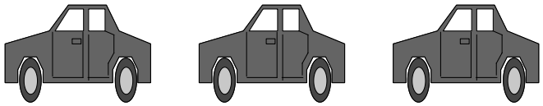
Mar
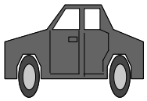
represents _______________ cars.

6. [3 marks: 1, 2]

Number of Blue Ribbons | Tally
4
3 | |
2 | ||
1 | ||

The tally table shows how many Blue Ribbons were received by thirty seniors’ clubs in a cooking contest.

(a) What percentage of clubs received more than two blue ribbons?

(b) How many blue ribbons were awarded?

7. [5 marks: 4, 1]

(a) Complete this table of shoe sizes for a group of students at Seaside Senior High
School.

Shoe Size | 5 | 6 | 7 | 8 | 9 | 10 | Total
Frequency |  | 6 | 11 |  | 8 | 4 | 40
Relative  Frequency | 0.025 |  |  | 0.25

(b) What is the “average” shoe size?

8. [2 marks]

The pie chart below shows the types of bread and cakes sold at Big Buns on a particular day.
Vanilla Slices

Hambuger Buns
Wholemeal Loaves
130°
20°
Chocolate Eclairs

50 vanilla slices were sold.
Calculate the number of hamburger buns sold.
9. [9 marks: 1, 3, 3, 2]
The pie graph below shows the different groups of year 11 students in
a school classified according to their year 11 mathematics enrolments.

(a) What percentage of students is enrolled in Applications?
(b) Show clearly how you would calculate the central angle for
the sector of the pie–graph that represents those who are enrolled in Methods.
(c) A stratified random sample of 12 students is to be selected from the
year 11 students in this school. Determine the number of representatives
from those who are enrolled in no maths courses. Justify your answer.
(d) Discuss the advantage of having a stratified random sample like the
one you constructed in part (c).
10. [10 marks: 2, 2, 3, 3]
A teacher was curious to find out the number of students in his class who were born during each of the four seasons of the year. The table below shows the number of students born and the season in which they were born. The teacher wishes to display this data in the form of a pie–graph.
Season | Number of students | Central Angle
Summer | 7
Autumn |  | 120º
Winter | 3
Spring
Total | 24

(a) Show clearly how you would calculate the central angle for
the sector of the pie–graph that represents those born in summer.
(b) How many students were born in autumn? Justify your answer.
(c) Complete the table above.
(d) Complete a pie–graph of the information given. Label your diagram clearly.

11. [5 marks: 1, 1, 1, 2]
A small group of students were surveyed regarding their recreational habits during recess on Fridays. The results are displayed below.

 | Male | Female | Totals
Basketball |  | 1
Chess | 1
Totals | 6 |  | 10

(a) How many males in the group played basketball?

(b) How many of the females did not play chess?

(c) How many students were male or played basketball?

(d) Do you think this survey would represent the interests of all the
students of the same age in Western Australia? Explain.
12. [6 marks: 3, 3]
(a) Jamie draws a pie–graph to display the number of students enrolled in the
various English courses in Year 11. Of the 150 students in Year 11, 20
students were enrolled in English as a Second Language (ESL). What is
the size of the angle for the sector representing students enrolled in ESL?

(b) Kyle draws a pie–graph to display the number of students enrolled in the
various English courses in Year 12. The sector representing students
enrolled in English Literature has a central angle of size 184º. How many
of the 135 students are enrolled in English Literature?
13. [6 marks: 2, 2, 2]
A group of students was asked which of the four semi–finalists they thought would win the local football grand final. The results are shown in this pie chart (NOT drawn to scale).
It is also known that 10 students voted for the TIGERS and 4 students voted for the LIONS.
(a) How many voted for the SHARKS?
(b) What is the size of the angle marked xº.
(c) How many students were there in the entire group?
14. [12 marks: 3, 4, 1, 2, 2]

120 year 12 students were surveyed regarding their use of weekend "free time". The number of males in the group equalled the number of females in the group. Half of the males played sport in their free time. Half of the females chose to do extra study. 25 males and 20 females spent their time watching TV.

 | Sport | Watching TV | Extra Study | Totals
Male
Female
Totals |  |  |  | 120

(a) Complete the table above.

(b) State the proportion of students who:
(i) were male
(ii) watched TV
(iii) chose Sport out of those who were males
(iv) were female out of the group who chose sport.
(c) State the ratio of those females who played sport compared to the males
who chose study.

(d) If another survey was conducted at school while the school football team
was absent, do you think the survey would be biased? Why?
(e) What would be a suitable way of surveying a group of 120 year 12's if the total year 12
enrolment was 240?

15. [6 marks: 2, 2, 2]

Jeff is anxious to find out the extent of community support for the proposal that there should be a curfew on household cats within his suburb each night from 10 pm to 6 am the next day. There are 926 households within his suburb. Jeff designs a questionnaire, which he will use on a sample.
Comment on the validity of his findings in each of the following cases.
(a) He selects the five households closest to his and surveys them with his
questionnaire.
(b) He randomly selects a household from each of the 48 streets in his
suburb and surveys them with his questionnaire.

(c) State some questions which you think could be on that questionnaire.
16. [4 marks: 2, 2]

The diagram below is a pie graph describing the distribution of 300 Year 11 students by Mathematics units.
(a) A stratified sample of 25 students reflecting the type of Mathematics' units
they do is to be chosen. Complete the table below to determine the
number of students from each category that should be chosen.
Mathematics  unit chosen | Working Space | Number of  students
Methods
Specialist

(b) State the size of the angle at the centre of the circle which defines the
"No Maths" sector.

17. [8 marks: 2, 2, 2, 2]
Ray is a researcher for a private community group and is planning to interview a sample of Australians to find out what Australians think about the “work for the dole scheme”. This is a government scheme where unemployed adults agree to perform assigned work in return for social security benefits. Listed below are some methods Ray has available for choosing the sample to survey. For each method described, comment on whether the method is bias free or not and explain why.
(a) Interviewing every 500th person in every phone directory in Australia
in a telephone survey.
(b) Choosing a retirement village at random and interviewing all the
residents in the retirement village.

(c) Choosing a location at random and interviewing the first 50 people
who walk past.
(d) Placing the survey question in a surfing magazine with a free
subscription to the same surfing magazine for two months to all respondents.
18. [7 marks: 1, 2, 2, 2]

A survey was conducted to determine if the school ball should be held in the first or second term of the school year. The survey question framed was:
In which term would you like the school ball to be held?
A. First term or B. Second term
Natasha conducted a survey on 100 Year 11 and 12 students. The results of Natasha’s survey is shown in the table below.

 | Ball in the first term | Ball in the second term | Total
Year 12 students | 30 | 10 | 40
Year 11 students | 45 | 15 | 60
Total |  |  | 100

(a) Of the students Natasha surveyed, what percentage preferred the
ball to be held in the first term?
(b) Of the Year 12 students Natasha surveyed, what percentage
preferred the ball to be held in the second term?

Kim conducted a second independent survey on a total of 80 students from Year 11 and
Year 12. Kim found that there were 65 students who preferred the ball to be held in the second term.
(c) Natasha argued that since the two surveys showed that there were
more students who preferred the ball to be held in the first term (75 of them in her
survey) compared to those who preferred the second term (65 in Kim’s survey), the
school ball should be held in the first term.
If you were Kim, what would be your counter–argument?

(d) Suggest how the two surveys could have produced such different results.

19. [5 marks: 3, 2]

A group of 81 elderly people live in a nursing home. Their ages are distributed as shown in the cumulative frequency table (Table A) below.
Age in years | <60 | <65 | <70 | <80 | <90 | <100
Number of people | 0 | 21 | 38 | 62 | 74 | 81
Table A

Table B below gives the same information in a different form.
Age in years | 60 ≤ x < 65 | 65 ≤ x < 70 | 70 ≤ x < 80 | 80 ≤ x < 90 | 90 ≤ x < 100
Number of  people | 21 | 17 | a | b | c
Table B

(a) State the values of a, b and c.

(b) The information from Table B was illustrated on a histogram, and the height
of the column representing the interval 65 ≤ c < 70 was 6·8 cm.
Calculate the height of the column representing the interval 70 ≤ x < 80.
20. [10 marks: 4, 4, 2]

(a) A management group had their ages recorded in this stem and leaf plot.

2 5 6
3 3 8 9
4 4 4 5 6
5 9 9 9
6 2

The same information was then represented on the graph below.

(i) Comment on the construction of the graph.

“The number of people in management throughout Australia in their 40’s is far greater than in any other age group.”

(ii) Comment on the above generalization made by someone who had just looked at the graph.

(b) "Out of 80 students interviewed in a big high school, 71 agreed with the Head Boy that
the school social should be restricted to Year 12 students only".

(i) In relation to the above situation, discuss briefly how bias may have been
introduced.
(ii) How might you have collected data to ensure an accurate reflection
of opinion?

(c) "There are fewer car accidents in Australia than in the United States of America. Therefore, it is safer to drive in Australia than in the U.S.A."
Comment briefly.

Chapter 2: Bivariate Statistics(i)

This chapter includes questions about:

Associations between categorical data.
Drawing a scatter plot for bivariate data
Fitting a line of best fit by eye to bivariate data.
Using the line to make predictions
Use the terms “interpolation” and “extrapolation”

Some questions require the use of a calculator.

1. [9 marks: 3, 1, 3, 2]

A survey of interest in this year's Melbourne Cup was conducted in a local Shopping Centre.
The 300 results were grouped according to Age and Interest.

 | Under 20 years | Between 20 and 40 years | Over 40 years
Interested | 85 | 70 | 25
Not Interested | 15 | 30 | 75
TOTALS | 100 | 100 | 100

(a) Find the percentage of people from the group who are

(i) interested in the Cup;

(ii) between 20 and 40 years old and not interested in the Cup;

(iii) either under 20 years old and not interested in the Cup or over 40 years old and
not interested in the Cup;

(b) Which is the explanatory variable?

(c) Use the data to draw a proportional column graph.

(d) Describe the association you believe is being exhibited here.

2. [14 marks: 5, 4, 1, 2, 2]

100 students were each asked to select an optional activity from three offered. Their choices
are shown in this table.

 | Drama | Woodwork | Swimming | Totals
Male | 17 | p | 23 | x
Female | 18 | m | z | 45
Totals | 35 | 25 | y | 100

(a) Find x, y, z, m, p.

(b) What percentage of students:
(i) are male?

(ii) chose drama?

(iii) did not choose woodwork?

(iv) chose drama or woodwork?

(c) Which is the explanatory variable?

(d) Use the data to draw a proportional column graph.

(e) Describe the association you believe is being exhibited here.
3. [11 marks: 5, 1, 3, 2]

Research into the effects of parents' smoking habits on the smoking habits of
5 000 high school students gave these results.

 | Student  smokes | Student  does not smoke
Both parents smoke | 300 | 1 300
One parent smokes | 320 | 1 840
Neither parent smokes | 90 | 1 150

(a) Find the percentage of students who
(i) smoke.
(ii) do not smoke.
(iii) have both parents smoking.
(iv) smoke and have neither parent smoking.
(v) have at least one parent smoking.

(b) Which is the explanatory variable?

(c) Use the data to draw a proportional column graph, with 3 labelled columns.

(d) Describe the association you believe is being exhibited here.

4. [10 marks: 1, 3, 1, 3, 2]

In an attempt to protect people from being eaten by crocodiles near a Northern town, some
options were suggested and a survey conducted. The responses were as follows:

Options | Local Residents | Tourists | Park Rangers
Catch and Relocate crocs | 28 | 13 | 15
Erect clearer warning signs | 28 | 73 | 7
Ban Human entry | 3 | 6 | 0
Shoot crocs | 60 | 23 | 0

(a) How many people were surveyed?

(b) Find the percentage of people surveyed who

(i) were tourists.
(ii) were Park Rangers and wanted to shoot the crocodiles.
(iii) wanted to catch and relocate the crocodiles.

(c) Which is the explanatory variable?

(d) Use the data to draw a proportional column graph.

(e) Describe the association you believe is being exhibited here.
5. [9 marks: 2, 1, 2, 2]

This 2 way table shows the choices made by 141 Year 11 students when proceeding to
Year 12.
 |  | Year 11
 |  | Applications | Methods
Year 12 | Applications | 80 | 10
 | Methods | 1 | 50

(a) Enter the data as percentages of each column total.

(b) Which is the explanatory variable?

(c) Use the data to draw a proportional column graph.

(d) Describe the association you believe is being exhibited here.

6. [11 marks: 2, 2, 2, 1, 2, 2]
The table below shows the ages (to the nearest year) of 8 pairs of married couples.
Husband’s Age | 23 | 45 | 32 | 43 | 21 | 30 | 34 | 41
Wife’s Age | 21 | 46 | 30 | 43 | 23 | 29 | 33 | 43

(a) On the axes provided draw a scatter–plot of this data.

(b) Describe clearly the strength and direction of the relationship
shown in your scatter–plot.
(c) Calculate , mean age for husbands and , the mean age for wives.
(d) Plot ( , ) on your scatter–plot.
(e) Draw in the straight line that best fits the points in your scatter–plot,
making sure that your line passes through ( , ).
(f) Use the line you drew to predict the age of a woman whose husband
is 40 years old. Describe clearly how you obtained your answer.
7. [13 marks: 3, 3, 2, 1, 2, 2]

The table below shows the marks achieved by students in an aptitude test taken before enrolment into a Mathematics course and the final marks achieved at the end of the year.

Student | Aptitude Test Marks  x | Final Mark  y
Audrey | 57 | 63
Barry | 67 | 72
Cary | 68 | 61
Danny | 78 | 85
Emery | 50 | 54
Franky | 69 | 72
Gary | 91 | 96
Harry | 86 | 92
Ivy | 73 | 81
Jerry | 68 | 64

(a) Draw a scatter graph for this data on the axes provided.

(b) Comment on the type of relationship between Final Marks and Aptitude Test
Marks.
(c) Calculate , the mean Aptitude Test Mark and , the mean Final Mark.
(d) Plot (,) on the scatter graph drawn in (a).
(e) Draw in the line of best fit between the Final Mark and the Aptitude Test Mark.
(f) Mary scored 98 in the Aptitude Test but missed several assessments
so that her Final Mark has to be estimated. Use the line you drew in (e)
to estimate her Final Mark.
8. [9 marks: 3, 1, 2, 2, 1]

The table below shows the number of text messages received and sent by Bethany (on her mobile phone) and the marks received for the mathematics tests she sat the next day.
Test No. | Number of text messages  sent and received, N | Mathematics test  mark, T
1 | 10 | 78
2 | 12 | 67
3 | 4 | 86
4 | 7 | 72
5 | 20 | 48
6 | 2 | 91
7 | 0 | 35
8 | 24 | 53
9 | 7 | 88
10 | 15 | 69

(a) On the given axis, complete the scatter graph between N and T.
(b) Indicate with a circle, the point which does not fit well with the other points.

(c) Ignoring the point identified in part (b), comment on the nature and type of
relationship between T and N.
(d) Ignoring the point identified in part (b), draw the line of best fit between
T and N on the diagram in part (a).

(e) Use the line drawn in part (d) to estimate the value of T when N = 15.

9. [12 marks: 3, 1, 1, 1, 2, 2, 2]
The table below shows the ranks achieved by several countries in the 1999 Repeat Test of the Third International Mathematics and Science Study.

 | Rank for  Mathematics | Rank for  Science
Australia | 13 | 7
Canada | 10 | 14
England | 20 | 9
Japan | 5 | 4
Malaysia | 16 | 22
Netherlands | 7 | 6
New Zealand | 21 | 19
Russia | 12 | 16
Singapore | 1 | 2
South Korea | 2 | 5
Taiwan | 3 | 1
United States | 19 | 18

(a) Plot this data on a scatter graph.

(b) Calculate the mean Mathematics Rank, m.
(c) Calculate the mean Science Rank, s.
(d) Plot the point with coordinates (m, s) onto the scatter graph in (a).
(e) On the scatter graph, draw in, by eye, a line through the point (m, s)
which seems to fit best. This line must pass through (m, s).
(f) Describe the relationship between Mathematics Rank and Science Rank.
(g) Use the line of best fit you drew in part (e) to predict the Science Rank of a
country with a Mathematics Rank of 9.
10. [6 marks : 2, 1, 1, 2]
Research is carried out on the length of recovery time in the paddock
and the percentage of strength recovered after stress fracture injuries
in racing horses. Data is given for a sample of 10 horses with the same injury.
Paddock time (weeks) | 30 | 35 | 38 | 40 | 42 | 44 | 48 | 51 | 54 | 60
% Recovery | 48 | 60 | 58 | 63 | 61 | 65 | 70 | 80 | 87 | 98

(a) Draw a scatter diagram using the axes provided.
(b) Draw in the line of best fit on your diagram.

(c) Use your line to predict the percentage of strength recovered for a
horse with stress fracture injuries, if it spent 52 weeks in the paddock.
Show your working out on the scatter diagram.

(d) Bill’s horse has such an injury. He believes that by putting him in the paddock to
rest for 64 weeks, he will be guaranteed to recover fully (100%).
Comment on Bill’s belief.
11. [10 marks: 3, 3, 4]

The coach of a junior softball club recorded the number of training sessions his 15 players attended during the season. He also assessed their skills ability on a scale from 0 to 20. His recordings are displayed in the given table.

Player | Attendance | Skills Score
Paul | 5 | 4
Susan | 11 | 8
Mary | 13 | 11
Mark | 7 | 6
Jason | 9 | 8
Kristen | 15 | 10
Beckie | 5 | 6
Joanne | 17 | 14
Peter | 9 | 7
John | 7 | 7
James | 11 | 10
Richard | 14 | 13
Sally | 15 | 13
Duncan | 16 | 15
Edward | 5 | 8

(a) Draw a scatter diagram to represent this data with attendance on the horizontal
axis and skills score on the vertical axis.

(b) Based on this data, do you believe there is a relationship between training and
skills? Describe this relationship.

(c) Draw a line of best fit for this data onto your scatter diagram and use it to predict:

(i) the skills score of a person who has attended 12 training sessions,

(ii) the number of training sessions a player with a skills score of 12 may have
attended.

Chapter 3: Number Patterns

This chapter includes questions about

Number patterns

Some questions require the use of a calculator.
1. [6 marks: 2, 2, 2]

The following table shows values of 2 ^{n} , where n is a counting number.
It also shows a pattern in the last digits of the values of 2n.

n | 2 ^{n} | Last Digit
1 | 2 | 2
2 | 4 | 4
3 | 8 | 8
4 | 16 | 6
5 | 32 | 2
6 | 64 | 4
7 | 128 | 8
8 | 256 | 6
9 | 512 | 2

(a) If n = 11, determine the value of

(i) 2 ^{n}

(ii) the last digit of 2 ^{n}

(b) Determine the value of counting number n such that 2 ^{n} would have a value
between 7 000 and 9 000.

(c) Use the pattern in the last digits to determine the last digit of 2 ⁹⁹
.
2. [13 marks: 2, 2, 2, 1, 2, 2, 2]

 | Column 1 | Column 2 | Column 3 | Column 4 | Column 5 | Column 6
Row 1 | 1 | 2 | 3 | 4 | 5 | 6
Row 2 | 11 | 12 | 13 | 14 | 15 | 16
Row 3 | 21 | 22 | 23 | 24 | 25 | 26
Row 4 | 31 | 32 | 33 | 34 | 35 | 36
Row 5 | 41 | 42 | 43 | 44 | 45 | 46
Row 6 | 51 | 52 | 53 | 54 | 55 | 56

(a) Write down all the prime numbers in Row 1.

(b) Write down all the perfect squares in the table.

(c) Write down all the numbers in the table that have a square root that is a
prime number.

(d) If x_{rc} represents the entry in row r and column c, state:
(i) x₂₁
(ii) the number of elements x_{rc} such that r > c.
(iii) the mean of entries x_{rc} such that r = c .
(iv) the entries x_{rc} if r + c = 7

3. [7 marks: 3, 4]

Freo Gory played 20 games of which 3 resulted in losses.
Scoring is 2 points for a win, 1 for a draw and 0 for a loss.
Gory’s total points earned were 33.

(a) How many wins did Gory have, and how many draws?
( Hint: form 2 equations involving w ( wins ) and d ( draws ).)

Another team scored 8 points from its 20 games.

(b) State all the possible triples of ( win, draw, loss) that would have achieved
that result.
Show a systematic method by which you arrived at your answer.
Two incorrect combinations are given in the table below.

Wins | Draws | Losses | Points
20 | 0 | 0 | 40 X
19 | 0 | 1 | 38 X

4. [7 marks: 2, 2, 2, 1]

Pascal’s Triangle has many interesting properties and is shown below.

1
1 1
1 2 1
1 3 3 1
1 4 6 4 1
1 5 10 10 5 1
1 6 15 20 15 6 1

(a) Complete the next horizontal line of numbers in Pascal’s Triangle.

The numbers on diagonal three (circled above) are described as triangular numbers.

(b) Explain by means of a diagram why they are called triangular.

A pentatope number is defined by the rule:

(c) Calculate the first four pentatope numbers.

(d) State the relationship between the Pentatope numbers and Pascal’s Triangle.
5. [8 marks: 1, 2, 2, 3]

An interschool competition uses percentage to record results. Percentage is calculated by using the rule;

% =

After Red played Green, Red had 150%.

(a) If Red scored 93 points,

(i) who won the game?

(ii) how many points did Green score?

(iii) what was Green’s percentage?

Blue played Gold.

(b) How is it possible that the sum of Blue’s percentage and Gold’s percentage
could be exactly 200%, based on their scores in that one game?
Show any organised working.

6. [3 marks]

2592 is a special number because,

Show that 34425 is a similarly special number.
The order of the digits must remain the same, and at least one digit becomes a power.
Show at least three trials, including the correct one.

7. [6 marks: 1, 1, 2, 1, 1]

"Jeans East − fits least" has a wide range of ladies jeans.
The prices seem to form a pattern:$25 $40 $55 $70

(a) What seems to be the pattern?

(b) What will be the next price in the range?

(c) State the rule as: "Price in terms of position in the range"

(d) What would be the 10th price in the range?

It was found that the 10th price in the range was not what was expected in (d).

- What does this prove about your answer to (c)?
8. [6 marks: 3, 3]

A prime number is a number which has exactly two factors: 1 and the number itself. For example, 2 is a prime number as its factors are 1 and 2, but 10 is not a prime number as its factors are 1, 2, 5 and 10.
Consider the formula x² + x + 11.
(a) Show that for x = 1, 2 and 3, the formula produces prime numbers.
(b) Find a value for x for which the formula fails to produce a prime number.

9. [6 marks: 1, 3, 2]

The first 5 square numbers are 1, 4, 9, 16, 25.
(a) What is the 11th square number?
A two digit number has its digits reversed and this new number is added to the original number to obtain the total T, for example, 36 + 63 gives T = 99 and 41 + 14 gives T = 55.
(b) Provide three other examples to show that the T is always a multiple of 11.
(c) Find a two digit number that has T as a square number.

10. [5 marks: 2, 1, 2]

(a) John believes that 4 is a factor of every even number. Comment on
his claim.

(b) Find a pair of integers (x, y) that satisfy the equation 7x + y = 11.

(c) Find a pair of non–zero integers (x, y) that simultaneously satisfies the
equations 7x + y = 11 and 12x − 2y = 4.

11. [12 marks: 4, 4, 4]

A naked number is a number whose digits other than 1 are ALL factors of the number itself. For example, 24 is a naked number because 2 and 4 are both factors of the number itself. 134 is not a naked number because, 3 and 4 are not factors of 134. 111 is not a naked number because there are no digits other than 1.

(a) The number 3x is a naked number, where x is a non–zero single digit number.
Find all possible values for x. Show your working. [Hint: Use a table.]

(b) The number x4 is a naked number, where x is a non–zero single digit number.
Find all possible non–zero values of x. Show your working. [Hint: Use a table.]

(c) Find all the naked numbers that are greater than 120 but less than 140.

12. [8 marks: 6, 2]

When two friends send each other a Christmas card, a total of two cards are sent.
When three friends send each other a Christmas card, a total of six cards are sent.

(a) Complete the following table which shows the total number of cards sent between
groups of varying numbers of friends.

No. of friends | 2 | 3 | 4 | 5 | 10 |  | n
Total no. of cards | 2 | 6 |  |  |  | 30

(b) A conjecture is made that regardless of the number of friends in the group,
the total number of cards will always be an even number.
Comment on this conjecture.

13. [12 marks: 4, 4, 4]

Find the value of the variable in each of the following patterns.

(a) 1 + 3 = 22
1 + 3 + 5 = x2
1 + 3 + 5 + 7 = y2
1 + 3 + 5 + 7 + 9 = z2
1 + 3 + 5 + ..................+ 19 + 21 = h2

(b) 13 + 23 = 32
13 + 23 + 33 = q2
13 + 23 + 33 + 43 = r2
13 + 23 + 33 + 4³+ 53 = s2
13 + 23 + 33 .......... + t3 = 212

(c) (i) State the nth line of pattern a)

(ii) State the nth line of pattern b)
14. [8 marks: 1, 4, 3]

The Highest Common Factor (HCF) between two numbers A and B is the largest number that can divide into both A and B without leaving any remainder. For example, the HCF of 48 and 36 is 12.

The Euclidean Algorithm is a method used to determine the HCF of two numbers. The example below shows how the Euclidean Algorithm works.

Example: To find the HCF between 1 028 and 240.

Start by dividing 240 into 1 028. It goes 4 times with a remainder of 68.
1 028 − 4 × 240 = 68
240 − 3 × 68 = 36
68 − 1 × 36 = 32
This is the HCF between
1 028 and 240
36 − 1 × 32 = 4
32 − 8 × 4 = 0

The final number on the right must always be 0. The second last number on the right is the HCF.

(a) It is required to find the HCF between 165 and 65. Displayed below are the steps in the Euclidean Algorithm for this problem.

Start by dividing 65 into 165. It goes 2 times with a remainder of 35
165 − 2 × 65 = 35
65 − 1 × 35 = 30
35 − 1 × 30 = 5
30 − 6 × 5 = 0
What is the HCF between 165 and 65?

(b) It is required to find the HCF between 144 and 80. Displayed below are the steps
in the Euclidean Algorithm for this problem.

Start by dividing 80 into 144. It goes a times with a remainder of 64
144 − a × 80 = 64
80 − 1 × b = c
b − 4 × c = 0

Find the values of a, b and c and hence the HCF between 144 and 80.

(c) Use the Euclidean Algorithm to find the HCF between 243 and 63.
You need to show all the steps in this Algorithm to gain full marks.
The first step has been completed for you.
243 − 3 × 63 = 54

15. [7 marks: 3, 4]

Most credit cards consist of 16 digits, which are protected by a special numerical check, called the Luhn Check.
The last digit of the credit card is always multiplied by 1, the next digit by 2, the next digit by 1 and so on, alternating between 1 and 2. The resulting products are then added together to obtain the final sum T. (If the resulting product is a two–digit number, eg 14, the digits are added together as 1 + 4 = 5).
For the credit card number to be a valid credit card number, the final sum T must be divisible by 10.

For example:
Consider the number 1234 5678 9876 5437. Performing the Luhn Check:

1 | 2 | 3 | 4 | 5 | 6 | 7 | 8 | 9 | 8 | 7 | 6 | 5 | 4 | 3 | 7
× | × | × | × | × | × | × | × | × | × | × | × | × | × | × | ×
2 | 1 | 2 | 1 | 2 | 1 | 2 | 1 | 2 | 1 | 2 | 1 | 2 | 1 | 2 | 1
Products are
2 | 2 | 6 | 4 | 10 | 6 | 14 | 8 | 18 | 8 | 14 | 6 | 10 | 4 | 6 | 7

Digits added together are:
2 + 2 + 6 + 4 + 1 + 0 + 6 + (1 + 4) + 8 + (1 + 8) + 8 + (1 + 4) + 6 + (1 + 0) + 4 + 6 + 7
Final Sum T = 80
The final sum 80 is divisible by 10. Hence this is a valid credit card number.
(a) Perform the Luhn check to determine if the following number is a valid
credit card number:
4584 7229 2887 7884
Justify your answer.

Products are
Consider the following number:
k621 4884 3256 7819.
where k is a single digit number between 0 and 9 inclusive.
Use the Luhn Check to explain why this number can never be a valid credit card number.
Products are

16. [11 marks: 3, 3, 2, 3]
Triangular numbers can be represented by a triangular array of squares.
From the diagram above, the first triangular number T₁ = 1 as there is only one square in the first diagram. Similarly the second and third triangular numbers are T₂ = 3 and T₃ = 6 respectively as there are 3 squares and 6 squares respectively in the second and third diagram.
(a) Find the next three triangular numbers, T₄, T₅ and T₆.
The diagram below shows the first three triangular numbers being doubled.

Notice in the diagram above that 2T₁ = 1 + 1, 2T₂ = 2 + 2² and 2T₃ =3 + 3².

(b) Use the pattern developed above to show that T₅₀ = 1275.
Show clearly all your working–out.

(c) Use the pattern developed in (b) to find a formula for the nth triangular
number T_{n}.
(d) Determine if 212 is a triangular number. Show clearly how you obtained
your answer.

Chapter 4: Bivariate Statistics(ii)

This chapter includes questions about

Drawing a scatter plot for bivariate data
Correlation coefficients
Calculating the equation of the regression line
Residual plots
Making predictions
Commenting on reliability

Some questions require the use of a calculator.
1. [2 marks]

The correlation coefficient between the number of robberies and the number of small business closures over a two year period was 0·95. On this basis, the following statement was made.

"The high value of the correlation coefficient indicates that small businesses close down because their premises are being broken into."

What is wrong with this statement? Explain the high value of the correlation coefficient given that the statement was made at a time of economic recession.

2. [2 marks]

After calculating the equation of the regression line connecting quantities x and y, a student evaluated the differences between the real values of y and the predicted values of y. He graphed these residuals as follows:

What could he conclude from his graph?
Give a reason for your answer.

3. [3 marks]

A series of data points includes the point (3,4).

Given that x$^{–}$ = 4 and y$^{–}$ = 5, and rxy = 1, find the equation of the line of regression of y on x.

4. [3 marks]

Write the equation of the regression line of y on x given these statistics:

x$^{–}$ = 3, y$^{–}$ = 7 b = 2

5. [5 marks]

In an experiment, a cricket team's batting totals were compared with the average "player comfort" level during the innings.

These results were obtained.

X : Player comfort Level | 26 | 50 | 75 | 93 | 126 | 152 | 190 | 212 | 235 | 252 | 272
Y: Total Runs | 240 | 200 | 130 | 105 | 100 | 105 | 95 | 120 | 140 | 190 | 250

rxy was calculated and the following comment made:

"r ≈ 0, so player comfort levels and batting totals are unrelated."

Check the accuracy of the calculation, then draw a scatter diagram showing the data pairs. What would be a more correct interpretation of r?

6. [6 marks: 3, 3]

A typist, known to make many mistakes, was asked to type a list of correlation coefficients and produced the following values:

–9·9, –0·95, 0·02, 1·2, 0·9

(a) What are the valid values of correlation coefficients in the list?

(b) Use separate sketch diagrams to illustrate scatter diagram representations of the valid values.

7. [2, 1 marks]

 | x–axis | y–axis
A | ages of some children | their heights
B | ages of some cars | their prices
C | ages of some footballers | their jumper numbers
(a) Which of these situations (A, B or C) is most likely to be represented by the scatter diagram? Justify your answer.

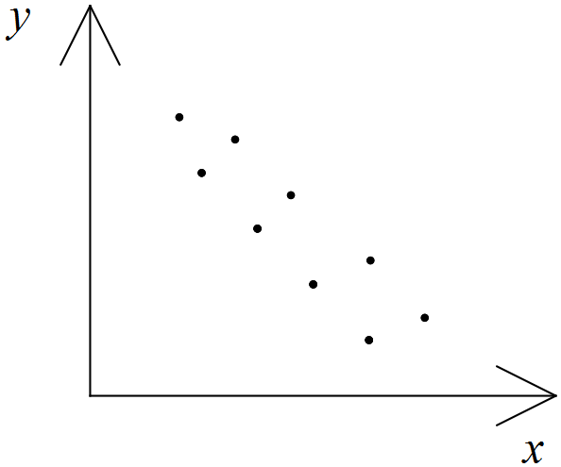

(b) Which of these correlation coefficients is the most appropriate for the given
scatter diagram?
–1·0, 0·7, –0·7, 1·2, 2·1, 15

8. [8 marks]

x | 1 | 2 | 3 | 4 | 5
y | 4 | 5 | 7 | g | 9
y$^{ˆ}$ | 4 | 5·25 | 6·5 | f | e
R | a | b | c | d | 0

A regression line was fitted to a set of data pairs (x, y).

The following table shows the predicted y values from the least squares equation, and the residuals.

Calculate a, b, c, d, e, f, g. [Hint: In that order.]

9. [9 marks: 1, 2, 1, 2, 1, 2 ]

Data points (x, y) were graphed as follows
(a) Which of the following values of would best describe the relationship?
Circle your choice. (i) 1 (ii) – 1 (iii) 0.9 (iv) – 0.3 (v) – 0.9

(b) Use words to describe the linear relationship between .

(c) A regression line was fitted to the data.
Which equation is most likely to be that of the line? Circle your choice.

(i) y = –17x + 20 (ii)
(iii) y = 17x – 17 (iv)

(d) If x represents fitness levels, and y represents weight for a sample of teenage tennis
players, comment on this statement.
"The graph shows that an increase in fitness levels causes a decrease in
body weight."

A residual is defined as , ie the y value of a data point subtract the
y co–ordinate of the corresponding point on the regression line.

A graph of residuals against was plotted.

(e) What important feature would you expect it to show?

(f) Explain briefly how residuals are related to the calculation of the least squares line.

10. [13 marks: 2, 1, 3, 3, 2, 2]

Mrs Sweep has lost her dog, Sooty. In despair, she phones the local radio station asking listeners for help.

As a result she receives several phone calls from people claiming to have seen a dog answering Sooty's description. Mrs Sweep records the listeners' sightings on a map of her neighbourhood.

The co–ordinates (x,y) are given in 0.5 km units, with (0,0) representing her home and are listed in the order of the times of the "sightings".
East (x) | 2 | 4 | 5 | 8 | – 3 | 9 | 12
North (y) | 3 | 7 | 11 | 15 | 11 | 17 | 20

(a) Describe in everyday language the position given by co–ordinates (–3, 11).

(b) Mrs Sweep believes that the reported 'sighting' (–3, 11) was probably not of Sooty.
Explain why.

After having removed ( –3 , 11 ), Mrs Sweep believes that Sooty's path is quite linear.

(c) (i) What statistic, available from your calculator will verify or disprove her belief?

(ii) Is her belief verified? Give a reason.

(d) With the sighting (–3, 11) removed, calculate the equation of the line which best
fits Sooty's path.

(e) When Sooty was 3 km east of home, predict how far north of home she was.

Mrs Sweep and Sooty used to live at ( 30, 50 ) before shifting to their current address.

(f) Do you think Sooty is heading for her old home?
Justify your answer mathematically.

11. [4 marks: 2, 2]
A series of data points has a regression line with equation y$^{ˆ}$ = 1·5 – 2x.
Which of the following points, a, b or c, is most likely to be
(i) the point (x$^{–}$, y$^{–}$)? (ii) an outlier?

(a) (0,0) (b) (8, –14·5) (c) (8, 81)

Give a reason for each answer.

12. [4 marks: 2, 2]

Steph the gardener has heard that playing music to melons will make them grow bigger. An experiment is conducted to find if there is a relationship between the number of hours of music played to each melon and the melon's size. The results for six melons are given in the following table:

Size (cm) | 12 | 15 | 16 | 20 | 21 | 25
Music played (hrs) | 1 | 2 | 3 | 4 | 5 | 6

(a) Calculate the correlation coefficient for the data.

(b) Is Steph correct in saying that playing music to the melons will make them grow
bigger? Give reasons for your answer.

13. [8 marks: 3, 1, 4]

Norma attends a weight–loss group. Her weight was 65 kg on joining the group.
Her weight losses are measured each week, and are recorded below.
Week | 1 | 2 | 3 | 4 | 5 | 6 | 7 | 8 | 9
Loss (kg) | 0·1 | 0·1 | 0·3 | 0·5 | 0·1 | b | –0·2 | 0·2 | 0·1
Cumulative Loss (kg) | 0·1 | 0·2 | 0·5 | a | 1·1 | 1·1 | c | 1·1 | 1·2

(a) Calculate the missing values denoted by a, b and c.

(b) Interpret the value of –0·2 in the table.

(c) Norma has a goal of getting down to 60 kg. Calculate a suitable regression
equation, and use it to find in which week she is likely to achieve her goal.

14. [3 marks]

The regression line of y on x has gradient 4 and passes through the
point (0, 5). Predict the value of y when x = 4.

15. [11 marks, 2, 2, 2, 3, 2]

Harold’s Car Hire displays its costs in a graph. Part of the graph is shown below.

(a) What is the value of the y intercept? What does it represent in the given context?

(b) What is the value of the slope of the line? What does it represent in the given context?

(c) Calculate the correlation coefficient between cost and distance.

(d) State the equation of the graph above. Be careful to include an appropriate restriction
on values of x.

(e) Ben hires a car from Harold’s Hire, and travels 700 km. Find the total cost.

16. [13 marks: 2, 1, 3, 2, 2, 1, 1, 1]
Agatha and Gertrude are fine snooker players. They played against each other in a match. The winner of the match was the first player to win 18 frames.
The frames were filmed for television purposes and the following cumulative times noted.
The first frame took 20 minutes.
The first two frames took a total of 43 minutes.
The first four frames took a total of 1 hour and 15 minutes.
The first nine frames took a total of 2 hours and 20 minutes.
The first 15 frames took a total of 3 hours and 50 minutes.
The first 24 frames took a total of 6 hours.
(a) Sketch the graph of “total time” against “number of frames”.

(b) On your sketch in part (a), draw in, by eye, the line of best fit.

(c) State the calculator’s equation of the line of best fit.
(d) Estimate how long it took to finish 10 frames.
(e) Use your answer to (d), to help determine how long the 10th frame took?

Agatha eventually won the match, 18 frames to 10.
(f) Estimate how long the whole match took.
(g) Calculate the average time per frame.
(h) How is your answer in (g) related to your answer in (c)?
17. [16 marks: 2, 1, 1, 2, 2, 1, 3, 2, 2]

The performance of eight brands of clothes dryer was researched and compared with the cost.
The performance of each brand was recorded in %. ( The larger the %, the better is the performance.)
Here are the results:

Brand | Performance (P) | Cost (C)
A | 90 | 870
B | 90 | 790
C | 65 | 690
D | 55 | 590
E | 50 | 570
F | 45 | 490
G | 45 | 830
H | 30 | 500

(a) Calculate the linear correlation coefficient for P and C, correct to two decimal places.

(b) By viewing a scatter diagram on your calculator, state which brand could be thought of
as an outlier.

(c) Remove the outlier and recalculate r _{PC.}

(d) Comment on your answer to c) in relation to your answer to a).

All further calculations should be with the outlier removed.

(e) Calculate the equation of the least squares regression line of C on P.

(f) Predict the cost of a dryer with a performance rating of 40%.

(g) Comment on the reliability of that prediction.

The residuals from the regression line are shown in the graph below.

(h) What can you deduce from the graph of these residuals?
(i) An observer claims that because the correlation is strong and positive,
that it is the performance which determines the price of the dryer.
Comment on the observer’s claim.
18. [14 marks: 1, 3, 1, 2, 2, 2, 2]

Babies of various ages (t) had their weights (w) recorded in the table below.

Age (months) | 3 | 4 | 6 | 6 | 7 | 9 | 12
Weight (kg) | 5 | 5.5 | 7.3 | 7.5 | 8.2 | 9.8 | 11.1

(a) Calculate the coefficient of linear correlation, r_{tw}.

(b) Calculate the least squares regression line equation of w on t.

(c) Predict the weight of a baby who is 5 months old.

(d) Comment on the reliability of your prediction in (c).
Give a reason.

The graph of the residuals ( Real – Predicted ) is shown below.
(e) Comment on the graph in terms of making predictions from the linear model in (b).Give a reason.

A researcher states “ The high value of r proves that a baby’s weight is caused by its age.”

(f) Comment on the statement.

Another study shows that the correlation between age and weight for adults is r_{tw} ≈ 0.2

(g) Draw a sketch, showing how the graph would look for adults between 50 and 60 years of age, with weights between 70 and 100 kg.
Show at least 10 points on your graph.

19. [ 9 marks: 1, 2, 1, 2, 2, 1]

Two quantities were measured and recorded in the following table.

x | 1 | 2 | 3 | 4 | 5 | 10
y | 3.14 | 12.56 | 28.26 | 50.24 | 78.5 | 314

An observer calculated the linear correlation coefficient and commented
“r ≈ 1, so a line is the best shape to fit through the points .”

(a) Calculate the value of the linear correlation coefficient, r.

(b) Draw a scatter plot of the information.

(c) After looking at the graph, make a better comment than the one given above.

Another observer commented correctly that y is related to x².

(d) By using curve fitting on your calculator, or number patterns or just observation,
state the simple rule connecting y to x².

(e) If x = 8 , predict the value of y.

(f) If x represents the radius of a circle, what quantity would y represent?
(Hint: ≈ 3.14)

20. [17 marks: 1, 1, 2, 2, 2, 2, 3, 1, 3]

The data given in the table below shows the age (in years) of all the workers in a small company, and the number of days sick leave taken last year by these workers.

x | Age | 43 | 40 | 51 | 25 | 28 | 60 | 33
y | Leave | 8 | 3 | 6 | 9 | 4 | 3 | 6

(a) What is the age of the oldest worker?

(b) How many workers are there in the company?

(c) State:

(i) the mean age

(ii) the standard deviation of the number of days sick leave.

(d) Plot the points from the table on a scatterplot.

(e) State the equation of the line of regression of “Days leave” against “Age”.
That is y on x.

(f) Graph your regression line from (e) on the axes above.
Show two key points used in drawing the line.

(g) Predict how many days a thirty year old employee might be expected to be absent.

(h) (i) State the value of r_{xy}.

(ii) Comment on the reliability of your estimate in (g).

21. [9 marks: 2, 2, 1, 1, 1, 2]

Anthropologists often predict the height of a person from the length of a discovered body part, such as a fossilized bone.
The humerus bone goes from the elbow to the shoulder.
Some data is given below for males, relating length of humerus bone ( x ) to body
height ( M ). Both lengths are in centimetres.

x | M
30 | 157
35 | 170
38 | 180
40 | 186
43 | 195
48 | 210
50 | 215
48 | 204
37 | 175
40 | 185

(a) State the value of the correlation coefficient between x and M.
Give your answer correct to 3 decimal places.

Consider the regression equation M = px + q fitted to the above data.

(b) State the values of p and q.

The graph of the Residuals against x values for the previous regression shows a totally random set of points.

(c) What can be deduced from this?

The rule used to predict the height of a female from the length of her humerus bone
( of length x centimetres ) is F = 2.7 x + 71

A 42 cm humerus bone was uncovered in an anthropological dig.

(d) Assuming the bone was from a female, how tall was she?

(e) Assuming the bone was from a male, how tall was he?

r _{Fx} was calculated from data collected over time to be 0.95.

(f) On the basis of r values, which of the two predictions, M or F, would lead to the
more accurate prediction? Give a reason for your answer.

22. [8 marks: 1, 2, 2, 3]

Electricity charges are made up of a fixed charge and also a cost per unit. The quarterly electricity charges for a household over a two year period are as follows:

Quarter | 1 | 2 | 3 | 4 | 5 | 6 | 7 | 8
No. of units used | 2300 | 3000 | 1900 | 2000 | 2400 | 3100 | 2500 | 2100
Cost ($) | 243 | 313 | 203 | 273 | 325 | 416 | 338 | 286

The information is represented graphically and shows that there has been a change in the unit cost, but no change in the fixed charge.

(a) When was the cost per unit different for the first time?

(b) How can you tell from the graph that there was a "fixed charge" as
well as a cost per unit?

(c) How much was the fixed charge?

(d) Assuming no further unit cost changes, determine the cost for a consumption
of 2800 units.
23. [13 marks: 2, 2, 1, 1, 2, 1, 2, 2]

A consumer magazine published data about fibre content in popular brands of breakfast cereals, identified by number.

Brand Number | 1 | 2 | 3 | 4 | 5 | 6 | 7 | 8 | 9 | 10
Fibre  Content (%) | 4.0 | 4.0 | 4.0 | 3.0 | 3.0 | 3.0 | 2.5 | 2.5 | 2.0 | 1.5

(a) Determine:

(i) the mean fibre content.

(ii) the standard deviation of fibre contents.

(b) Draw the median boxplot for the fibre content of the 10 brands.

(c) If every sample measured weighed 30g, state the mean weight of fibre content
for these selected brands.

The same 10 brands have their energy content (in kj per serve) recorded below.

Brand Number | Energy Content
1 | 480
2 | 470
3 | 480
4 | 460
5 | 450
6 | 480
7 | 220
8 | 470
9 | 470
10 | 470

(d) Calculate the correlation coefficient, r, for fibre and energy, based on the 10
brands given.

(e) Determine the equation of the regression line which could be used to predict
energy if fibre content is known.

(f) Predict the energy content for a brand which contained 3.2% fibre.

(g) Comment on the reliability of your prediction in (f).Support your comment with
a reason.
If the 10 data pairs are graphed, it would show an obvious outlier.

(h) (i) Which brand was the outlier?

(ii) State the effect on r if the outlier was removed.
24. [9 marks: 1, 2, 1, 3, 2]

A human finger has two knuckles separating the finger into three sections.
The following measurements of two of these sections were recorded to the nearest millimetre from a group of adults.

Section 1 (mm) | 25 | 28 | 30 | 31 | 27
Section 2 (mm) | 40 | 45 | 49 | 50 | 44

(a) Determine the correlation coefficient between the Sections 1 and 2.

(b) Calculate the equation of the line used to predict Section 2 lengths from
Section 1 lengths.

(c) Predict the Section 2 length on an adult whose Section 1 length was 26 mm.

(d) Comment on the reliability of your prediction.

These section lengths are related to each other in much the same way as consecutive terms in the Fibonacci Sequence are related.

(e) Describe the relationship, and use it to remake your prediction in (c).

25. [16 marks: 2, 1, 2, 2, 4, 1, 2, 2]

A researcher is interested in the relationship between the daily dosage of an anti−smoking drug and the amount of weight gained over a four week period.
The data he collected shows the mean weight gain amongst the survey group, and the corresponding dosages of the drug over the same period.

x: Dosage (mg) | 10 | 20 | 30 | 40 | 50 | 60
y: Weight Gain (kg) | −0.5 | 1 | 1.6 | 2.1 | 2.4 | 3.1

(a) Calculate the correlation coefficient, r_{xy}.

(b) Interpret the value of the −0.5 in the context of the question.

(c) Determine the equation of the line used to predict weight gain from dosage.

(d) Use your line to predict the weight gain for a dosage of:
(i) 35 mg (ii) 75 mg

(e) Comment on the reliability of both predictions in (d), giving reasons for
your comments.

(f) If z represents weight loss, state the value of r_{xz}.

(g) State the equation of the regression line of z on x.

(h) Due to the correlation coefficient, the following statement was made;
“Taking the drug causes people to gain weight.” Comment.

26. [4 marks: 1, 1, 1, 1]

A least squares regression line was fitted to some data.
Residuals were then calculated and graphed.
What deduction concerning linear fit could be made if the graph of the residuals looked like:

(a) (b)
(c) (d)

27. [14 marks: 1, 1, 3, 4, 2]

Paradise Travel advertises trips to Sunset Island.
A selection of costs for various lengths of stay is given in the table .

Number of Nights (n) | Cost (c)
2 | $ 710
5 | $ 950
7 | $ 1 110
12 | $ 1 510
15 | $ 850

(a) Calculate the coefficient of linear correlation between n and c.

The cost of the 15 day holiday was wrongly recorded in the table.
It should have been $1750.

Correct the value in your calculator then answer the following questions.
( Check: If = 6030, you have entered the data correctly.)

(b) What is the new value of r_{nc}?

(c) State the equation of the least squares regression line of c on n.

(d) Predict the cost of a ten night holiday and comment on the
reliability of that prediction.

It is found that cost is a linear function of airfare and accommodation cost per night.

(e) State:

(i) the cost of the air travel

(ii) the accommodation cost per night

28. [ 14 marks: 1, 3, 1, 2, 2, 3, 1, 1 ]
The price of a lettuce ( x cents ) and the corresponding numbers of lettuces sold (y) are recorded over an 8 week period and recorded in the table below.

Week | 1 | 2 | 3 | 4 | 5 | 6 | 7 | 8
x | 42 | 53 | 66 | 75 | 112 | 233 | 211 | 200
y | 340 | 400 | 500 | 550 | 800 | 1400 | 1400 | 1300

If your data was entered correctly, = 1 080 930

- What does represent in this setting?

(b) (i) State the equation of the line used to predict y if the price is known.
(ii) State the value of r_{xy}.

(c) Why does this value of r_{xy} suggest that the line could be suitable for making
predictions?

The graph of the residuals ( y –) is given.
(d) State how this residual graph can be used to support/not support reliability of
prediction.

(e) (i) Predict the value of sales if the price was $1.20 per lettuce.

(ii) Comment on the reliability of your prediction.

A different least squares regression line is used to predict price from a known sales value.

(f) Briefly describe how this different regression line is determined.
Use the word “residuals” in your description.
(g) Is it mathematically correct to say that since r_{xy} is high, sales are being determined
by price? Explain.
29. [ 9 marks: 1, 2, 1, 3, 2 ]

A researcher discovered a relationship between an ant’s speed, S, measured in metres per minute, and the temperature of the ant’s surroundings, T, in degrees Celsius.
His research included the following data.

T | 10 | 20 | 23 | 27 | 33
S | 1.8 | 4.1 | 5.2 | 5.9 | 7.5

(a) Determine the correlation coefficient between T and S.

(b) Determine the least squares regression equation for S on T.

(c) Comment on predictions based on temperatures where T > 33 or T < 10.

(d) (i) Predict the average speed of ants if the surrounding temperature is 22°.

(ii) Comment on the reliability of this prediction.

The researcher produces a residual plot as shown below.

(e) What information does it supply regarding the reliability of the prediction in (d)?

30. [ 13 marks: 2, 1, 2, 2, 2, 4 ]

Data points (x, y) are given in the table below.

x | –3 | –2 | –1 | 0 | 1 | 2 | 3
y | –38 | –13 | –2 | 1 | 2 | 7 | 22

(a) Calculate the least squares regression line of y on x.

(b) State the linear correlation coefficient, r _{xy}

(c) Predict y when x is four, and comment on the reliability of that prediction.

A table of residuals from your regression line is given below.

x | –3 | –2 | –1 | 0 | 1 | 2 | 3
R | –11 | 6 | 9 | 4 | –3 | –6 | 1

(d) Sketch the graph of Residuals against x.

(e) What evidence does the Residual plot provide regarding the appropriateness
of using a linear model ? Explain your answer.
An equation of the form y = Ax³ + Bx² + Cx + D is fitted to the original data points.

The Residual plot from that cubic model is given below.

(f) Determine the values of A, B, C and D.
31. [ 9 marks: 2, 2, 2, 2, 1 ]

The following graph relates x and y.

The line of regression of y on x was fitted to the data. The equation is given as:

y = –1.4x + 11.5 with

(a) Determine the value of r_{xy} .

(b) For the x value of 6, determine:

(i) the predicted value of y.

(ii) the value of the residual.

(c) If an x value was to increase by 3, estimate the associated change in y.

(d) If the point (9, 3.5) was removed, state the effect this would have on r_{xy}.
Give a reason for your answer.

. (e) If , calculate the value of .

32. [ 11 marks: 3, 5, 1, 2 ]

Historically, many countries have changed their methods of transporting freight.
The data below shows the tonnage moved by ship (x) and the tonnage moved by road (y) for various years in a particular country.
Measurements are for the same year and in millions of tons.

x | 1 | 1.5 | 2.2 | 3 | 7 | 5.1 | 3.6 | 9 | 4 | 5.7
y | 30 | 7.3 | 5.1 | 4 | 0.9 | 2.1 | 3.6 | 0.3 | 3 | 1.7

Researcher A fitted a line to the data.

(a) (i) State the correlation coefficient.

(ii) Determine the equation of the line used to predict y from x.

Researcher B removed a point which he believed didn’t fit well, probably
caused by a recording error.
His results then showed r_{xy} = – 0.94 and y = – 0.86x + 7.03

(b) (i) Which point did Researcher B remove?
(ii) Predict y when x = 2.4

(iii) Comment on the reliability of the prediction from (ii).
Researcher B then drew a graph of the residuals against x values, and concluded correctly that it would be more appropriate to fit a different shape ( not a line ) to the data.

(c) What feature of the residual graph would have lead him to that conclusion?

He fitted a quadratic with equation y = 0.12x² – 2x + 10

(d) What numerical difference would it make to his prediction in (b) (ii) ?

Chapter 5: Eulerian, Hamiltonian and Shortest Path

This chapter includes questions on
Bipartite Graphs
Adjacency Matrices
Eulerian and Hamiltonian Paths
Shortest Path

It is unlikely that a calculator will be required for this topic.

1. [ 5 marks: 3, 2]

The table shows some Big Bash clubs and some national Test teams who share players.

 | Scorchers | Sydney Sixers | Melbourne Stars
Australia | 2 | 2 | 3
England | 2 | 1 | 1
West Indies | 1 | 1 | 0

(a) Draw a bipartite graph to represent the information.

(b) Is this a complete bipartite graph? Explain.

2. [ 8 marks: 3, 2, 1, 2]

Four snooker players are having a practice round robin day, where every player plays every other player exactly once.

(a) Construct a graph that displays the players A, B, C and D in that competition.

(b) Is that graph complete? Explain.

(c) How many games are played?

(d) Draw the adjacency matrix that represents the information.

3. [7 marks: 2, 1, 1, 3]

The following bipartite graph shows those parents who are involved in the Safety House program in our neighbourhood, and are at home on any given day.

(a) On which days will Bill not be available?

(b) Which parent is available the least?

(c) On which day is there the greatest number of parents available?

(d) If there were $220 per week made available for after school care provided by these
parents, to how much would Barbara be entitled?

4. [13 marks: 1, 2, 2, 4, 4]

(a) Which of the following networks are planar? Give a reason.

(b) Which of the following networks contain an Eulerian circuit? Give a reason.

(c) Which of the following networks contain a Hamiltonian cycle? Give a reason.

(d) Verify Euler’s rule applies to each.

(e) Construct a bipartite graph linking each graph to the descriptors :Eulerian, semi– Eulerian, Hamiltonian, semi–Hamiltonian.

(i) (ii)
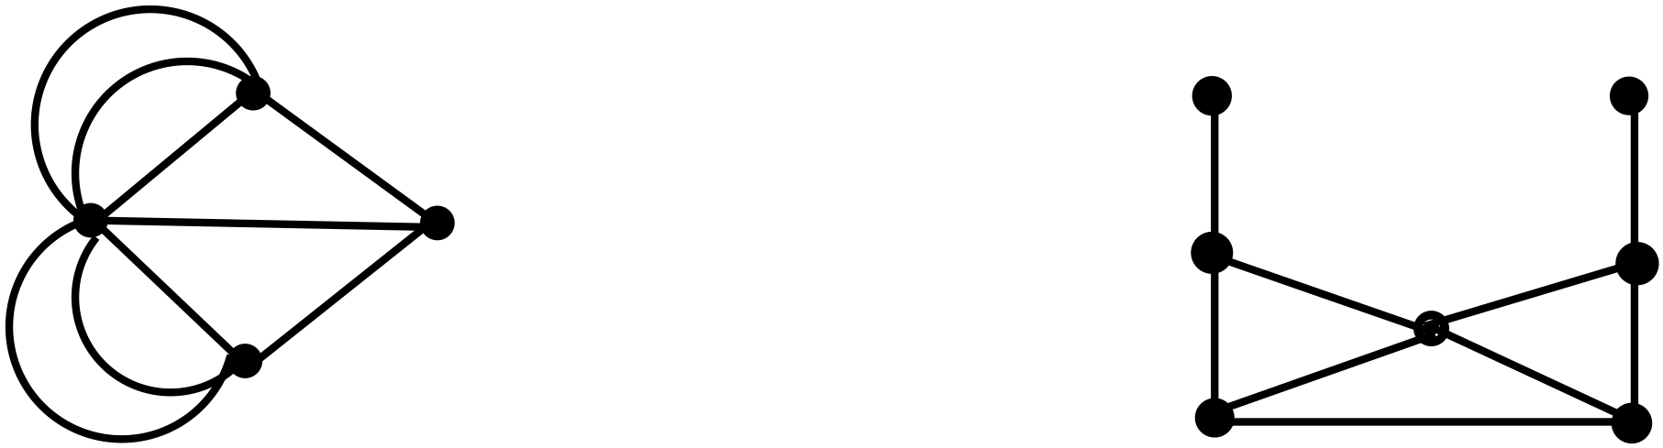

(iii) (iv)

(f) If the adjacency matrix for graph(i) is drawn, and called A, then what meaning is given to A²?

5. [13 marks: 1, 3, 1, 1, 3, 3, 1]

Each of these networks contains a Semi-Eulerian path.

(a) Define “a Semi-Eulerian path.”

(b) Show a starting point, and a finishing point for each Semi-Eulerian path.

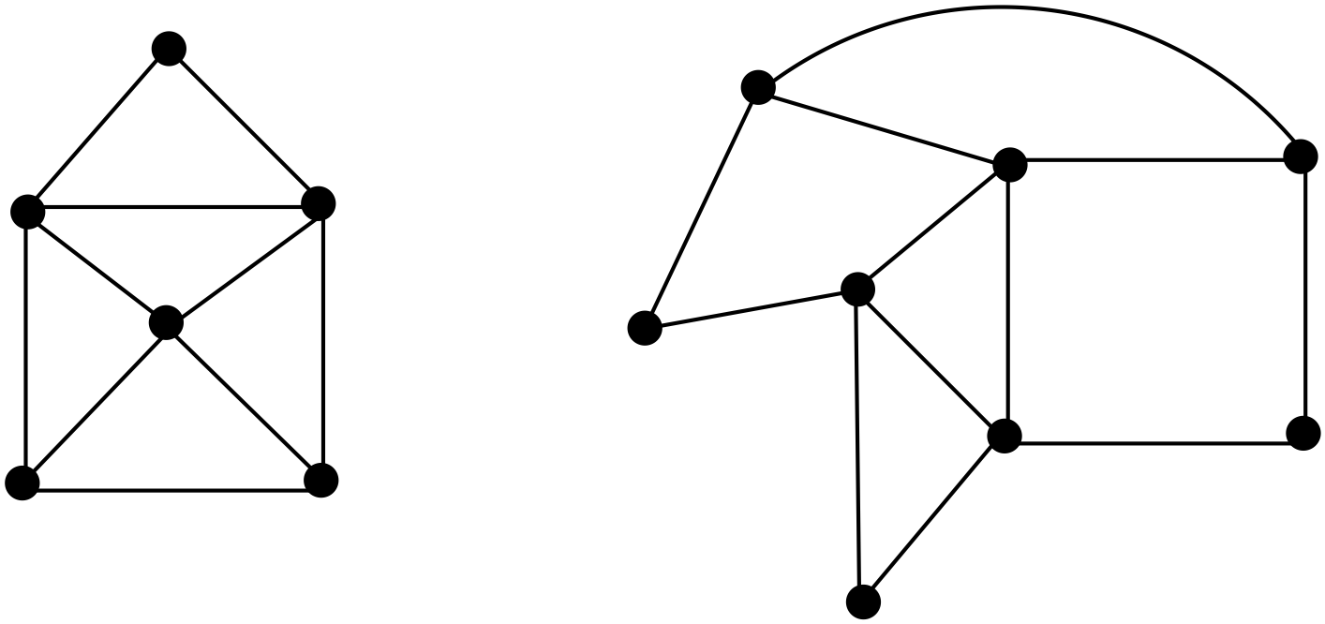 (i) (ii) (iii)
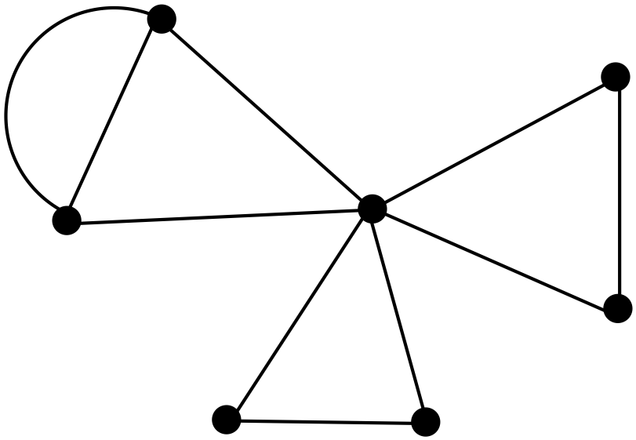

(c) Complete this statement:

If a network with two odd vertices is traversed, one odd vertex will be the starting
point, and _____________________________________________.

(d) Which of the networks given contain a Hamiltonian cycle?

(e) Verify Euler’s rule applies to each of the given networks.

(f) Construct a bipartite graph linking each graph to the descriptors: Semi-Eulerian,
Hamiltonian, semi–Hamiltonian.

(g) If the adjacency matrix for graph(i) is drawn, and called A, then what meaning is given to A³?

6. [10 marks: 1, 3, 1, 1, 1, 2, 1]

Each of these networks contains an Eulerian circuit.

(a) Define “Eulerian circuit.”

(b) Show a starting point, and a finishing point for each Eulerian circuit.

(i) (ii) (iii)

(c) Complete this statement:
If a network with zero odd vertices is traversed, the starting point, can be any vertex,
and _____________________________________________.

(d) Which of the networks given contain a Hamiltonian path?

(e) Verify Euler’s rule applies to each of the given networks.

(f) Construct a bipartite graph linking each graph to the descriptors: Eulerian and
Hamiltonian.

(g) If the adjacency matrix for graph(i) is drawn, and called A, then what meaning is given to A⁴?

7. [4 marks: 2, 1, 1]

This cube can be collapsed to a 2–D network.

(a) Check that Euler’s rule is satisfied by the 3–D figure and also by its 2–D planar equivalent.

(b) The planar version shows that there is no Eulerian circuit. Why not?

(c) What is the smallest number of diagonals that need to be drawn on the faces of
the cube so that it does contain a Semi-Eulerian path?

8. [6 marks: 3, 2,1]

This board game has paths made up of varying numbers of squares.
A player rolls a die. The number on the die determines how many squares the player moves.
Players start from Aztec House. The object is to be the first player to get to the Treasure Chest.
Any arc may be taken at a vertex.
The network below represents the routes on the board, with numbers representing the number of squares between vertices.
(a) Find the shortest route from Aztec House to the Treasure Chest.
Mark it on the diagram above and state its length.

(b) By how many squares is it shorter than the next shortest route?

(c) If a player can only throw a maximum of 6 on any throw of the die,
how many throws would he need to win the game?

9. [9 marks: 3, 3, 2, 1]

John lives in Calingiri and needs to get to Dalwallinu for a cricket match.

(a) What is the shortest path and how long is that path?
(Distances are given in kilometres)

(b) If John needs to pick up Andrew from Yerecoin on the way, will he get to cricket on
time, given that the game starts in 90 minutes from his leaving Calingiri, and they can
safely travel at 90 km/hour?

(c) State the order of each vertex (town) on the network ( map) and determine if it is possible for a road safety officer to start at one town and inspect every one of the listed roads without having to travel over any roads twice.

(d) Calculate the minimum distance a salesman would travel from Ballidu to visit every town once and only once.
10. [6 marks: 2, 4]

While on holiday at Innamincka, Agatha hired a car in order to visit Gertrude, who lived in Windorah. Agatha used the map given below.

(a) How far did she travel, and on what route, given that she wanted to travel the shortest
possible distance to Windorah.

(b) If hire costs were $1.20 per km, what did the round trip cost her, given that she
returned via Mooraberrce and Cordillo Downs, still wishing to minimise travel cost.

11. [4 marks: 2, 2]

Here is a simplified map showing some possible routes from Denbany to Freeburn.
On one copy, indicate

(a) the shortest route and state its length.

and on another copy, indicate

(b) the shortest route that passes through Manjerton, and state its length.

12. [5 marks: 2, 1, 2]

It is possible to travel by coach from one town to another according to the following cost schedule where amounts are $.

(a) Find the cheapest way of travelling from Blue Town to Uptown, and state the cost.

A traveller wishes to visit all of the towns, starting at Blue Town and finishing at Uptown.

(b) Describe this as Eulerian or Hamiltonian.

(c) Find the minimum cost for the traveler.

13. [6 marks: 1, 1, 2, 2 ]

The following diagram shows some of the more commonly used roads from Perth International Airport to Observation City .

The distances in km are indicated for each section of travel.
(a) How many different routes are shown, always travelling basically West from the Airport to Observation City?

(b) Calculate the minimum distance from the airport to Observation City.

Taxi fares are $3.50 set fee plus 95c per km. Mary asks the driver to take her to Observation City. The driver assures her she will need $40.00.

(c) Is the driver going to take her by the shortest path? Explain.

(d) What would she be charged if taken on the longest of the routes shown ?

14. [7 marks: 2, 2, 1, 2]

Peter is a keen jogger and over a period of months knows his times for various "legs" of his path from home to work. The times are given in minutes.

(a) Find his quickest route from home to work.

(b) Find his longest route from home to work. (assume no cycles)

Peter takes his mobile phone with him, and on arrival at A, receives a message instructing him to get to work as soon as possible.

(c) What route will he most likely take?

(d) If he normally jogs at 10km/hour, how far is A from Work along the shortest route?

15. [7 marks: 4, 3]

John intends visiting friends in the south west of Western Australia.
John has a friend in each town.
He plans to visit a different friend each day, and then return to his base
each night using the roads shown.

(a) Which town should he use as his base if he wishes to keep travelling distance to a minimum?
Use the table below to organize your thoughts, and state the minimum
travelling distance.

Base Town | Total travelling distance from this base

After freak flooding in the area, all the above roads were badly damaged.
It was necessary to restore road connections as soon as possible.

(b) Which road(s) could be left damaged for a short time while still having all towns
connected, and keeping road building distance to a minimum?
Show your connections on the diagram.

16. [10 marks: 4, 3, 2, 1]

Dan drives a delivery van for a Perth business. The businesses which he visits are
represented by the vertices on the road network drawn below.

The times, in minutes, it usually takes between businesses are shown on the arcs.

(a) Determine the least time taken to travel from:

(i) A to K. State the path used.

(ii) A to K via D. State the path used.

The opening of the new Roe Highway has meant a direct path from G to K with a travelling time of 10 minutes.

(b) If he needed to make a delivery from D to K, how much time would he
save if he used the new path? Show your working clearly.

(c) Starting from A, state
(i) a Hamiltonian cycle.

(ii) the Hamiltonian cycle of minimum length.

(d) For which type of situation would the answers to (c) be relevant?

(i) Dan wants to show a new driver every road that can be travelled in doing
deliveries.

(ii) Dan wants to show a new driver every business that can be visited in doing
deliveries.

17. [ 8 marks: 2, 4, 2]

Not to scale.

A tourist lands at Learmonth Airport and wishes to travel to Coral Bay by road.

(a) Determine the shortest distance from Learmonth Airport to Coral Bay.

(b) He wishes to visit Osprey Sanctuary as well as Coral Bay. Determine the shortest
distance possible by travelling to both places and staying overnight at one of them,
if

(i) he has a 4WD.

(ii) he doesn’t have a 4WD.

18. [ 5 marks: 3, 2]

The diagram below represents a road network linking ten towns. The number on each arc represents the time, in minutes, taken to travel between towns along that arc.
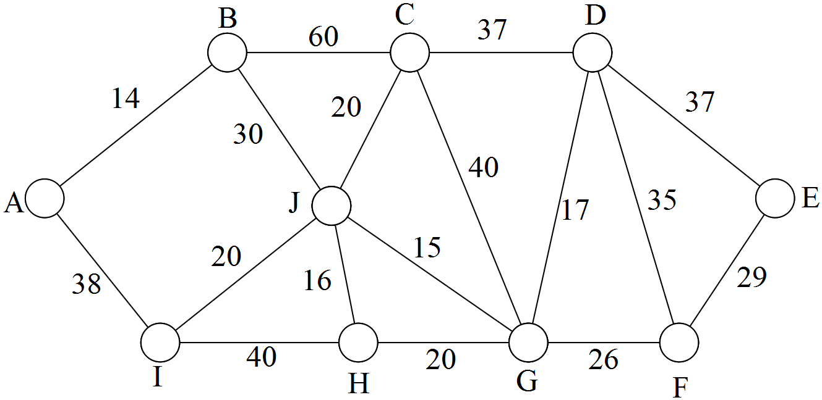

(a) Find the quickest route from A to E, and state that time. To obtain full marks, numbers
must be added to the following diagram, showing that an appropriate method has been
used.
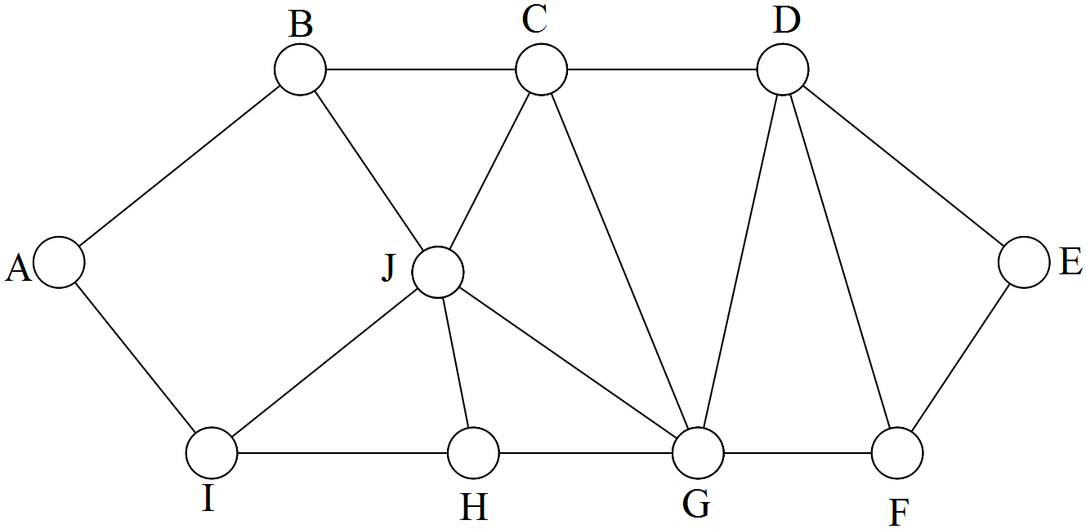

(b) Find the quickest route from A to E that passes through C.
What is the time taken to travel on this route?


Chapter 6: Recurrence

This chapter includes questions about

Recursive definitions
Difference patterns
AP’s and GP’s and their rules and graphs.
First order recurrence relations

Some questions require the use of a calculator.

1. [16 marks: 3, 2, 2, 1, 2, 3, 3]

The matrix below consists of arithmetic sequences in rows and arithmetic sequences in columns.

 | Column  1 | Column  2 | Column  3 | Column  4 | Column  5 | Column  6 | Column  7
Row 1 | 4 | 7 | 10 | 13 | 16 | 19 | 22
Row 2 | 7 | 12 | a | 22 | 27 | 32 | 37
Row 3 | 10 | 17 | 24 | 31 | 38 | b | 52
Row 4 | 13 | 22 | 31 | 40 | 49 | 58 | 67
Row n | 3n + 1 | c | 7n + 3 | e | 11n + 5 | f | 15n + 7

(a) State the missing values a, b and c.

(b) State the common difference d, for the:

(i) 2nd row

(ii) 3rd row.

(c) Complete row n, by finding expressions for e and f.

(d) Show that the common difference in the nth row is 2n + 1

(e) State the formula for the nth term in the nth row.

(f) The following statements can be related to the matrix.

(i) If n does not occur in the table (and never will) then 2n + 1 is a prime number.
Verify this for three numbers not in the table.

(ii) If n is in the table then 2n + 1 is not prime.
Verify this with three numbers in the table.

2 [4 marks: 2, 2]

State the first four terms of the following recursively defined sequences.

(a)

(b)

3. [4 marks, 1, 1, 2]

Consider T _{n+1} = aT_{n} +b, T₁ = 5

(a) If a = 1, what word describes the sequence beginning with T₁?

(b) If b = 0, what word describes the sequence beginning with T₁?

(c) If a = 2 and b = 2, list the first 3 terms of the sequence.

4. [9 marks: 1, 1, 2, 3, 2]

The number of dots in the following “dot rectangles” form a sequence with general term T _{n} . i.e. T _{n} is the number of dots in rectangle number n.

Rectangle Number 1 2 3 4

The widths of the rectangles form the sequence : 1, 2, 3, 4,…
The lengths of the rectangles form the sequence : 3, 4, 5, 6, …

(a) State the width and length of rectangle number 5.

(b) State the width and length of rectangle number 10.

(c) State the width and length of rectangle number n.

(d) Hence, or otherwise, determine the value of

(i) T₅

(ii) T₁₀

(iii) T _{n}

A “ dot rectangle “ from the same sequence is drawn and the dots counted.

(e) If there were 143 dots, determine which dot rectangle it was.

5. [ 3 marks: 1, 1, 1]

(a) Draw the next picture in the sequence.

(b) If T₁ = 2, T₂ = 6, T₃ = 12 etc, determine a value for T₆

(c) Use differences to state whether the formula for T_{n} is linear, exponential or neither.

6. [8 marks: 6, 2]

(a) Calculate the first 4 terms of the sequences given by these recursive definitions.

(i) T_{n} = 2 T_{n–1} + 7 , T₁ = 5

(ii) T_{n} = 2 T_{n–1} + , T₁ = 5

(iii) T_{n} = 2 T_{n+1} + 7 , T₄ = 5

(b) Which of the above sequences have a straight line graph?
Give a reason for your answer.

7. [6 marks: 2, 4]

If ,

(a) state the values of A₁, A₂, A₃ and A₄.

(b) define the sequence using:

(i) a recursive rule in symbols.

(ii) a recursive rule in words.

8. [6 marks: 2, 1, 3]

y = 60x + 100 describes a traveller who starts 100 km from home, and continues, travelling away from home at 60 km/hr.

(a) Define the sequence recursively.

(b) How far will he be from home after 3 hours?

(c) If the graph of his journey was drawn, what would be its main features?

9. [6 marks: 2, 2, 2]

The triangular numbers can be expressed as 1 + 2 + 3 + …….

(a) State the first four triangular numbers.

The same set of numbers can be expressed by using the rule .

(b) State the first four triangular numbers using this method, showing your working.

A recursive definition can give the same result.

(c) State the first four triangular numbers using this method, showing your working.

10. [3 marks]

An arithmetic progression has T3 = 8 and T7 = 20.

Calculate the first term, and the common difference.

11. [2, 2, 2 marks]

(a) Write out the first 5 terms of the sequence defined by
Tn = Tn–1 + 2n , T1 = 2. [n > 1]

(b) Write out the first 5 terms of the sequence defined by
Tn = n(n + 1) [n ≥ 1]

(c) Calculate T10 of the above sequence. Which formula is easier to use, and why?

12. [7 marks: 3, 2, 2]

The following sequence

19, 15, 11, …

is arithmetic, and has formula Tn = 23 – 4n.

(a) Verify that the formula is correct.

(b) Calculate the 10th term of the sequence.

(c) Write the recursive formula that describes the above sequence.

13. [9 marks: 2, 3, 2, 2]

Consider the sequence generated as follows:
t1 = 20; tn = $\frac{1}{2}$ · tn–1 where n > 1.

(a) Write the first 4 terms of the sequence.

(b) Write a formula expressing tn in terms of n.

(c) Calculate the tenth term of the sequence using either formula.

(d) Which formula is easier to use? Give a reason.

14. [9 marks: 6, 3]

(a) Identify each sequence as arithmetic, geometric or neither.
Give a reason for your choice.

(i) Tn = 75(0·8)n–1

(ii) 0, 6, 11, 15, 18, 20, …

(iii) T1 = 100, Tn = Tn–1 – 1·5

(b) State T7 for each sequence.

15. [10 marks: 6, 1, 3]

(a) Calculate the first 5 terms of the sequences given by the difference equations

(i) Tn+1 – 2Tn = 0 , T1 = 10

(ii) Tn+1 – 2Tn = 2 , T1 = 10

(iii) Tn+1 – 2Tn – 5 = 0 , T1 = 10

(b) Which of the three sequences shows the fastest rate of growth?

(c) Classify the sequences as Arithmetic, Geometric or "Neither".

16. [12 marks: 10, 2]
A student draws graphs for the following:

Tn = $\sqrt{Tn–1}$
He uses as his starting value, T1,
i) –8
ii) 0
iii) 0·5
iv) 1
v) 2
(a) Draw the graphs, where possible, and comment on any similarities and differences in the graphs.

(b) A child enters a positive number greater than 1 into his calculator, then repeatedly presses the $\sqrt{}$ button. What value will the calculator display after 176 presses?

17. [8 marks 3, 2, 3]

The terms (Tn) in a Geometric series are graphed below.
T_{n}

6

5

4

3

2

1

n
1 2 3 4 5

(a) From the graph, give a value for (i) T1
(ii) T2
(iii) T3
The relationship between successive terms in the series can be
described by this recursion formula:

(b) Evaluate r.

(c) Calculate:

(i) T6

(ii) Tn

18. [6 marks: 2, 2, 2]

The following graphs represent sequences:

(a) (i) and (iii) represent Arithmetic Sequences. Comment on the value of the common differences.

(b) (ii) and (iv) represent Geometric Sequences. Comment on the value of the common ratios.

(c) This graph could be thought of as a special G.P. or a special A.P.

(i) If it is a G.P. state the common ratio.

(ii) If it is an A.P. state the common difference.

19. [11 marks: 2, 4, 3, 2]

Consider the sequence

$\frac{4}{3}$ , $\frac{9}{5}$ , $\frac{14}{7}$ , $\frac{19}{9}$ , $\frac{24}{11}$, … where Tn = $\frac{5n–1}{2n+1}$

(a) Find T10 of the sequence.
(b) Evaluate T100 and T1000 to 3 decimal places.
(c) Graph n on the horizontal axis and Tn on the vertical axis.
(d) Describe the behaviour of this graph.

20. [12 marks]

The following graphs have been drawn to correspond to four sequences.

Four recursive definitions and four general rules have been developed which will match these graphs. They are given below.
1. Tn = Tn–1 + 2 5. T_{n} = 2n + 1
2. Tn = Tn–1 – 1 6. T_{n} = 4 – n
3. Tn+1 = 2Tn 7. T_{n} = 3(–2)n–1
4. Tn+1 = –2Tn 8. T_{n} = 1·5(2n)
Use the table below to write your answers to a) and b).
(a) Match each of the graphs with its recursive definition and general rule.
(b) Determine the vertical scale for each graph.

 | Rec. Def. | Gen. Rule | T1
A
B
C
D
21. [4 marks]

Which of the following recurrence relations have a steady state solution?
For those which do, determine that solution.
(a) A_{n+1} = – 0.2A_{n}, A₁ = 100

(b) A_{n+1} = 2A_{n}, A₁ = 100

(c) A_{n+1} = 0.5A_{n} – 20, A₁ = 100

(d) A_{n+1} = 20 – 0.5A_{n}, A₁ = 100

(e) A_{n+1} = 20 + 0.4A_{n}, A₁ = 100

22. [ 2 marks]

The recurrence relation A_{n+1} = 15 + 0.8A_{n}, A₁ = 20
has a steady state solution. Calculate that solution.

23. [4 marks: 2, 2]

The recurrence relation A_{n+1} = –5 + kA_{n}, A₁ = 20
has a steady state solution of –8.

(a) Calculate the value of k.

(b) Evaluate (i) A₁₀₀ (ii) A₂

24. [ 4 marks]

A_{n+1} = 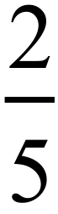 A_{n} – k has a steady state solution.
Determine the value of k and the steady state solution if A₁ = 10 and A₂ = 6.

25. [5 marks: 2, 2, 1]

(a) Solve x = 13 – 0.3 x

(b) Find the first 3 terms of A_{n+1} = – 0.3 A_{n} + 13 where A₁ = –10

(c) Find the steady state solution for A_{n+1} = – 0.3 A_{n} + 13 .
( Hint: Consider part (a)).

26. [6 marks: 2, 2, 1, 1]

(a) Solve x = 0.6x – 6

(b) Find the first 3 terms of A_{n+1} = 0.6 A_{n} – 6 where A₁ = 2

(c) Determine A₅₀₀. ( Hint: Consider part (a)).

(d) Would you classify the sequence defined in (b) as increasing, decreasing or
steady state?

27. [ 6 marks: 2, 1, 1, 2]

Consider the recurrence relation A_{n+1} = 2 + 0.5A_{n}, A₁ = 10
(a) State the first 3 terms.

(b) Determine A₃₀ from your calculator table.

The graph of A_{n} shows the terms approaching a value, k.

(c) From the graph or a table, determine k.

(d) Determine k by solving an equation.

28. [ 6 marks: 4, 2]

A recursive sequence is defined as

for n ≥ 1, with T₂ = 0, T₃ = 1 and T₄ = 2

(a) Find:

(i) T₁

(ii) T₅

(iii) T₆

(iv) T₇

(b) John believes that the terms form an Arithmetic Progression.
Investigate his claim.

29. [ 8 marks: 3, 3, 2]

The recursive definition:
where T₁ = 4
defines a sequence.

(a) Give the first four terms of the sequence.

(b) Use difference patterns, or otherwise, to state a general rule, and use it to
determine the twentieth term of the sequence.

(c) By projecting the sequence backwards, or otherwise, determine the value of the
smallest term(s) of the sequence.

30. [ 6 marks: 3, 3]

These recurrence relations are of the form A _{n+1} = x A_{n} + y with A₁ = z.
Determine the value of x, y and z in each case.

(a)
n | 1 | 2 | 3
An | 3 | 14 | 58

(b)
n | 3 | 4 | 5
An | 13 | 63 | 313

Chapter 7: Applications of Sequences

This chapter includes questions about

AP’s and GP’s, and also applications of general first order recurrence relations.

Some questions require the use of a calculator, particularly to find terms in a sequence provided in a calculator table. These tables also provide information about sums of terms, which although outside the syllabus, enable many more interesting applications to be investigated.

1. [6 marks: 3, 3]

A pine plantation is established in rows which form a trapezoidal–shaped area as in the diagram below; each tree is represented by a circle. The first row contains 6 trees, the second 7 trees, the third 8 trees and so on, with each row consisting of one more tree than the previous row.

0 | 0 | 0 | 0 | 0 | 0
0 | 0 | 0 | 0 | 0 | 0 | 0
0 | 0 | 0 | 0 | 0 | 0 | 0 | 0
0 | 0 | 0 | 0 | 0 | 0 | 0 | 0 | 0
0 | 0 | 0 | 0 | 0 | 0 | 0 | 0 | 0 | 0
0 | 0 | 0 | 0 | 0 | 0 | 0 | 0 | 0 | 0 | 0

(a) Determine the number of trees in the 40th row.

(b) Determine the total number of trees in the plantation which consists of 40 rows.
Use the table of sums after inserting a recursive rule.

2. [8 marks: 2, 2, 2, 2]

The number of atoms of hydrogen in a molecule of water, H2O, is 2.
The number of atoms of hydrogen (h) for various numbers of water molecules (w) are shown in this graph.

(a) Give the recursive relationship between the values of h.

(b) State the functional relationship between h and w.

(c) State the gradient of the line drawn joining the points above. What relationship exists between the gradient and your study of sequences?

(d) Avogadro's number (6·02 x 1023) gives the number of water molecules in a MOLE. How many atoms of hydrogen are there in a mole of water molecules?

3. [8 marks: 3, 5]

(a) Andrew takes a job on a starting salary of $8 000, but with a guaranteed $1 000 raise each year for the next 6 years. Find his salary after his 6th raise.

(b) Ben takes a job with a lower starting salary than Andrew, but with a guaranteed $1 200 raise each year for the next 6 years.

(i) How much more would Ben be earning after his 6th raise than he did originally?

(ii) After their 6th raise, Andrew's salary and Ben's salary were the same. What was Ben's starting salary?

4. [4 marks]

Kate swings on the local park swing and in so doing traces out an arc length of 6 metres once her Dad has stopped pushing.
The length of the arc is reduced to 0·6 of its previous amount on each subsequent swing.
If movements of about 10 cm count as being stopped, use a table to find how many swings Kate had before she stopped.

5. [6 marks: 2, 2, 2]

Erica’s Pizza Bar has a display of pizzas, each cut into a different number of sections.
The pizza cuts form an interesting sequence:
The first pizza has only one section. (It is not cut at all.)
The second pizza has two sections. (It has been cut once across the centre.)
The third pizza has four sections. (It has been cut twice across the centre.)
The fourth pizza has six sections. (It has three cuts across the centre.) ........and so on.

Calculate the number of sections in:

(a) the fifth pizza.

(b) the sixth pizza.

(c) the nth pizza.

6. [12 marks: 3, 3, 3, 3]

Rod visits a casino regularly and develops a system which he believes will win.
This is it:

He bets $1 on an even money chance.( i.e. a 50 : 50 bet, or odds of 1 : 1 )

If he loses, his next bet is $2.
If he loses again, his next bet is $4.
If he loses again, his next bet is $8. etc.

(a) Assuming he loses nine consecutive times, what will his next bet be ?

(b) The casino has a $2 000 limit per bet.

(i) What is the greatest number of consecutive bets that Rod could lose before he
was stopped from betting?

(ii) What would be the amount of his last bet?

(c) Rod takes $200 with him to the casino.

(i) How many consecutive bets could he lose using his system?

(ii) How much money would he have left after his last losing bet?

(d) How much money would he win overall if he wins:

(i) on his first bet?

(ii) on his tenth bet, having lost all of his previous nine bets?

7. [8 marks: 1, 1, 1, 3, 2]

A gymnastics institute monitors increased performance brought on by a new training apparatus.
The increase in performance level seems to be always 10% of the previous week’s increase.
The same statement can be written mathematically as : L _{T+1} − L _{T} = 0.1 ( L _{T} − L _{T–1} )
where L _{T} is the performance level at any time T weeks after starting the program.

If a gymnast originally has a performance level L ₀ of 100 units, and after the first week of using the new apparatus her new level, L ₁, is 190 units, then

(a) determine L ₁ − L ₀
(b) determine L ₂ − L ₁
(c) determine L ₃ − L ₂
(d) sketch the graph of L _{T} against T on the axes given.
(e) state the limit of her performance level using the new apparatus. Give a reason or show any relevant working.

8. [11 marks: 2, 4, 3, 2]

The times taken, in minutes, to catch a group of n caged finches, one at a time, are given as terms, T_{n} , of a geometric sequence.

(a) Complete the table of values given below for n = 1,2,3,4 and 5
Round values of T_{n} to be correct to 2 decimal places.

n | 1 | 2 | 3 | 4 | 5
T_{n} | 2.4 | 2.88 | 3.46

(b) (i) How long would it take to catch a group of 8 finches?

(ii) How long would it take to catch the eighth finch?

(c) If it took just under a quarter of an hour to catch a group of finches, how many were in the group?

(d) Write a recursive definition that represents the sequence described earlier.

9. [13 marks: 2, 1, 3, 2, 1, 2, 2]

Fiona and Andrew have just announced their engagement. Fiona’s parents are planning their engagement party at a local restaurant. Entertainment and nibbles will be provided there. On checking prices with the restaurant, it seems that the band will cost $200 and food will be a set price of $12 per head.

They produce a table of figures as shown.
NUMBER OF PEOPLE | 10 | 15 | 20 | 25 | 30
COST ( $ ) | 320 | 380 | 440 | 500 | 560

(a) Draw a graph of people (x) against cost (y) for the data given above.

(b) Explain why it would be strictly incorrect to join the points to form a
continuous graph in (a).

(c) Write a general rule which states y as a function of x for the situation described above.

(d) If they were hoping to spend a maximum of $1 000, how many people could they invite?

(e) Fiona’s guest list comprised 64 people. What would this number of people cost?

(f) The final guest list swells to 80. Andrew’s parents decide to contribute $500 towards
the cost. How much will Fiona’s parents need to pay?

(g) State the cost equation, in recursive form, if a cheaper band, charging $150, had been preferred.

10. [10 marks: 2, 2, 6]

Grand Canyon is a trotter. His training in preparation for a new racing season involves increasing his distance work from 100 m per day in the first week to 2500 m per day in the 5th week.

His increase per week is a fixed "x" metres.

(a) Calculate x.

(b) What distance did he work over each day during week 3?

Grand Canyon trains 6 days per week.

(c) (i) What distance does he work over on his
α) llth day of work?
ß) 13th day of work?

(ii) Find the total of his distances worked in his 5 week preparation time.

11. [8 marks: 2, 2, 2, 2]

(a) Draw the 4th diagram in the sequence

(b) Use difference patterns, or your calculator, to find the relationship between the number of dots (y) and the position in the sequence (x).

(c) Hence, or otherwise, find the number of dots in the 13th diagram.

(d) Find in which position in the sequence is the diagram containing 77 dots.

12. [5 marks]

A reticulation company charges $20 per metre for the first 4 m dug to put in a bore, $35 per metre for the next 4 m, with further 4 m increases each costing an extra $5 per metre.

Find the total cost of sinking a bore to a depth of 28 metres.

13. [6 marks: 2, 2, 2]

(a) The above triangle has sides which form an Arithmetic sequence. Verify that the Pythagorean theorem applies to the above triangle.

It can be shown that all right triangles whose sides are in Arithmetic sequence are proportional to the 3, 4, 5 triangle shown above.

(b) Find 2 other such triangles.

(c) Kevin is keen to disprove the theory, and believes that a triangle whose sides are 10, 12, 14 is an exception to the rule. Make some calculations to either support or reject his claim.

14. [5 marks: 3, 2]

Bill is practising for an upcoming snooker tournament.

He puts in 1 hour the first day, 80 minutes the second day, 100 minutes the third day and continues to increase his practice time by 20 minutes per day.

(a) For how long could he possibly keep up this routine if his maximum practice time is 8 hours per day?

(b) If he has 10 possible practice days available before the tournament, how much time will he have put in on the table by that date?
15. [6 marks: 1, 2, 2, 1]

The value of a machine decreases each year by 20% of its value at the start
of that year.
Consider the following question, and the two methods of solution given.
Question If the machine cost $ 30 000 when new, calculate its value at the end of Year 2.

Solution Method 1:
Value at the start of Year 1 = 30 000
Loss of value in Year 1 = 6 000
Value at start of Year 2 = 24 000
Loss of value in Year 2 = 4 800
Value at the end of Year 2 = 19 200

Method 2:

Value at the start of Year 1 = 30 000
Value at the end of Year 1 = 30 000(0.8) = 24 000
Value at the end of Year 2 = 24 000(0.8)= 19 200

(a) Explain the relevance of 0.8 in method 2.

(b) Calculate the value of the machine at the end of year 3.

(c) State an expression for the value of the machine at the end of year “ p”.

(d) Which of the following graphs best represents the ongoing value of
the machine?

16. [21 marks: 5, 2, 3, 3, 3, 4, 1]

In 2000, Crawley Bars Brewing produced 1 million litres of dark ale.
Market research indicated the need to increase production by 15% per year, beginning from 2001.
(a) State the number of litres produced in:
(i) 2001
(ii) 2002
(iii) 2005 ( to the nearest 1000 litres)
(iv) year n, where n is the number of years after 2000.

(b) Determine in which year production will first exceed 3 million litres.
Production (y) in millions of litres of pale ale is shown below for values of n between the years 2000–2003.
It is thought the relationship is quadratic.

Year | 2000 | 2001 | 2002 | 2003
n | 0 | 1 | 2 | 3
y | 1.1 | 1 | 1.1 | 1.4

(c) (i) Determine the rule that relates y to n.
(Use quadratic regression on your calculator)
(ii) Hence, or otherwise, predict production in 2004.

In 2004, the management considered the following:
If our company was forced to produce only one of dark ale or pale ale, which would we choose?
Some board members suggested the pale ale.
(d) Use graphs and/or tables and explain over what years their view is reasonable.

Some board members took a longer term view, and suggested the dark ale should be the one chosen.
(e) Use graphs and/or tables and explain over what years their view is reasonable.

Crawley Bars Brewing also produce Creamy which has a production graph shown below, with p representing production ( in millions of litres ) and n representing year after 2000.
(f) (i) State the rule connecting p and n.
(ii) Hence, or otherwise, predict production in 2004.
(iii) At what rate is production dropping?

If production is less than 550 000 litres, it is deemed to be not financially viable.
(g) Determine the final production year for Creamy.
17. [4 marks: 2, 2 marks]

A computer depreciates in value by 20% per year.
If Robert purchases a new one for $1 800, what will it be worth in

(a) 2 years?

(b) n years?

18. [8 marks: 1, 2, 4, 1]

Dan drives at 60 km/hour and checks the odometer ( trip meter ) every 3 minutes beginning at 1 p.m.

(a) What calculation is necessary to show that 60 km/hour = 1 km/minute?

Dan’s first check shows the odometer reading to be 20311.

(b) State the next 5 readings.

(c) State a formula for the odometer reading:
(i) at the n th check.

(ii) after n minutes.

(d) State the odometer reading at 2 p.m.

19. [4 marks: 2, 1, 1]

Positive growth is often thought to be either "linear" or "exponential".

(a) Match each word to one graph.

(b) Which of the three graphs could represent the growth of an investment with compound interest?

(c) Match graph C to one of the following equations.

(i) Q = 20 (0·94)t

(ii) Q = 20 (1·05)t

(iii) Q = 20 (1 + 2t)
20. [8 marks: 3, 2, 1, 1]

A pond has 1 lily pad on its surface and the number of pads (n) doubles each day.

(a) Express this in the form of an equation.

(b) Find n on:
(i) the second day
(ii) the 17th day

(c) Find the % increase from day to day.

Today for the first time, the surface was completely covered.

(d) When was it half covered?

21. [6 marks: 4, 2]

The managing director of ABC Steel said in her annual report that profits were down 10% for the third consecutive year.

(a) If profits were $250 000 this year, what were they 3 years ago? Use a geometric progression to help you.

"If this trend continues, where will it all end?" the worried executive
exclaimed.

(b) Where will it end:
(i) in theory?

(ii) in practice?

22. [9 marks: 6, 3]

John buys a new car for $25 000.

In the first year it depreciates by 22%, and from then on by 10% per year.

(a) What is the car worth after

(i) 1 year
(ii) 2 years
(iii) 3 years
(iv) n years?

To offset this loss in value, John decides to cut costs by reducing his petrol consumption by 15%. However petrol prices increase by 15%.

(b) What will be the overall effect from these 2 changes?
23. [10 marks: 5, 2, 3]

Bill buys a new car and insures it for $20 000.

(a) State the depreciation rate on Bill's car.

(b) Use the exponential graph of subsequent insured values to determine the formula relating V (Value) and t (time).

(c) Use the formula from (b) or an equivalent recursive formula and calculator table to determine after how many years the insured value will be less than $5 000 for the first time.

24. [6 marks: 1, 1, 2, 2]

The population (P) of some leaf–eating caterpillars is growing exponentially according to the rule
P _{n+1} = 1.08 P_{n} The original population, P₀, was 3 000.
where n is the number of months since measurements were first taken.

(a) What is the percentage increase in population per month?

(b) What was the population after 4 months?

When the population reached 30 000, a viral infection destroyed 80% of the caterpillars.

(c) When did this viral attack occur? (To the nearest month)

(d) If the remaining 20% of the caterpillars were the beginnings of a new
population, Q, which increased at the same rate as P, make a simple
comparison between population P and population Q for any given
equivalent time period t.

25. [9 marks : 2, 1, 2, 4]

The population of crocodiles, C, in an area of the Northern Territory, is predicted by the formula C _{n+1} = 1.05 C_{n} with C₀ =18 000 where n is the number of years from the beginning of 2013.
(a) How many crocodiles are predicted for the beginning of 2015?

(b) The crocodile population is increasing by 5% per year. Explain how this could be
deduced from the formula.

The neighbouring human population, H, was 25 000 at the beginning of 2013, and is increasing at 4% per year.
(c) Give a recursive formula for H _{n+1}, from the beginning of 2013.

It is estimated that when the crocodile population exceeds 25 000, or when the human population exceeds 35 000, then the need to expand their habitat will bring the two populations into closer contact, with dangerous consequences for both.
(d) In what year is this likely to happen?

26. [8 marks: 2, 3, 1, 2]

Aloha was a popular seaside resort in the Bahamas.
As the graph shows, population in Aloha had been growing in a linear way
between 1860 and 1900.
(a) Determine the average increase per year over that period.

Due to political unrest, the population decreased exponentially from 1900, as shown in the graph, until in 1940 it was again 38 000.
(b) Calculate the percentage decrease per year over the period 1900 to 1940.

From 1940 to the present day, the population increased at 1 % per year,
according to the rule P _{n+1} =r P_{n} with P₀ = a where a is the population in 1940
(c) State the values of a and r.

(d) Assuming this growth continues, predict the population in the year 2020.

27. [9 marks: 4, 2, 3]

The population of West Town is shown in the table for years after 1875.

Year | 0 | 1 | 2 | 3 | 4 | 5 | 6 | 7 | 8 | 9 | 10
Population | 500 | 553 | 605 | 662 | 730 |  |  | 970 |  |  | 4732

(a) Calculate the average growth rate in % per annum for the first 4 years.
(b) Complete the recursive rule which relates Population (P) from one year to the next
P _{n+1} = r P _{n} with P₀ = a
by calculating "a" and "r".

(c) Which of these two newspaper headlines would have been more appropriate for West Town, and over what years.
"Plague hits West Town" or "Gold discovered in West Town".

Give a reason for your choice.

28. [ 10 marks: 3, 2, 2, 1, 2]

n
1 | 1 | − | −
2 | 1 | = 1
3 | 2 | = 2
4 | 3
5 | 5
6 | 8
7 | 13
8 | 21
9 | 34

(a) Fill in the missing values in the table.
(b) As n becomes larger and larger, what happens to:
(i) ?
(ii) ?
(c) What will – become as n becomes very large?
(d) Solve the following equation for x.
(e) Explain the result in (d) in terms of your answers to (b) and (c).
29. [4 marks]

An isolated island, with a population of 2 million people, becomes devastated by a disease.
The population is seen to increase by 1% per year due to the natural birth rate, but it also decreases by 50 000 per year due to the disease.
What is its population at the end of 5 years?

30. [13 marks: 3, 3, 2, 5]

A silage pit has the concentration of its temperature at the centre.
The temperature of this central point increases by 8% per hour, with
an initial temperature of 16º Celsius.

(a) Calculate the temperature after:

(i) 1 hour

(ii) 8 hours.
Reticulation provides a cooling spray to the pit for a brief amount of time.
It has the effect of reducing the temperature by 1º at that time.
The spray is applied at the end of every hour.

(b) (i) Show that the temperature after 1 hour is 16.28 °C.

(ii) State the temperature after 2 hours.

(c) If the temperature is ko just after the spray has been applied, what
will it be exactly 1 hour later?

The pit ignites when the temperature reaches 100° C.

(d) Determine when this will happen if the spray continues to be applied
at the end of every hour.
Show any formulae or tables used in obtaining your answer.

Chapter 8: Financial Mathematics

This chapter includes questions about

Recursion applied to savings and loans
Investments including the revision of compound interest
Effective rate
Inflation and Depreciation
Most questions require the use of a calculator
1. [15 marks: 3, 2, 2, 2, 2, 2, 2]

Chris decides to invest $400 per year in an account with an interest rate of 8% p.a.

(a) Copy and complete the following table.

Year | Amount at Beginning of  Year | Interest | Amount at End of  Year
1 | $400 | $32 | $432
2 | $832
3
4
5

If the amount at the beginning of year N is a_{n}, then the balance in year N+1 is a _{n+1},
where a _{n+1} = P.a _{n} + Q

(b) What were P and Q for this example?

(c) What will P and Q always represent?

Use your calculator to complete the above table, and answer these questions.

(d) check the amount in the account at the beginning of year 5.

(e) check the amount in the account at the end of year 5.

(f) find the amount in the account at the beginning of year 8.

(g) find the amount in the account at the end of year 10.

2. [ 12 marks: 3, 1, 1, 2, 3, 2 ]
The table below shows Ross’s loan account for the purchase of his car.

 | A | B | C
Year | Opening Balance | Balance + Interest | Amount after Repayment
1 | 4000 | 4000(1.2) | 4000(1.2) – 1000
2 | 3800 | 3800(1.2) | 3800(1.2) – 1000
3
4

(a) Enter the values for Year 4.
(b) Calculate the interest rate.
(c) How much is the annual repayment?

If an entry in column A is called a_{n} and the next entry in column A is called a _{n+1},
then a _{n+1} = Q a_{n} + G.
(d) Determine the values of Q and G.

You could now produce the complete table in your calculator.
(e) Enter the values for the last meaningful line of the table.( Year 9. )
The total amount of interest paid on this loan was actually $ 4 840.22

(f) What was the equivalent simple interest rate on this loan over the period of nine years?

3. [ 11 marks: 2, 2, 1, 3, 2, 1 ]

Jayme is saving for a car.She has a lump sum of $ 1 000 to begin with. She adds to it by saving $ 100 in the first month, then $ 125 the next month, $ 150 the next and so on.

(a) How much will she save in the sixth month?
(b) How much will she have saved in total after six months of saving?
( Do not include her original $ 1 000 )

Jayme then decides to borrow $ 4 000 from the local bank, which charges interest at the rate of 6 % p.a. compounded monthly. She makes repayments monthly.
The following spreadsheet shows the progress of her loan.

Month | Opening Balance | Interest for the month | Balance after repayment
1 | 4 000 | 20 | 3 620
2 | 3 620 | 18.10 | 3 238.10
3 | 3 238.10 | 16.19 | 2 854.29
9 | 906.26 | 4.53 | 510.79

(c) How much is her monthly repayment?
(d) State a recursive definition for the sequence in the “Opening Balance” column.
(e) During which month will she repay her loan?
(f) How much is her final repayment?
4. [12 marks: 1, 1, 4, 2, 2, 2]

Trust Me Auto’s advertises a used car for a cash price of $7990. Alternatively, it could be purchased for no deposit and repayments of $172 per month for approximately 63 months at a reducible monthly rate of 12% per annum.

(a) Why is “no deposit” so attractive to buyers?

(b) What is the financial advantage to a purchaser of having a large deposit?

The table below represents the loan schedule for the purchase outlined above.

Month | Amount owing at start of  month | Interest | Repayment | Amount owing at end of  month
1 | 7990 | 79.90 | 172 | 7897.90
2 | 7897.90
3 | 7804.88
4 | 7710.93
5 | 7616.04
6 | 7520.20
7 | 7423.40 | a | b | c
8 | d
…
…
61 | 468.22
62 | 300.91
63 | 131.91 | 1.32 | 133.23 | 0

Determine:

(c) the values of a, b, c and d.

(d) the total amount paid for the vehicle.

(e) the total interest paid.

A local moneylender lent John the $7990 so that he could pay cash.
His charge is 10% per annum simple interest over 5 years.

(f) Determine the amount of interest that would be paid under this system.
5. [11 marks: 1, 4, 2, 1, 1, 2]

Dan borrows $ 5 000 from the bank to purchase a car. The annual rate is advertised as 8% per annum for his personal loan.
(a) Calculate the monthly interest rate, either exactly as a fraction or correct to four
decimal places.
Dan repays $ 200 at the end of each month. Interest is calculated monthly.
The following table shows the progress of his loan on a monthly basis.
Month | Opening Balance |  | Interest for the  month |  | Repayment | Amount owing at end of  month
1 | $5,000.00 |  | $ 33.33 |  | 200 | $4,833.33
2 | $4,833.33 |  | a |  | 200 | b
3 | $4,665.56 |  | $ 31.10 |  | 200 | $4,496.66
4 | $4,496.66 |  | $ 29.98 |  | 200 | $4,326.64
5 | $4,326.64 |  | $ 28.84 |  | 200 | $4,155.48
6 | $4,155.48 |  | $ 27.70 |  | 200 | $3,983.18
7 | $3,983.18 |  | $ 26.55 |  | 200 | $3,809.74
8 | $3,809.74 |  | $ 25.40 |  | 200 | $3,635.14
9 | $3,635.14 |  | $ 24.23 |  | 200 | $3,459.37
10 | $3,459.37 |  | $ 23.06 |  | 200 | $3,282.43
11 | $3,282.43 |  | $ 21.88 |  | 200 | $3,104.32
12 | $3,104.32 |  | $ 20.70 |  | 200 | $2,925.01
13 | $2,925.01 |  | $ 19.50 |  | 200 | $2,744.51
14 | $2,744.51 |  | $ 18.30 |  | 200 | $2,562.81
15 | $2,562.81 |  | $ 17.09 |  | 200 | $2,379.90
16 | $2,379.90 |  | $ 15.87 |  | 200 | $2,195.76
17 | $2,195.76 |  | $ 14.64 |  | 200 | $2,010.40
18 | $2,010.40 |  | $ 13.40 |  | 200 | $1,823.80
19 | $1,823.80 |  | $ 12.16 |  | 200 | $1,635.96
20 | $1,635.96 |  | $ 10.91 |  | 200 | $1,446.87
21 | $1,446.87 |  | $ 9.65 |  | 200 | $1,256.51
22 | $1,256.51 |  | $ 8.38 |  | 200 | $1,064.89
23 | $1,064.89 |  | $ 7.10 |  | 200 | $ 871.99
24 | $ 871.99 |  | $ 5.81 |  | 200 | $ 677.80
25 | $ 677.80 |  | $ 4.52 |  | 200 | $ 482.32
26 | $ 482.32 |  | $ 3.22 |  | 200 | $ 285.54
27 | $ 285.54 |  | $ 1.90 |  | 200 | $ 87.44
28 | c |  | $ 0.58 |  | d | 0

(b) Determine the value of:
(i) a (ii) b (iii) c (iv) d
(c) How much did Dan actually pay for the car? (including interest)
(d) Calculate the total amount of interest that Dan paid.
(e) If the bank compounded interest on the daily balance rather than the monthly balance, would the total amount of interest have been less, more, or the same as above?
Dan could have borrowed the $ 5 000 from his family on an “interest free” basis, provided he pays it back in 2 years.
(f) Assuming Dan makes equal monthly payments, calculate the minimum he would need to pay each month.

6. [ 11 marks: 3, 2, 1, 2, 2, 1 ]

John has taken out a loan of $10 000 at a reducible interest rate of 6% per annum, calculated monthly. Standard repayments are set at $400 per month.

John wants to pay off his loan more quickly. He decides to increase his payments to $500 per month.
Month | Amount Owing | Interest | Repayment | Balance  after Repayment
1 | 10000.00 | 50.00 | 500 | 9550.00
2 | 9550.00 | A | 500 | B
3 | 9097.75
4 | 8643.24
5 | 8186.45
6 | 7727.39
7 | 7266.02
8 | 6802.35
9 | 6336.37
10 | 5868.05
11 | 5397.39
12 | 4924.38
13 | 4449.00
14 | 3971.24
15 | 3491.10
16 | 3008.55
17 | 2523.60
18 | 2036.21
19 | 1546.40
20 | 1054.13
21 | 559.40
22 | 62.20 | 0.31 | C | 0.00

6. (continued)

(a) State the values of A, B and C.

(b) What was the total amount of interest paid?

Alan adopted a different money saving strategy. He kept the payment at $400 per month, but paid an extra $1 000 lump sum at the beginning of months 6, 11, 16, 21 and so on (the highlighted entries below).

His payment schedule follows.

Month | Amount  Owing | Interest | Repayment | Balance  after  Repayment
1 | 10000.00 | 50.00 | 400 | 9650.00
2 | 9650.00 | 48.25 | 400 | 9298.25
3 | 9298.25 | 46.49 | 400 | 8944.74
4 | 8944.74 | 44.72 | 400 | 8589.46
5 | 8589.46 | 42.95 | 400 | 8232.41
6 | 7232.41 | 36.16 | 400 | 6868.57
7 | 6868.57
8 | 6502.91
9 | 6135.43
10 | 5766.11 |  |  | 5394.94
11 | 4394.94
12 | 4016.91
13 | 3637.00
14 | 3255.18
15 | 2871.46 |  |  | 2485.82
16 | x
17 | 1093.25
18 | 698.72 |  |  | 302.21
19 | 302.21 | 1.51 | 303.72 | 0.00

(c) Determine the value of x.

(d) Calculate the total paid using Alan’s scheme.

(e) State two advantages of Alan’s system.

(f) What would be a disadvantage of Alan’s system?

7. [13 marks: 3, 5, 5]

(a) The Jones family borrows $200 000 to purchase a home. They pay a mortgage of
$1 400 per month. Interest is calculated at the rate of 6% p.a., compounded
monthly.

Calculate a, b and c in the following table.

Month | Opening Balance | Interest | Balance after monthly repayment
1 | 200 000 | 1 000 | 199 600
2 | 199 600 | 998 | a
3 | b | c

(b) The Smith family believes that renting is a better option than having a mortgage.
They rent a house. Rents are increased by 3% at the end of every year.
Originally, they paid $80 per week.

Assuming a 52 week year, determine:

(i) what the weekly rental is five years later.

(ii) how much rent the Smith family has paid in total by the end of the fifth
year.

(c) Peter decides against renting and mortgaging, and decides to stay at home with
his parents and save until he has enough to pay cash for a particular house which
costs $200 000 today.
He places $400 per month into an annuity, earning 6% p.a., compounded
monthly, for 10 years.

(i) How much will he have saved by that time? (To the nearest $500)

(ii) Even if he had saved $200 000, could he pay cash for that same house
in 10 years time, if it was for sale? Explain clearly.

8. [ 6 marks: 3, 1,1, 1 ]

Agatha sells her home for $400 000. She invests all the money in an annuity, which earns interest of 6% p.a. compounded monthly, and which is paid to Agatha in a cheque of $4 000 per month. The following table shows the beginning of Agatha’s investment situation.

Month | Balance at the  beginning of  the month | Interest for the  month | Payment to  Agatha | Balance at the  end of the  month
1 | 400 000 | 2 000 | 4 000 | 398 000
2 | 398 000 | a | 4 000 | b
3 | c

(a) Determine the values of a, b and c.

(b) What will happen to the $400 000 eventually?

(c) What instructions could Agatha give to the bank, so that her balance:

(i) is always $400 000?

(ii) increases?

9. [7 marks: 3, 1, 3]

Mary borrows $8000 for her first car. She repays $500 at the end of each month to a finance company, which charges her interest of 16%p.a. compounded monthly.

(a) Use a table to show her financial situation over the first three months of her loan.

(b) How much does she owe immediately after her third payment?
(c) How much interest is calculated in the first three months?
10. [11 marks: 2, 1, 2, 2, 3, 2]

Lisa and David want to borrow $300 000 to buy a small apartment. The annual interest rate is 8% p.a., compounded monthly. Repayments are made monthly.
They can afford to pay $2 000 per month.

The amount owing at the end of each month is given by the recursive formula:

(a) Evaluate A₁, A₂ and A₃, i.e. the amounts owing after the 1st, 2nd and 3rd repayments
have been made.

(b) Would $2 000 per month be a big enough repayment for this loan to be repaid
eventually? Explain clearly.

A change of employment means that David and Lisa can afford to pay $500 more per month.
The table below shows the progress of the loan.

Month | Amount owing | Interest | Repayment | Balance at end  of Month
1 | 300 000 | 2 000 | 2 500 | 299 500
2 | 299 500 | 1 996.67 | 2 500 | 298 996.67
3 | 298 996.67 | 1 993.31 | 2 500 | 298 489.98
4 | 298 489.98 | 1 989.93 | 2 500 | 297 979.91
5 | 297 979.91 | 2 110.69 | 2 500 | 297 590.60
6 | 297 590.60 | 2 107.93 | 2 500 | 297 198.53
7 | 297 198.53 | 2 105.16 | 2 500 | 296 803.69
8

(c) When did the rate change? How do you know it changed?

(d) What is the new interest rate?

(e) Assuming there are no more rate changes, complete the line for month 8.

(f) After seven months, they have paid $17 500 in repayments.
How much of the principal have they repaid by then?

11. [11 marks: 1, 1, 2, 3, 2, 2]

Ben and Selena take out a loan to purchase a car. They had a deposit of $2 000 and borrowed the rest.
The following partly completed spreadsheet shows the progress of their loan.
Month | Starting  Amount | Interest | Repayments | Balance
1 | 14000.00 | 93.33 | 1200 | 12893.33
2 | 12893.33 | 85.96 | 1200 | 11779.29
3 | 11779.29 | 78.53 | 1200 | 10657.82
4 | 10657.82 | 71.05 | 1200 | 9528.87
5 | 9528.87 | m | 1200 | n
6
7
8 | 6096.67 | 40.64 | 1200 | 4937.31
9 | 4937.31 | 32.92 | 1200 | 3770.23
10 | 3770.23 | 25.13 | 1200 | 2595.36
11 | 2595.36 | 17.3 | 1200 | 1412.66
12 | 1412.66 | 9.42 | 1200 | 222.08
13 | 222.08 | 1.48 | p | 0.00

(a) What was the cash price of the car?
(b) How much did they pay per month?

(c) Calculate the monthly interest rate, in %, correct to two decimal places.
(d) Calculate the values of m, n and p.

(e) If the total interest paid over the 13 month period was $ 624.14, determine the
simple interest rate for this loan.

(f) If their deposit had been $12 000 instead of $2 000, how many repayments would
have been needed?

12. [4 marks]

When cleaning out his grandfather's shed in 2015, Ben found an old and unpaid I.O.U. made out in favour of his grandfather by the State Government of 1895, for the amount of £1 and 10 shillings.

Ben learnt that £1–10 shillings had a conversion ratio of 2:1, so that it was worth about $3. He therefore decided not to pursue the claim.

What he had not considered was the interest on the I.O.U., at a rate of 10% p.a. compounded annually till 2015.

What was he entitled to?
13. [5 marks]

Kate wins Lotteryo.She is given the choice of:

(i) One million dollars OR

(ii) 1 cent on November 1st, 2 cents on November 2nd, 4 cents on November 3rd,
doubling each day until and including, November 30th.

Which prize is more valuable, and by how much? Show all working.

14. [ 7 marks: 2, 3, 2 ]

The price of petrol in a country town is $1.30 per litre, and this seems to be rising by
2% per week.

(a) In which week would the cost be more than $1.50 for the first time?

(b) Joy fills her 50L tank each week. How much will she have spent on petrol
over a 52 week period, beginning at $1.30 per litre?

(c) Joy pays her fuel costs from a share portfolio, which she estimates to be
earning her simple interest of 8% per annum. What must the initial value have
been, if the interest gained exactly balances the fuel costs for the year?

15. [6 marks: 3, 3]

The following table shows the value of $1000 compounded at 10% p.a. over differing periods:

Years | Compounded  Annually | Compounded  Quarterly | Compounded  Monthly | Compounded  Daily
1 | 1100 | 1103·81 | 1104·71 | 1105·16

(a) Verify the $1104·71 entry. (It is correct).

(b) Charles Customer believes that with the aid of computers, banks should be able to
compound his interest each minute.
How much difference would it make on $1000 at 10% p.a. for 1 year?

16. [3 marks]

The R & U Bank advertises its investment rate on savings as 15% p.a. compounded annually. The A & Z Bank advertises its investment rate on savings as 14% p.a. compounded monthly. On the basis of interest rates alone, where would you invest your savings? Show all working.

17. [8 marks: 1, 2, 5]

Part of a Home Loan Repayment Guide is reprinted below.
The figures shown are for monthly repayments on a loan of $1 000.

Rate p.a. | Original Term of Loan in Years
 | 15 | 20 | 25 | 30
8·00  8·25  8·50  8·75  9·00  9·25  9·50  9·75  10·00 | 9·56  9·70  9·85  9·99  10·14  10·29  10·44  10·59  10·75 | 8·36  8·52  8·68  8·84  9·00  9·16  9·32  9·49  9·65 | 7·72  7·88  8·05  8·22  8·39  8·56  8·74  8·91  9·09 | 7·34  7·51  7·69  7·87  8·05  8·23  8·41  8·59  8·78

A young couple who wish to borrow $75 000 at 9·5% p.a. over 25 years would calculate as follows: 75 x 8·74 = $656 per month.

(a) Use the table to find the monthly payments on a loan of $80 000 for 30 years at
9% p.a.

(b) How much will actually be repaid over that time?

(c) Calculate the interest paid and the simple interest rate charged per month over
the period of the loan.

18. [9 marks: 6, 3]

Ian wins Lotto, and after spending freely for a while, is advised to invest some before he "blows" it all.

He puts $200 000 into a high performance account where interest is 9% compounded monthly.

He also purchases some real estate for $200 000 which he sells at a profit (after expenses) of $20 000 two years later.

He also buys a luxury yacht for $100 000, which hits a reef off Rottnest Island and sinks. He recovers only $50 000 from insurance.

(a) Calculate his overall investment performance, to the nearest $100, over the 2 year
period.

(b) What equivalent rate of simple interest, in % per annum, has this investment
portfolio earned him over the two year period?

19. [9 marks: 4, 1, 4]

Deidre borrowed $20 000 to buy a car. The following spreadsheet shows Deidre's loan account changing on a monthly basis under reducible interest of 12% p.a.

A | B | C | D
20 000  19 900  19 799  19696·99  r | 200  199  197·99  196·97  s | 20 200  20 099  19996·99  p | 19 900  19 799  19696·99  q

(a) Replace the headings A, B, C, D with word descriptions.

(b) How much is Deidre's regular monthly repayment?

(c) Calculate p, q, r, s.

20. [10 marks: 3, 3, 4]

Pam borrows $20 000 for home improvements. She repays $7 000 at the end of each of the next two years. Her loan attracts interest of 12% per annum calculated quarterly.

(a) Find the equivalent interest rate calculated annually rather than quarterly.

Hence, or otherwise
(b) Complete the table, giving amounts to the nearest dollar.

Year | Amount  Owing | Interest for  the year | Balance after  yearly payment
1  2 | 20 000  $\boxed{}$ | $\boxed{}$  $\boxed{}$ | $\boxed{}$  $\boxed{}$

At the end of the second year, Pam receives a small inheritance based on a lump sum of $7 500 which had been compounding at an annual rate of 10% p.a. for 3 years.

(c) Will she have enough to pay off her loan? Show your calculations.

21. [13 marks: 3, 3, 2, 5]

An investor finances a property development by borrowing $300 000 at
9% p.a. compounded monthly. He sells the developed property two years later.

(a) If he makes no repayments, what will he owe on his loan when he sells the
property?

After selling the developed property, the investor calculates he made 15 % p.a.
simple interest on his investment (excluding the interest payments on his loan).

(b) What was the selling price of the property?

(c) How much profit did he make, considering the interest he had to pay on the loan?

Another investor borrowed some money from a different lending institution at
8.5% p.a. compounded daily.

(d) Determine which investor had the better rate.

22. [10 marks: 2, 8]

(a) Use the formula
A = P(1 +r)t

Where A = Amount, P = Principal, r = rate (as a decimal), t = number of years
to calculate the balance if $100 is invested for 2 years at 10% compounded annually.

(b) The rule of 72 is a "rough rule" for finding how long money takes to double when
invested at compound interest.
The rule gives the doubling time at r% p.a. to be $\frac{72}{r}$.
(i) Calculate the amount at the end of the predicted doubling times for the small
rates and 4%, for an investment of $100.

(ii) Repeat the calculations for medium rates of 8% and 9%.

(iii) Repeat the calculations for high rates of 24% and 36%.

(iv) Comment on the usefulness of the rule of 72.

23. [7 marks: 1, 2, 4]

The following table shows the growth of $1000 when invested at compound interest and simple interest. Interest is calculated annually in each case.

Year | Amount 1 | Amount 2
1  2  3  4  5  10  20  50  100 | 1100  1210  1331  1464·10  1610·51  2593·74  6727·50  117 390·85 | 1100  1200  1300  1400  1500  2000  3000  6000

(a) Which column shows compound interest? Give a reason.

(b) Calculate the interest rate for each form of investment.

(c) Calculate the amounts after an investment time of 100 years.

24. [10 marks: 2, 3, 2, 3]

Ben buys his mother’s car for $11,600. He pays a deposit immediately and the balance is repaid at $400.00 per month, interest free. It takes 2 years to repay the loan.

(a) How much was the deposit?

Ben’s mother takes the $400 each month and deposits it in an account at The West Scot Bank earning interest of 9% p.a. compounded monthly.

(b) Complete the table to show how much she will have in the account
immediately after her third deposit

OPENING  BALANCE | DEPOSIT | INTEREST AT  END OF MONTH | CLOSING  BALANCE
0

(c) How much will she have immediately after her eighth deposit?

(d) It can be shown that Ben’s mother earned $ 875.39 interest over the two year period. For comparison, calculate the compound interest obtained on $9600 invested
at 9 % p.a. compounded annually over the 2 year period.

25. [5 marks: 3, 2]

(a) Calculate the amount, or final value, if $30 000 is invested for 10 years at 6% p.a.
payable quarterly.

(b) Give an expression for the final value if $P is invested for y years at r% p.a. payable
quarterly.

26. [7 marks: 2, 1, 2, 2]

John's repayment schedule for an investment loan is shown in the spreadsheet.

A: Date | B: Repayment | C: Opening  Balance | D: Interest | E: Closing Balance
JAN | – | 100 000 | 750 | 100 750
FEB | 750 | 100 000 | 750 | 100 750
MAR | 750 | 100 000

(a) Calculate the nominal yearly interest rate.

(b) Why would this loan be referred to as an 'interest only' loan?

(c) If the interest rate was decreased, but John maintained his current repayments, what
would happen to:

(i) the amounts in column D ?

(ii) the amounts in column E. ?

(d) If the interest rate was increased, and John maintained his current repayments, what
would happen to:

(i) the amounts in column D?

(ii) the amounts in column E?

27. [20 marks:1, 1, 2, 1, 2, 2, 2, 4, 1, 1, 3]

In January 1993, Dan received $40 000 as a Lotto dividend. He put it all in a box under his bed, and added $100 per week to it from his weekly wage.

(a) How much will he have after 1 week?
(b) How much will he have after 1 year?
(c) When will he have doubled his original $40 000? State your answer in weeks.

In January 1993, Kate received $30 000 as a Lotto dividend. She invested it in a block of land, and received regular appraisals of the value of the land from local real estate agents. The land seems to be increasing at a constant rate of 20% p.a.

(d) How much will the block be worth after 1 year?
(e) How much will the block be worth after 2 years?
(f) When will the block have doubled in value?
(g) Verify that their 'investments' have equal value after approximately 3.75 years.

5 years after purchasing the block of land, values began to tumble exponentially.

The graph, not to scale, shows the value  of the two 'investments' since 1993. | Time  (in years since 1993)
(h) Use words to describe the situation at points A, B, C, and D.

It is calculated that the equation of the exponential tumble in property values is given by V = 74 650 (0.95)n where n is the number of years after the values began falling.

(i) State the maximum property value reached.
(j) State the rate at which property values are dropping.
(k) Complete the table of values below to find the co–ordinates of D, to the
nearest year and the nearest $1 000.

 |  | Time n | Dan | Kate
 |  | 4 | 60 800 | 62 208
 |  | 5
 |  | 6
 |  | 7
 | Chapter 9: Time Series

This chapter includes questions on

The multiplicative model
Calculating moving averages
Calculating seasonal indices
Calculating seasonally adjusted figures
Making predictions

Some questions require the use of a calculator.
1. [3 marks: 1, 1, 1]

The model for time series is

TIME SERIES = TREND x SEASONAL INDEX (+ ERROR)

Which component of the model is given in each of these cases.

(a) A flash flood which destroyed crops in an isolated region.

(b) Summer temperatures which always positively affect the sales of swimming pools.

(c) The cost of living as reflected in the increase in the consumer price index over time.

2. [4 marks: 2, 1, 1 marks]

For the time series graph given

(a) Calculate the 3 point moving average when t = 4

(b) State the period of this time series

(c) Estimate the value of x when t = 9.

3. [3, 1, 1, 2 marks]

The profit made by J T Enterprises is shown below.
t (years) | 1 | 2 | 3 | 4 | 5 | 6
Profit ($1000) | 5·8 | 4·7 | 4·9 | 4·5 | 4·7 | 4·4

(a) Sketch the time series graph.

(b) Use your graph to describe the "trend".

(c) Use your graph to predict the profit for Year 7.

(d) In order to answer in (c) what assumptions do you need to make about:

(i) the trend

(ii) the seasonal index

4. [7 marks: 1, 2, 2, 2]

Consider this time–series graph.

(a) Describe the trend in this graph.

(b) Describe the seasonal variation in at most 2 short sentences.

(c) If using moving averages to help establish the trend, which order,
2, 3, 4, 5 or 6 point, would be most appropriate? Why?

(d) The graph drawn above is best suited by one of these descriptions.
State the correct one, and give a reason.

(i) Sales of hot Do–nuts in the Hay St mall.

(ii) Market share of Yukky Cola is shrinking – this drink is becoming
less and less popular.

(iii) The business cycle of prosperity, recession, depression and recovery.
5. [8 marks: 2, 2, 2, 2]

For the following time series:

75 83 100 90 103 112 98 110

(a) Find the fourth moving average of order 3.

(b) Find the third moving average of order 4.

(c) Which of a) or b) is more appropriate to the series?

(d) Predict the approximate value of the next term in the series.
(Consider the graph of the raw data.)

6. [13 marks: 1, 2, 2, 2, 4, 2]

This table shows sales of computer software over a three year period.

PERIOD | SEASON | SALES | 4 PCMA
1 | Summer 2013 | 25
2 | Autumn 2013 | 17
3 | Winter 2013 | 28 | 22.25
4 | Spring 2013 | 18 | 22.75
5 | Summer 2014 | 27 | a
6 | Autumn 2014 | 19 | 23.75
7 | Winter 2014 | 30 | 24.25
8 | Spring 2014 | 20 | 24.75
9 | Summer 2015 | 29 | 25.25
10 | Autumn 2015 | 21 | 25.75
11 | Winter 2015 | b
12 | Spring 2015 | 22

(a) Why was it appropriate to fit a 4 point moving average?

(b) Calculate the values of a and b.

(c) Calculate the seasonal index for the Autumn season.

(d) Use your calculator to find the equation of the linear trend component of the time
series.

(e) Use your answers to (c) and (d) to predict the sales in the Autumn of 2016.

(f) State the value of the Autumn sales of 2013 in seasonally adjusted terms.

7. [17 marks: 2, 1, 2, 1, 4, 3, 4]

In 2010 Andrew started his own gardening business. His hours worked per week
expressed in quarterly figures over a three year period are given in the table.

Year | Quarter | Hours Worked | 4CMA
2010  2011  2012 | 1  2  3  4  1  2  3  4  1  2  3  4 | 30  45  55  35  33  50  60  40  36  55  64  44 | *41·625  42·625  43·875  45·125  46·125  47·125  48·25  49·25

(a) Plot hours worked against time.
(b) What seems to be the period of this time series?
(c) Verify the calculations marked with an *.
(d) Plot the trend series.
(e) Use your graph in d), together with an appropriate seasonal index to predict
Andrew's likely hours of work per week in the second quarter of 2013.
(f) Fit a regression equation to the smoothed data, and check your answer from e).
(g) Andrew decides that when demand grows to about 80 hours per week in the high
season, he will employ a helper. When is that likely to happen?

8. [5 marks]

The accountant of a company calculated the following seasonal indices based on quarterly sales over a number of years of gathering data.

QUARTER | SEASONAL  INDEX(%)
JANUARY | 70
APRIL | 130
JULY | 110
OCTOBER | x
The following table shows the sales for 2015.

QUARTER | SALES ( $ )
JANUARY | 15 000
APRIL | 18 000
JULY | 12 000
OCTOBER | 19 000

Each quarter had a different sales team leader. A bonus is paid to that sales team leader whose sales figures ( in seasonally adjusted terms ) were the best.
The sales leader for which quarter should receive the bonus? Justify your answer with some relevant calculations. Determine x first.
9. [15 marks: 4, 3, 2, 2, 2, 2]

The following time series data gives the number of full time workers in a major city.

Time Period  t | Date | Workers  w (1000's) | 3 Point Moving Average
1  2  3  4  5  6  7  8  9  10  11  12  13 | April 2012  May  June  July  August  September  October  November  December  January 2013  February  March  April | p  5855  5837  5905  5806  5882  5876  5839  5965  5911  5890  5922 | 5833  5865·7  5849·3  5854·7  q  5865·7  5893·3  5905  5922  5907  m

(a) Calculate the values of "p" and "q".

(b) Plot those points which indicate the trend component of the time series.

(c) Draw in a line of best fit "by eye", for the trend data, and use it to estimate the value of
m, for time period 12.

The regression line for the moving average data is

W = 5817·3 + 8·88t, where t is the time period.

(d) Calculate the value of m using the regression equation. (correct to 1 d.p.)

(e) Is the trend value of numbers of workers increasing or decreasing? Explain using

(i) your trend line
(ii) the given regression equation

(f) Determine the number of workers for April 2013. Use the value of m calculated
in (d) to help you.

10. [8 marks: 2, 1, 3, 2]

Sales data for “ Kate’s Fashion Shop” shows a periodic pattern with four distinct seasons : Summer, Winter, Autumn and Spring, as would be expected.

The sales data can be modelled as a time series where
Time Series ≈ Trend x Seasonal Index

The trend line fitted to the 4 point centred moving averages is given by
Trend = 5 + 9t
where t is the time period and trend values are in $ 1 000 units.

(a) Are sales increasing or decreasing? Give a reason.

Kate’s sales are always highest in summer. The seasonal index for summer is calculated as 1.5

(b) Last summer, actual sales were $ 33 000. State this sales figure in seasonally adjusted
terms.

(c) Next summer, the value of t will be 10. Predict the value of sales for next summer.

Sales figures for five consecutive time periods were:
$58 000, $60 000, $55 000, $52 000, $60 000

(d) Calculate the 4 point centred moving average for this data.

11. [12 marks: 4, 4, 2, 2]

Export data, expressed as a time series, is given in the table.

Time  Period (t) | Year | Quarter | Value of  Exports  $million | 4–point  moving  average | Centred  4–point moving  average | % of the mean
1 | 2012 | 1 | 200 |  |  | 104.3
2 | 2012 | 2 | 180 |  |  | 93.9
 |  |  |  | A
3 | 2012 | 3 | 192 |  | 192.375 | 100.1
 |  |  |  | 193
4 | 2012 | 4 | 195 |  | 194.25 | 101.7
 |  |  |  | 195.5
5 | 2013 | 1 | 205 |  | 195.875 | 104.3
 |  |  |  | 196.25
6 | 2013 | 2 | 190 |  | 196.375 | 96.7
 |  |  |  | 196.5
7 | 2013 | 3 | 195 |  | 198.375 | 99.2
 |  |  |  | 200.25
8 | 2013 | 4 | 196 |  | B | 99.7
 |  |  |  | 200.25
9 | 2014 | 1 | 220 |  | 200.25 | 109.3
 |  |  |  | 200.25
10 | 2014 | 2 | 190 |  | 200.75 | 94.4
 |  |  |  | 201.25
11 | 2014 | 3 | 195 |  |  | 96.9
12 | 2014 | 4 | 200 |  |  | 99.4

The following table shows the calculation of the seasonal indices.

Year | 1st Quarter | 2nd Quarter | 3rd Quarter | 4th Quarter
2012 | 104.3 | 93.9 | 100.1 | 101.7
2013 | 104.3 | 96.7 | 99.2 | 99.7
2014 | 109.3 | 94.4 | 96.9 | 99.4
Seasonal  Indices  (%) | 106.0 | C | D | 100.3

(a) Calculate the values of A, B, C and D.

A regression line is fitted to the centred moving average data.
It has equation = 1.2t + 189.3, where represents the Trend component
of the Time Series.

(b) Use the equation given and the appropriate seasonal index to predict the
value of sales in the 4th Quarter of 2015. Show all working.

(c) Calculate the seasonally adjusted sales for the last quarter of 2014.
Round your answer to the nearest million dollars.

(d) Are sales increasing or decreasing with time?
Support your answer with some mathematical evidence from the question.

12. [ 11 marks: 1, 2, 3, 1, 2, 2]

A world –wide charity distributes large amounts of aid to needy people.
The value of that aid ( in $ 10 000 units ) is recorded below on a quarterly basis
for 12 consecutive quarters.

Quarter | 1 | 2 | 3 | 4 | 5 | 6 | 7 | 8 | 9 | 10 | 11 | 12
Value | 673 | 714 | 773 | 792 | 756 | 801 | 824 | 856 | 827 | 893 | 904 | 917

The graph is provided.

(a) Comment on any cycles that are obvious from the graph or the table.

It is decided to use four point centred moving averages to smooth the data.

(b) Determine the value of the four point centred moving average centred at time
period five.

The line used to predict the trend component of this time series has equation

Trend = 18.2 t + 694.3 where t is the quarter number.

The seasonal effect for the first quarter each year was an increase of 0.5 %

(c) Predict the value of aid ( in $ ) for quarter 17.

(d) State the seasonally adjusted aid ( in $ ) for quarter 5.

The value of aid in quarter 13 was actually ten million dollars.

(e) Do you find this figure surprising? Explain your answer mathematically.

Aid then became less, exponentially, with no seasonal effect, at the rate of 1% per quarter from quarter 13 onwards.

(f) State the value of aid in quarter 16, to the nearest $ 100 000.
13. [10 marks: 1, 3, 2, 4]

A fast food outlet announces the new “Crunchy Burger.”
The table below shows Time Series data for the first three weeks of sales.

Day | Weekday | Sales | 7–point moving  average
1 | Monday | 35
2 | Tuesday | 29
3 | Wednesday | 31
4 | Thursday | 42 | a
5 | Friday | 49 | 48.14
6 | Saturday | 70 | 49.29
7 | Sunday | 80 | 51.71
8 | Monday | 36 | 53.7
9 | Tuesday | 37 | 55.57
10 | Wednesday | 48 | 57
11 | Thursday | 56 | 58.71
12 | Friday | 62 | 60.29
13 | Saturday | 80 | 61.86
14 | Sunday | 92 | 62.14
15 | Monday | 47 | 62
16 | Tuesday | 48 | 61.71
17 | Wednesday | 50 | 61.86
18 | Thursday | 55 | 61.57
19 | Friday | 60
20 | Saturday | 81
21 | Sunday | 90

(a) Calculate “a” in the table.

(b) The graph of the raw data and the 7–point moving averages is shown below.
(i) State the period of the data.
(ii) Describe the Trend in words.
(iii) What is the effect of using a 7 point moving average?

(c) Show that the Seasonal Index for Tuesday is 67.1%

Assume the model Sales = Trend x Seasonal Index.
(d) Do what is necessary to predict the sales for Tuesday of week 4, given that the
equation of the trend line is y = 44.26 + 1.15 t. Show all working.
14. [13 marks: 2, 1, 3, 2, 2, 2, 1]

The retail sales of a Perth department store are given in millions of dollars over a two year period.

The graph of the same data is given below.

(a) Use words to describe:

(i) the Trend component of this Time Series.
(ii) important seasonal behaviour.

(b) Why would a 12 point moving average be more appropriate than any other in order to smooth the data?
(c) Calculate the 12 point moving average centred at September, 2002.
Show your calculations.

The equation of the trend line fitted to the moving averages and the time periods (t) is:

Trend = – 0.02t + 2.5 where Jan 2002 has t = 1, Feb 2002 has t = 2 etc.

The seasonal index for December is 1.01

(d) Predict the sales for December, 2004.
(e) For management review purposes, estimate ( predict ) the sales for December, 2000.
(f) If the seasonally adjusted sales for some December was m, would the retail sales
figure for that same December be higher or lower than m? Explain.
(g) The company accountant manages this store and also another shop in Perth which sells gas heaters. In what most obvious way would the two time series graphs differ?
15. [11 marks: 3, 2, 4, 2]

Joes’ Fish Restaurant shows the following sales.

Week | Day | t | Sales  (100s $) | 5 Point Moving Average  (y)
 | Tuesday | 1 | 6.2 | −
1 | Wednesday | 2 | 7.0 | −
 | Thursday | 3 | 9.3 | 9.2
 | Friday | 4 | 11.4 | A
 | Saturday | 5 | 12.1 | 9.22
 | Tuesday | 6 | 6.3 | 9.2
2 | Wednesday | 7 | 7.0 | 9.26
 | Thursday | 8 | 9.2 | 9.4
 | Friday | 9 | 11.7 | 9.42
 | Saturday | 10 | 12.8 | 9.48
 | Tuesday | 11 | 6.4 | 9.5
3 | Wednesday | 12 | 7.3 | 10.02
 | Thursday | 13 | B | 10
 | Friday | 14 | 14.3 | −
 | Saturday | 15 | 12.7 | −

(a) Calculate A and B.

(b) Calculate the seasonal index for Saturday.

It is also known that the equation to determine the moving average from the time period
is given as:
y = 0.08 t + 8.81

(c) Use this equation and your result from (b), to predict the sales, in whole
dollars, for Saturday of week 7.

(d) State two factors that Joe would need to consider in judging reliability of the
prediction made in (c).

Chapter 10: Minimal Spanning Tree

This chapter includes questions on

Drawing & interpreting networks
Determining minimum connecting distance using the network or Prim’s algorithm

Some questions require the use of a calculator.

1. [3 marks: 1, 2]

Underground power cables need to be laid to connect sites in a caravan park. Trenches need to be dug for the cable. The following diagram shows the joining distances (in metres) between sites.

(a) Find the smallest length of trench needing to be dug.

(b) Show the connection tree.

2. [4 marks]

It is important that these country centres are connected by rail for wheat transport. Distances stated are in kilometres. A government grant has been approved for the minimum connecting railway, to a total of $10 million. If costs are $100 per metre, prepare a statement of costs, either accepting the monetary offer or asking for more.

3. [8 marks: 2, 2, 4]

A property developer proposes the following design for a small retirement
complex with houses situated at A, B, C, D and E, and a mini–hospital for
use by all.

E

A
B
C

D
Mini
Hospital

The cost in $ for providing a railed path between houses and the mini–hospital
is given in the following table.

 | A | B | C | D | E | M.H.
A | –––– | 1000 | 1500 | –––– | –––– | ––––
B | 1000 | –––– | 1200 | –––– | 2000 | ––––
C | 1500 | 1200 | –––– | 900 | 1100 | ––––
D | –––– | –––– | 900 | –––– | –––– | 1300
E | –––– | 2000 | 1100 | –––– | –––– | 1400
M.H. | –––– | –––– | –––– | 1300 | 1400 | ––––

(a) What is the total cost of the above paths ?

(b) If funds are insufficient to supply all the paths, calculate the cheapest way of ensuring all houses are linked, either directly or
indirectly, to the mini–hospital. State the cost and show the linkage.

(c) If the costs in the table have been calculated at $100 per metre, find the shortest path from B to the clinic, and the length of that path.

E

A
B
C

D
Mini
Hospital

4. [8 marks: 2, 2, 2, 2]

The following network shows the distances in 100 metre units between important places in a planned new town.

(a) Draw a table showing the above information.

(b) Hence, or otherwise, find the minimum length of road required to connect these places.

(c) Show this connection on a clearly labelled network diagram.

(d) If the Co–operative Store cannot be joined by road to the Hospital, what is the next best option? Show this on a clearly labelled network diagram.

5. [10 marks: 8, 2]

(a) List all the spanning trees in the above diagram.

(b) If AB = 15, AC = 8, BD = 8 and DC = 15, find the minimal spanning tree, and give its length.

6. [12 marks: 3, 3, 3, 1, 2]

The following table gives costs (in $1000's) of gas links between country centres A to F.
 | A | B | C | D | E | F
A  B  C  D  E  F | – | 20  – | 12  9  – | 8  14  –  – | –  –  5  8  – | –  –  11  –  12  –

(a) Draw the network.

(b) Find the minimum cost of linking all towns to gas. Show the connections on a diagram.

(c) Check your answer by using Prim's Algorithm on the table.

The most expensive connection in the planned tree was not made due to lack of funds.

(d) Which town was left unconnected?

(e) Write an inequality which states the amount of funds that were available.

7. [ 2 marks ]

S
P
Q
R

Give 2 reasons why the minimal spanning tree for the network PQRS can not be that which is marked in bold.

8. [7 marks: 3, 2, 2]

The following network shows distances in metres between sprinklers in the grounds of a proposed retirement village.

(a) Find the shortest method of connecting the sprinklers with pipes for reticulation purposes. Show the connection on a diagram, and state
the minimum connecting distance.

(b) A slug enters the pipes through the sprinkler at A and sets off in the direction of G. He travels at 5 cm per minute, and the reticulation is due to begin watering again in 12 hours.If purely by chance, it selects the shortest route, will it manage to exit at G before being flooded? Show all calculations and working. Use the diagram below to help.

Due to restrictions caused by the position of buildings, the pipes were laid using the following plan:
(c) If piping costs $3 per metre, calculate the extra cost incurred by the restrictions.

9. [5 marks: 2, 2, 1]

The table shows the distances from one town to another.

 | A | B | C | D | E
A | – | 70 | 105 | 38 | 71
B | 70 | – | 64 | 40 | 32
C | 105 | 64 | – | 28 | 41
D | 38 | 40 | 28 | – | 55
E | 71 | 32 | 41 | 55 | –

(a) Draw the network represented by the above table.

(b) Determine the shortest set of roads that connect these towns together. [Use either the table or the diagram].

(c) State the minimum connecting distance.

10. [8 marks: 2, 2, 2, 2]

An oil company has 5 storage tanks which need to be connected by pipes in order to be able to transfer oil from one tank to any of the other 4 with a minimum number of pipes in the network.

The cost (in $1000's) of installing a pipeline between 2 tanks is given, where the dash
(–) indicates no pipeline can be installed.

TANK A B C D E

A – 5 – 7 3
B 5 – 6 3 –
C – 6 – 8 –
D 7 3 8 – 5
E 3 – – 5 –

(a) Draw the network

(b) Show the minimal Spanning tree on the network you have drawn

(c) Check that your answer to (b) is correct by using Prim's Algorithm
on the table.

(d) What is the cost of this optimal connection?

11. [6 marks: 2, 2, 2]

(a) Find the shortest path, and its length, from Newman to Marble Bar.

(b) If a gas pipeline was to connect all towns on the map, find the minimum connecting distance, and draw the corresponding tree diagram.

(c) Find the maximal spanning tree, and give its length.

12. [9 marks: 3, 1, 5]
The following table and network shows road distances between towns A, B, C, D and E.
A
30 | B
80 | 50 | C
x | 60 | y | D
104 | k | 24 | 14 | E
E
C
E
A
50
10
14
30
B
D
(a) Calculate the values x, y and k.
A bus travels from A to E at an average speed of 60 km per hour.
(b) How much time does the trip take?
Before the roads were built, the possible routes were as shown below.
(c) (i) Show the minimal spanning tree on the network.
(ii) State the length of the minimal spanning tree.
Length =
(iii) Comment on the eventual choice of roads if it was meant
to minimise total length.

13. [9 marks: 2, 7]

Cable T.V. is being laid from city centre A to the following suburban centres
labelled B, C, D, E, F, G, H and K. Distances are marked in kilometres.
(a) Find the minimum length of cable required to connect all suburbs to A.
Use the diagram above to answer the question.

A workman finishes laying cable in suburb K and wants to go home to suburb C.
Use the network below to help.

(b) (i) What is the shortest path by which he can get home?
State its length.

(ii) At an average speed of 80 km/hour, how many minutes
will it take him?

(iii) If he needed to visit town D on his way home, what will be the minimum
distance he can travel from K to home?

14. [9 marks: 3, 2, 2, 2]

Before telephones, carrier pigeons were used to send messages.

The following network shows four towns (vertices) and the travel routes (arcs) with distances in kilometres on each arc.

A pigeon at town A flies directly to town B, then returns directly to town A.
It then flies directly to C and directly back to A.
It then flies directly to D and directly back to A.

(a) How long does it take for the pigeon to complete this journey if he flies at an average
speed of 40 kilometres per hour?

(b) Determine the minimum flying distance to fly from A to visit all the other towns, if the pigeon only returns to A after visiting the final town in its journey.

Once telephones were invented, lines were laid to connect towns together.

(c) (i) State the minimum length of cable needed to connect the four towns.

(ii) Clearly show this connection on the diagram above.

15. [11 marks: 2, 4, 3, 2]

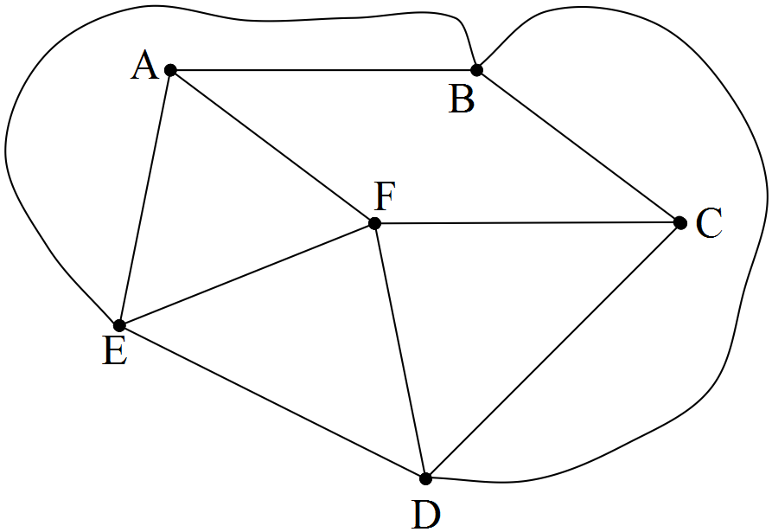 Seaside Senior High School has a building program underway. Underground cabling is to be installed between subject department offices. These offices are labelled as A, B, C, D, E and F below.

Because of building restrictions due to existing plumbing and gas lines, some direct cabling is not considered feasible. Eg. A is not connected directly to C or D.

(a) List all other direct connections that are not considered feasible.

All direct connections are considered equally expensive at $ 3000 each, except for AB which would cost $ 2000.

(b) (i) Show on the diagram above a method of connection which would keep cost to a
minimum.

(ii) State the minimum cost of connecting all offices.
As an afterthought, security wiring is to be laid as well. The cost of this wiring is given in the diagram below ( in hundreds of dollars.)
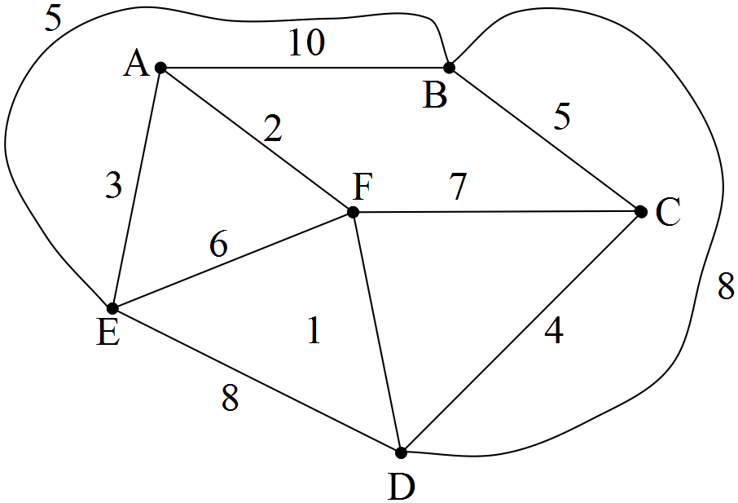

Considering security wiring only,

(c) (i) calculate the minimum cost.

(ii) show the minimum cost connection on the diagram above.

The cabling and wiring will be laid side by side on the same path.

(d) Determine the minimum cost for the dual project.

16. [5 marks: 2, 2, 1]

An old house is to be completely re–wired with new electrical cable. The places that need to be connected are shown on the diagram below.

The distances, in metres, between the places which can be connected are listed below.

Connection | Distance (m)
A to B | 12
A to M | 6
B to C | 12.2
B to M | 11
A to E | 3.5
E to M | 5
E to F | 6
E to D | 9
M to D | 8
C to D | 7.5

(a) Draw the connection network on the diagram above.

(b) Draw the network which will complete the wiring connections using the least
amount of wiring.

(c) What is the least amount of wiring needed?

17. [6 marks: 3, 3]

The only arrangement of 8 consecutive digits (not counting rotations or reflections) such that any two adjacent vertices sum to a prime number is given below in the cube.
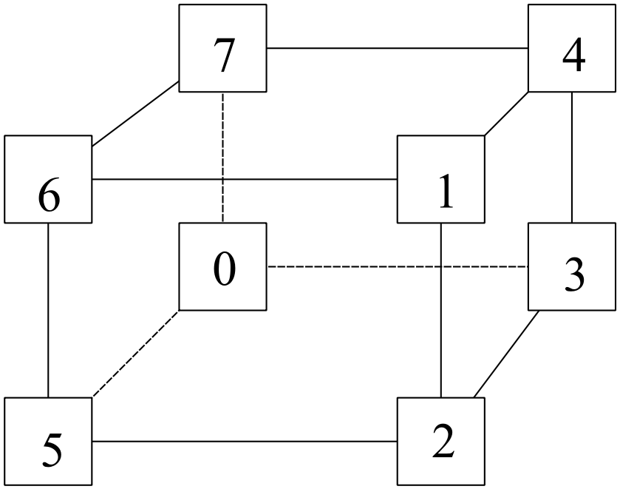

(a) Show, by listing all the possible pairings, that the statement is correct.

(b) If the length of the connecting arcs are given by the positive difference
between the vertex values, show the minimum connecting tree and state its length.


18. [9 marks: 2, 4, 3]

The following network has ten vertices: A, B, C, ………, J. The numbers on each path represent the distances, in km, between pairs of vertices.
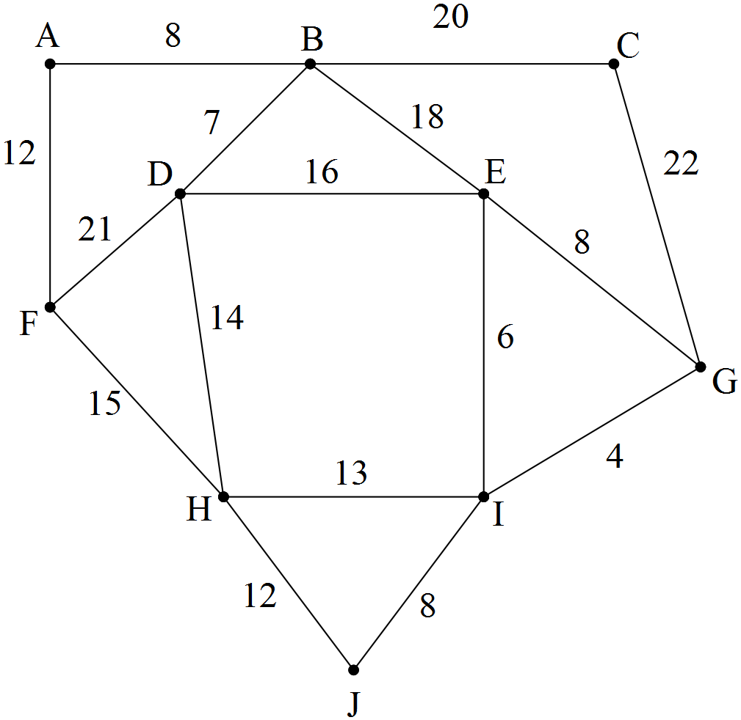

(a) A minimal spanning tree from the above network would be useful in investigating
which one of the following situations? Give an explanation.

(i) A salesman starting from town A and wanting to visit every other
town (vertex).

(ii) A system of pipes is needed to connect all towns to a gas supply at A.

(iii) A road network is needed to allow the greatest amount of traffic flow
between A and J, along the roads (paths).

(b) (i) Show the minimal spanning tree on the diagram above.

(ii) State the length of the minimal spanning tree.

(iii) State the number of paths in the spanning tree from (i).

(c) Develop a rule for the number of paths in a spanning tree for a network with n
vertices.
Show evidence of some systematic working.

19. [14 marks: 3, 3, 3, 1, 4]

The following table gives costs (in $1000's) of gas links between country centres A to F.
 | A | B | C | D | E | F
A  B  C  D  E  F | – | 20  – | 12  9  – | 8  14  –  – | –  –  5  8  – | –  –  11  –  12  –

(a) Draw the network.

(b) Find the minimum cost of linking all towns to gas.
Show the connections on a diagram.

(c) Check your answer by using Prim's Algorithm on the table.

The most expensive connection in the planned tree was not made due to lack of funds.

(d) Which town was left unconnected?

(e) Write an inequality which states the amount of funds that were available.

Chapter 11: Maximal Flow

This chapter includes questions on

Drawing & interpreting networks
Determining maximal flow
Using minimum cut

Some questions require the use of a calculator.

1. [3 marks]

In the following flow diagram, the "minimum cut" has a value of 22 as shown.
Show that the theorem "minimum cut = maximum flow" is true in this situation.

2. [5 marks: 2, 3]

In the above flow diagram EF + DF = 18.

(a) Explain with reference to the source, why maximum flow cannot be 18.

(b) What is the maximum flow?

3. [7 marks: 2, 1, 4]

Consider the network given:

(a) Identify (i) the source
(ii) the sink

(b) Why can the maximum flow into the sink not exceed 17?

(c) Determine the maximum flow from source to sink. Show your working.
4. [9 marks: 3, 3, 3]

The network represents a road system connecting towns A and G. The maximum flow (in hundred's of vehicles per hour) is given on the arcs.

(a) Determine the maximum flow from A to G.

(b) Draw a diagram showing that maximal flow.

(c) Over time, the road surface from E to G deteriorates, decreasing the possible flow to 7. The local authority decides to upgrade the road from F to G to accommodate a flow
of 6.

(i) How will this affect the maximal flow?
(ii) Would any further upgrading of FG have been useful? Explain.

5. [4 marks: 2, 2]

A reticulation system is represented by the following network.

(a) If all pipes have a flow capacity of 50 units, and 150 units are pumped in
at A, calculate the outcome at G.

(b) If all junctions A,B,C,.......G require access to flow, which pipe could be
removed without altering the total amount of flow?

6. [6 marks: 2, 1, 1, 2]

A directed flow network is given.

Flow capacities are shown on the arcs.

The maximal flow diagram is as follows.

(a) Show that the amount leaving source = amount entering the sink.

(b) Determine the maximum flow.

(c) Which arc(s) were not used.

(d) If one arc could be upgraded, which would it be, and by how much?

7. [8 marks: 2, 3, 1, 2]

(a) Identify the source and sink in the following directed flow
diagram.

(b) Find the maximum flow from source to sink.

(c) Which arc could be closed off without affecting the flow?

(d) If Arc AE was increased by 7, what would be the effect on the maximal flow?

8. [6 marks: 3, 1, 2]

A large marketing group has their annual picnic for members and friends at the showgrounds.

There is concern that there may be a large amount of queuing because of the number of people wishing to use the rides in side–show alley.

The flow rates in people per seven minute ride are given in this diagram.

(a) What is the maximum flow for any seven minute period?

It is decided to enlarge an activity to take up the overflow.

(b) Which flow should be increased and by how much?

(c) What will be the new maximum flow through the network?

9. [6 marks: 2, 2, 2]

The network below represents maximum flow ( in kilolitres per hour ) through
each pipe in a reticulation system.
(a) State the source and the sink .
(b) Calculate the maximum flow through the network.

(c) If the maximum flow was to be 26, which pipe would need to be changed to allow
more flow, and by how much would it need to be changed?

10. [4 marks: 2, 2]

At this stage, it is not possible to calculate the flow through the system because we do not know the values of a, b, c and d.

- What is the maximum value of the flow through the system?

- If a = b = c = d = 8, calculate the value of the maximum flow through the system.

11. [8 marks: 2, 3, 3]

The following network represents a reticulation system. The numbers are
flow rates in m³ per minute units in the direction from A towards D.

(a) CD + FD = 28.
With reference to the flows leaving the source, show that the flow into the sink
cannot be 28.

(b) Calculate the maximum flow through the network.

(c) Show the maximum flow on the diagram above.

12. [6 marks: 2, 2, 2]

Determine the maximum value of flow for each of the following flow diagrams, where all unidentified flows are greater than 20.

(a)
Maximum value of flow =

(b)
Maximum value of flow =
(c)
Maximum flow =

13. [8 marks: 1, 2, 2, 1, 2]

(a) State the source and the sink.
(b) Calculate the maximal flow.

(c) Show the flow on a separate diagram.

(d) If arc BD was reduced by 3, what effect would it have on the maximal flow?

(e) If you could increase the flow in one arc only, which one would you
choose for maximum effect? State the increase.

14. [8 marks: 3, 1, 2, 2]

The following table indicates direct traffic flow ( in hundreds ) through a road system joining towns A, B, C, D, E and F.
From
To

(a) Draw the traffic flow network using the vertices below.

(b) Identify the source and sink.

(c) Calculate the maximum flow.

(d) By changing the flow in one arc only, state how the maximum
flow can be increased by 10.

15. [9 marks: 5, 1, 1, 2]

The following perfect system, where flow from the source equals flow to the sink, represents the network of oil pipelines in a country. The numbers indicate the flow through the pipes in 1000s of Litres per hour.

(a) Find X, Y, Z, K, and W.

(b) State the flow through the system.

(c) Use the minimum cut theorem to verify your answer to (b).

(d) If X, Y, Z, W and K are each replaced with pipes taking 9 000 Litres per hour, calculate the maximum flow through the system.

16. [4 marks: 1, 1, 1, 1]

The following flow diagram shows the flow from source to sink.

(a) State the flow through the system.

(b) For each of the following networks, state whether it is possible or not possible, to
achieve the same flow diagram as above, if maximum flow is required.
(i)

(ii)

(iii)

17. [10 marks: 3, 2, 2, 1, 2]

The network below represents a road network connecting six shops, all part of the Beer Shop franchise. The number on each arc indicates the maximum number of journeys per day (due to constraints of traffic, distance, driver availability etc) along that arc.
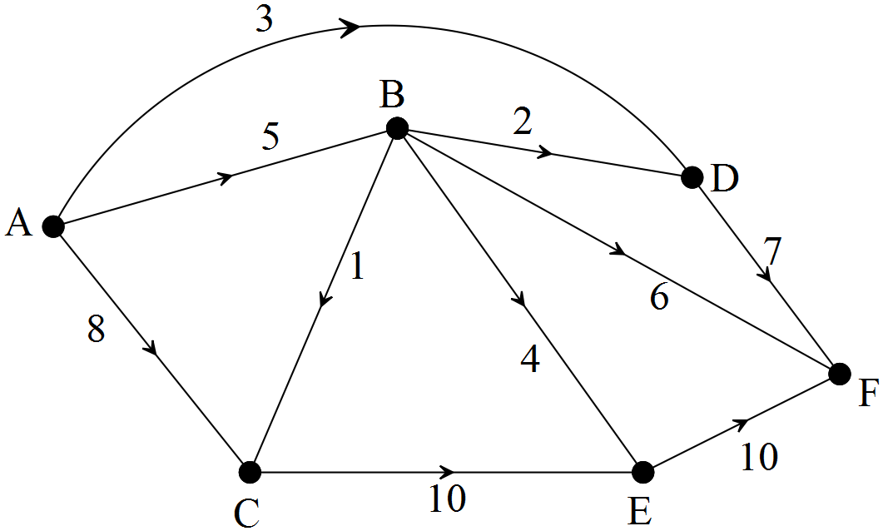

A is the distribution centre. That is the main shop.

(a) Find the maximum daily flow through the system from A to F.
Show systematic working to allow your answer to be checked.

(b) Show the flow through the system on the diagram below. The flow should
reflect your answer to (a).
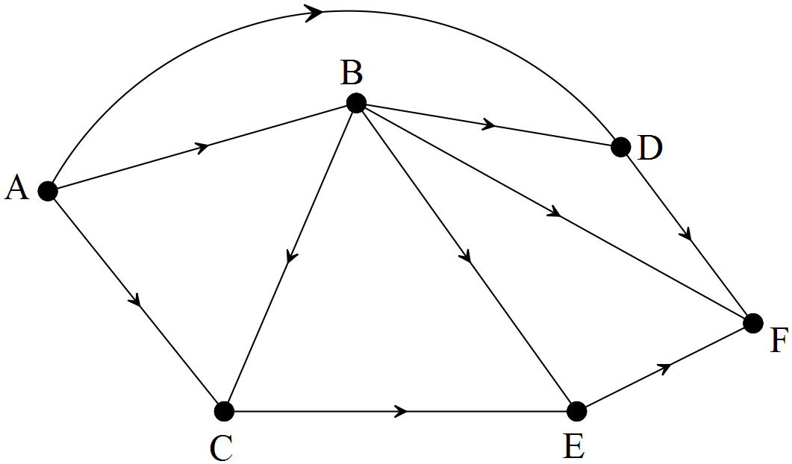

(c) What effect, if any, would there be on the maximum flow from A to F if
the following changes were made? Consider each change separately.

(i) Direct route from A to D was widened, allowing four journeys per day.

(ii) An extra driver was employed, allowing B to F to become ten per day.

(iii) The driver who did B to D left, and was not replaced.

18. [ 8 marks: 4, 2, 2]

The network below represents a road traffic system connecting 8 centres.
The number on each arc indicates the maximum number of vehicles, in hundreds per hour, that can travel along that path.

(a) Find the maximum hourly flow of traffic through the system from A to H.
Systematic working needs to be shown for full marks.

(b) Show the maximum flow on the diagram below.

A new road from A to B, capable of carrying 1000 vehicles per hour, is constructed.

(c) (i) Show this on the diagram below.

(ii) What effect does this road have on the maximum traffic flow?

Chapter 12: Project Networks

This chapter includes questions on

Drawing & interpreting project networks
Determining minimum completion time and critical path

Some questions require the use of a calculator.
1. [8 marks: 1, 2, 1, 2, 2]
Aeroplop Airlines is reviewing its use of ground time. The company wishes to efficiently manage turn–around time. i.e. the process where the airplane is prepared for almost immediate take–off once it has landed.
"Turning the plane around" requires the completion of the following tasks.
Task | Description | Time Required | Predecessor
A | Unload passengers | 15 minutes | ––––––
B | Unload cargo | 30 minutes | ––––––
C | Clean cabin | 20 minutes | A
D | Load new cargo | 27 minutes | B
E | Load new passengers | 25 minutes | C

Consider the following two project networks. One is correct and the other is incorrect.
(a) Refer to the activities and their precedents to explain why the first diagram is incorrect.
The following questions refer to the correct network.
(b) State the critical path.
(c) Find the minimum completion time.

(d) If unloading the cargo is delayed by five minutes, find what effect, if any, there will be
on the overall completion time.

It is estimated that expensive new apparatus can reduce the time taken to load new cargo by up to 50%.

(e) Would it be wise to recommend purchasing the new apparatus? Briefly state your
reasons.

2. [18 marks: 8, 4, 6]
After cyclone damage, a country town’s sporting arena and clubrooms are being reconstructed.

(a) The list of activities, activity times and precedents is given below.

Activity | Description | Time ( Weeks ) | Precedent
A | Remove debris from arena. | 5 | ––
B | Install underground power. | 4 | A
C | Upgrade reticulation for arena. | 2 | B
D | Plant lawn on oval. | 6 | C
E | Safety fence the surrounds. | 2 | A
F | Design club rooms. | 2 | ––
G | Build clubrooms. | 7 | E, F
H | Erect light towers. | 8 | E, F

(i) Draw the network.

(ii) Mark the critical path on your diagram or state it.

(iii) Determine the minimum completion time.

(iv) How much slack time is available for designing clubrooms?

The time for activity D can be reduced by allocating extra planters at a cost of $500 per planter. Each extra planter reduces the planting time by 1 week.
The maximum time reduction for planting is 4 weeks.

(v) What will be the most worthwhile payment? Give a reason.

(b) The old reticulation pipes had a capacity of 200 units of flow.
The new pipes were of a different size as shown below.
(i) Calculate the maximum flow through the system.

(ii) Comment on the choice of new pipe sizes. Give a reason.

2. (continued).

(c) The underground power was connected from the mains to
- the reticulation power shed ( R )

- the lighting towers ( 6 of them: T1, T2, T3, T4, T5, T6 )

- the clubrooms ( C )

- the caravan overflow site in the centre of the arena.( C.O.S.)

The network shows the position of key places and their distances apart.
The arena is circular with a radius of 105 metres.
The towers and clubrooms are on the edge of the arena.

(i) Calculate the minimum length of power line required to connect all the arena’s
facilities to the mains.

(ii) Show the minimum connection on the network above.

(iii) If an inspector from Western Power wants to check at least two light towers and
the other nodes, C.O.S., C and R, how far must he walk if he starts from the
mains outlet and finishes at R?

3. [4 marks: 2, 2 ]

Consider the following project network.
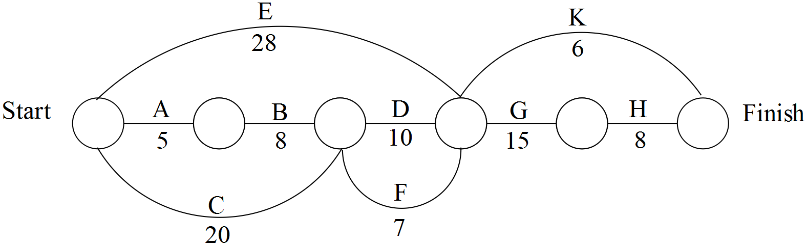

(a) Determine the critical path and the minimum completion time for the project.
Times in hours are given on arcs.

(b) If F is delayed by x hours, the whole project will be delayed.
State the minimum value of x. ( x is a whole number.)

4. [7 marks: 4, 2, 1]

Dan has hit a cricket ball through a window.
The broken window needs to be replaced.
The following activities make up the project.

 | Activity | Time ( mins ) | Predecessor
A | Order correct sized glass panel from shop. | 5 | –
B | Pick up glass panel and putty from shop and  return home. | 30 | A
C | Remove broken window. | 15 | –
D | Put putty into window frame. | 5 | B, C
E | Insert new glass panel. | 2 | D
F | Putty the other side of glass panel and smooth. | 10 | E
G | Clean up broken glass from near the window. | 5 | B, C

(a) Draw the project network.

(b) Calculate the minimum completion time.

(c) How long would the project take Dan by himself?

5. [9 marks: 2, 2, 2, 3]

A project is in the planning stages. The following network shows the progression of the project, with tasks identified using capital letters.

The following table shows times for each activity.

TASK | TIMES (Days)
A | 2
B | 3
C | 5
D | 6
E | 3
F | 2
G | 4
H | 8
J | 2

(a) Which tasks could be considered “critical”?

(b) What is the minimum completion time of the project?

(c) If one activity could be reduced by 2 days, why would B not be chosen?

(d) If J no longer requires D to be finished before J can begin, but does require H
to be completed before J begins, redraw the diagram and determine by how
much H can be delayed without affecting the minimum completion time.

6. [7 marks: 2, 1, 4 ]

The following table shows times for John’s building project.

TASK | TIMES (Days)
A | 2
B | 3
C | 5
D | 8
E | 3
F | 2
G | 4
H | 8

The project network looks like this:

(a) Determine the critical path.

(b) State the minimum completion time.

Consider the new times in the table below.

TASK | TIMES (Days)
A | 2
B | 3
C | 5
D | 8
E | 3
F | x
G | 4
H | y

(c) If the only critical path was AF, and its length of completion was 13 days,

(i) solve for x.

(ii) write an inequality for y.
7. [5 marks: 1, 1, 1, 2]

The following project network has activities listed on arcs, and the times taken for those activities also on the arcs.

(a) State the minimum time required to complete the project network.

(b) State the critical path.

(c) If H was delayed by 10, what effect would it have on the project’s completion?

(d) The overall completion time needs to be reduced by at least 10%. State a way
of doing so by reducing any two tasks by at most 20%.
8. [7 marks: 1, 1, 2, 2, 1]

Megaplex management draw up a network for an up–coming project, consisting of
stages A, B, C, ……H.
The number of days required for each stage is shown on the project network.

(a) State the critical activities in this project.

(b) Calculate the smallest length of time it would take to complete this project.
(c) Given that overall completion is not delayed, state the latest possible starting time for
Activity:

(i) B

(ii) F

Costs for the project are estimated at $ 10 000 per day.

(d) State the $ savings ( if any ) if A is reduced by 2 days.
Give a reason for your answer.

Industrial disputes cause activity F to take 3 days longer than planned.

(e) What effect does this have on the overall completion time of the project?
9. [8 marks: 2, 1, 1, 4]

The network below shows activities and times, in weeks, for the completion of a road improvement project.

(a) State the critical path, and the associated minimum completion time for the project.

(b) How much slack time is available for activity D?

(c) If activity H was delayed by 10 weeks, what would be the effect on the overall
completion time?

(d) (i) If K could begin after B had finished, redraw the network.

(ii) State the new critical path and the minimum completion time.

10. [5 marks: 1, 1, 1, 1, 1]

The project network below shows a set of activities, with numbers representing duration times, in weeks.

(a) State the number of activities which make up the project.

(b) How many activities in total must be completed before activity M can start?

The critical path is ABEHM.

(c) State the minimum completion time for the project.

(d) State the restriction on the duration of activity D.

The critical path changes to ABFGM.

(e) What must be true of the duration of activity G?
11. [11 marks: 4, 1, 1, 2, 3]

Plum’s Plumbing installs deep sewerage to a new estate. They identify 10 activities required for project completion. These, and the associated activity durations, are given below.

(a)
Connection | Duration (Weeks) | Immediate Predecessor(s)
A | 4 | −
B | 5 | A
C | 7 | B
D | 6 | B
E | 7 | B
F | 4 | C
G | 2 | E, F
H | 4 | E, F
I | 3 | D, G
J | 1

(i) A network for this project is shown. The network is incomplete as activities D
and E must be included. Draw and label activities D and E on this network.
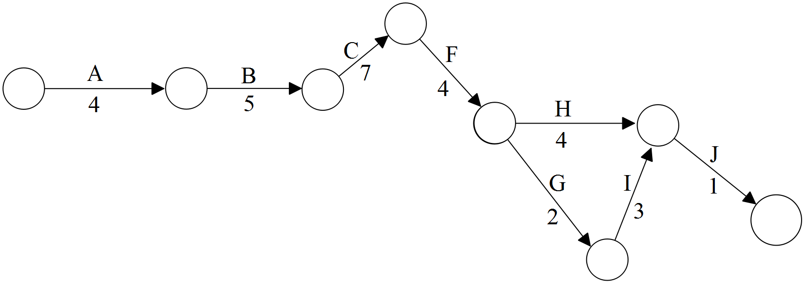

(ii) The table is also incomplete, in so far as the predecessor(s) for activity J
have been omitted. By looking at the network above, complete the table.

(b) State the critical path.

(c) State the minimum completion time.

(d) If D is increased by 8, what would be the effect on the minimum completion time?

(e) What possible change, or set of changes, could result in the critical path
becoming ABCFHJ?

12. [7 marks: 3, 2, 2]

Bill and Erica are doing some gardening one Saturday afternoon.
The activities, and completion times, are given below:

A : Trim trees above aviary (15 minutes)
B : Clean out the aviary (20 minutes)
C : Rake up trimmings and put into trailer (10 minutes)
D : Mow lawn and put clippings in trailer (30 minutes)
E : Weed garden and put weeds in trailer (60 minutes)
F : Take trailer to tip (20 minutes)
G : Water lawns and garden (15 minutes)

The order of precedence for the activities is as follows:

A and E begin together
B must be after A
C must be after B
D must be after C
G and F must be after both E and D

(a) Construct the project network.

(b) What is the minimum time to complete the project, and the corresponding critical path?
(c) How late can the weeding begin without delaying the whole afternoon's project?

13. [9 marks: 3, 2, 1, 1, 2]

The Smith family intend making a long trip in their station wagon into the country. The morning that they leave sees much activity in their home. The tasks to be done are as follows:

A Prepare a picnic lunch for when they stop on the way. (30 minutes)
B Clean the inside of the car. (10 minutes)
C Check under the bonnet for the efficient running of the motor.
(20 minutes)
D Wash the outside of the car. (20 minutes)
E Pack inside the car with picnic lunch and games for the children.
(5 minutes)

Times taken are shown in brackets.

NB: It is not advisable to tune the motor while the car is being washed, so these activities should follow each other. Packing inside the car will not be done until all else is completed.

The network begins as follows, with 3 people available to do the tasks.

(a) Copy and complete the network.

(b) Which activity must start first, and by how many minutes?

(c) Show the critical path on your diagram.

(d) What is the least total time in which everything can be completed?

(e) How would the solution to d) change if there were only 2 people to do
the tasks?
Draw a new network and show the new critical path, given that A, B, C must still
precede all other activities.

14. [10 marks: 4, 2, 4]

Bill and Ben plan to have a game of snooker at the local centre. Several activities must take place between making the decision to go, and actually playing the opening shot.

ACTIVITIES PRECEDENT REQUIRED
TIME (mins)

A: Find cues in back shed – 10

B: Put cues in car A 2

C: Bill drives to Centre B 8
(Ben is a passenger)

D: Ben takes cues from car and C 2
enters Centre

E: Bill finds a parking spot D 3
then enters Centre

F: Ben waits in the queue for D 10
use of table

G: Set up balls in correct F 2
position

H: Play the opening shot G,E 1

(a) Draw a project network to represent the above information.

If the game itself takes 20 minutes to play,

(b) Find the minimum time required between deciding to play and determining the winner of the game.

(c) If it takes Bill 5 minutes extra to park the car, and the queue takes an extra 5 minutes to clear, find the total delay in the project.

15. [10 marks: 4, 1, 1, 2, 2]

Rod has an inbuilt oil heater and wishes to replace it with an inbuilt gas space heater.

 | Activity | Time  (Days)
A | • Shop around to purchase the space heater | 3
B | • Have gas fitter attach meter box to the house | 2
C | • Remove old oil heater | 1
D | • Have Alinta Gas connect gas to the property | 5
E | • Have gas fitter install gas heater and make all connections | 2
F | • Have Alinta Gas inspector install meter in meter box after checking all connections are satisfactory | 2
 | Heater is ready for use.

The order in which activities should be completed are:

A, B, C start
D follows B
E follows C, A
F follows E, D

(a) Construct a project network to represent the information.

(b) What is the minimum time to complete the project?

(c) State the critical path.

(d) Which activity(s) will least affect the overall completion time of the project? Why?

(e) Due to winter demand, it took 10 days for gas to be connected to the property. By how much was the project delayed?

16. [10 marks: 1, 1, 1, 3, 1, 1, 2]

The network indicates activities which make up a project. The times for the activities are stated in minutes.

Earliest starting times are given in the top half of the node circles.

(a) What is the earliest possible finishing time?

(b) Use letters to state the critical path.

(c) What is the time for activity B?

Latest possible starting times are given in the bottom half of the node circles

(d) Complete the diagram.

Determine the effect on the overall completion time of the project if a delay of 5 minutes occurs in

(e) Activity D.

(f) Activity B.

(g) Determine the maximum possible delay in activity F before completion time is affected.

17. [7 marks: 1, 4, 1, 1]

The times, in days, for the activities involved in preparing for an overseas holiday to a pre–determined destination requiring vaccinations are shown in the project network given. The person concerned had never been overseas before and has no passport. He completes the lead up activities in the order shown.

(a) State the minimum completion time.

(b) Determine the values for r and s and the activities for p and q.

Activity | Time | Immediate  predecessors
A: Make booking with travel agent | r | –
B: Get passport | s | –
C: Get vaccinations | 1 | A
D: Organise debit cards | 1 | p
E: Pay travel agent | 1 | q
F: Collect tickets | 1 | E
G: Pack belongings ready for flight | 1 | F

(c) State the critical path.

(d) If debit cards were organised immediately following vaccinations taking place, draw the new network, and state any change to the minimum completion time for the project.

18. [5 marks: 1, 1, 3]

The diagram shows part of a project network. The times of activities, a, b, c, d are shown in days.

(a) What is the least time in which all four activities can be completed?

(b) Which activity must be started first?

(c) What are the latest starting times for the other three activities?

19. [10 marks: 4, 1, 1, 4]

The table shows the activities and matching times needed to install a TV antenna,
including re–tuning of TV.

Activity Time
Minutes
A : Check TV reception 3
B : Inspect Roof 3
C : Bolt antenna in 10
optimum position
D : Fit antenna socket 5
into wall
E : Run coaxial cable from 5
antenna to wall socket
F : Connect TV with 1
antenna socket
G : Tune TV 3

The order in which the activities should be completed is as follows:

A :
B, D follow A
C : follows B
E : follows C and D
F : follows E
G : follows F

(a) Construct a project network to represent the above information.

(b) What is the minimum time to complete the project?

(c) State the critical path.

(d) John and his assistant began the job at 9 am.

(i) When will the TV be ready to use?

(ii) What is the latest time activity D can begin without delaying the finishing time?

(iii) If the drill bit is blunt such that D takes 15 minutes, what will be the finishing
time?

20. [7 marks: 4, 1, 1, 1]

The following recipe for Tomale pie is a set of activities which form part of a project network.

A | Preheat oven to 200°C | [5 minutes]
B | Brown the beef | [5 minutes]
C | Stir in soup, corn and taco sauce and heat to boiling | [5 minutes]
D | Cook on low heat | [5 minutes]
E | Pour into casserole dish. | [1 minute]
F | Combine scone mix from packet with $\frac{1}{2}$ cup water | [2 minutes]
G | Spoon evenly over meat mixture | [2 minutes]
H | Bake in moderate oven. | [25 minutes]

Activity Predecessors
A −
B A
C B
D C
E D
F −
G F,E
H G

(a) Construct the project network indicating activities on arcs.

(b) Calculate the minimum time for the project to be completed.

(c) State the critical path for the project network.

It is found, through experience, that if the scone mix is combined with the water and not spooned immediately over the meat mixture, it becomes like glue.

(d) With this in mind, when should activity F begin?

Chapter 13: Task Allocation

This chapter includes questions about

Task Allocation and the Hungarian Algorithm

Some questions may require the use of a calculator.
1. [9 marks: 2, 3, 4]

Seaside S.H.S. has three major buildings needing repainting during one week of the school holidays. Because of the short time available, three contractors are asked to provide quotes for the three buildings separately. Each contractor will be given one building to paint. The school wants to minimise cost. The quotes are submitted to the school, and are shown in the table as thousand dollar units.

 | Building 1 | Building 2 | Building 3
Contractor 1 | 4.8 | 8.5 | 2.9
Contractor 2 | 4.6 | 8.1 | 3.2
Contractor 3 | 5.2 | 8.3 | 3.7

(a) Use a bipartite graph to illustrate all the possible allocations.

(b) list the possible allocations and hence determine how the tasks will be allocated to
result in minimum cost to the school.

(c) Show the steps of the Hungarian Algorithm to verify your result from (b).

.
2. [6 marks]

Four huge haulpaks are currently at four different locations, but need to be transported to four mines, one haulpak to each mine. The transport distances, in km, are shown in the table. Use the Hungarian Algorithm to minimise the total distance travelled.

 | Mine 1 | Mine 2 | Mine 3 | Mine 4
Haulpak 1 | 85 | 60 | 60 | 75
Haulpak 2 | 30 | 90 | 50 | 60
Haulpak 3 | 120 | 90 | 80 | 100
Haulpak 4 | 40 | 100 | 90 | 110

3. [7 marks: 1, 5, 1]

Harry is selling four identical cricket cards, all with differing degrees of flaws, through the auction site, cbay. Five bidders each put in a bid on each of the four cards. Each bidder stipulates that they only want at most one of the cards. The bids, in $, are shown in the table below.

 | Card 1 | Card 2 | Card 3 | Card 4
Bidder 1 | 140 | 60 | 200 | 130
Bidder 2 | 160 | 70 | 220 | 150
Bidder 3 | 130 | 80 | 190 | 130
Bidder 4 | 130 | 60 | 180 | 130
Bidder 5 | 160 | 40 | 190 | 150

(a) A “dummy” card, card 5, must be added in order to use the Hungarian Algorithm.
Why is this?

(b) How should the cards be allocated to the bidders so that Harry receives the maximum
amount for his cards?

(c) Which bidder misses out on a card?

4. [6 marks]

Dave is the manager of a team in a Really Small Cricket competition. Teams have 6 players.
Dave rates the players in each of the batting positions, 1 – 6, throughout the season.
Those ratings are shown in the table, on a scale from 1 to 25, with 25 being the best.

 | Player 1 | Player 2 | Player 3 | Player 4 | Player 5 | Player 6
1 | 24 | 18 | 2 | 7 | 4 | 12
2 | 24 | 18 | 2 | 7 | 4 | 12
3 | 20 | 17 | 9 | 10 | 22 | 21
4 | 15 | 10 | 12 | 15 | 17 | 23
5 | 8 | 5 | 13 | 11 | 9 | 16
6 | 3 | 4 | 14 | 16 | 10 | 13

With the final approaching, Dave wants to finalise the batting order to maximise the team performance.

Use the Hungarian Algorithm to allocate players to batting orders.

SOLUTIONS

Chapter 1: Collecting & Representing Data

1. (a) 50%
(b) × 360 = 60º
(c) (i) = 120
(ii) 720 − 120 = 600
(d) n(GC) = = 360
n(GC with no Aussie born parents)
= ( ) × 360 = 30

2. Use a histogram when data is continuous.

3. (a) 60
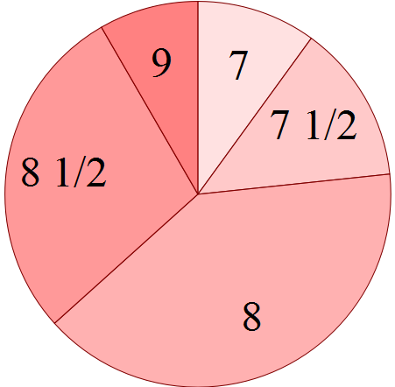 (b)

(c) (i) 8.06 (2dp)
(ii) 8
(iii) 8
(d) (i) mode
(ii) mean
4. (a)

Score 1 2 3 4 5 6
Freq 4 6 6 5 5 4
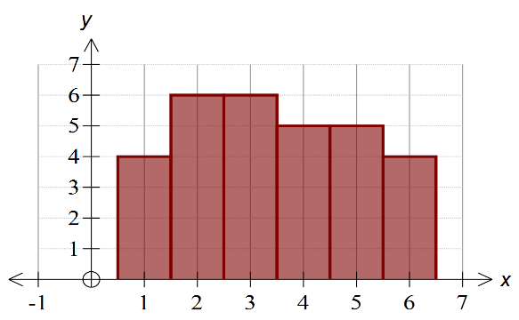
(b)

(c) Median = 3
Mode = 2, 3

5.
Jan |   
Feb | 
Mar | 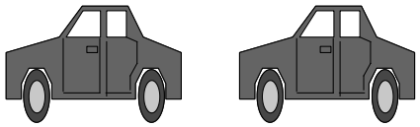

represents 8 cars

6. (a) ≈ 36.67%
(b) (4 x 5) + (3 x 6) + (2 x 7) + (1 x 12)
= 64

7. (a)
Shoe Size | 5 | 6 | 7 | 8 | 9 | 10 | Total
Freq | 1 | 6 | 11 | 10 | 8 | 4 | 40
Rel. Freq | 0.025 | 0.15 | 0.275 | 0.25 | 0.2 | 0.1 | 1.0

(b) 7 (modal size)

8. 20° represents 50 vanilla slices
130° represents x hamburger buns
∴
9. (a) 37%
(b) 360 × 27% = 97.2º.
(c) 12 × 23% = 2.76 ≈ 3 students
(d) Each category is proportionally
represented.
Each person within a category has an
equal chance of being elected.

10. (a) × 360 = 105º
(b) × 24 = 8.
(c)
Season | Number of students | Central Angle
Summer | 7 | 105º
Autumn | 8 | 120º
Winter | 3 | 45º
Spring | 6 | 90º
Total | 24 | 360º

(d)
Sectors
Labels
Accuracy
11. (a) 5
(b) 1
(c) 7
(d) No. Sample too small and list of interests
too narrow.

12. (a) × 360 = 48º
(b) × 135 = 69 students.

13. (a) × 10 = 6
(b) = ⇒ x = 60º.
(c) Total = 6 × 4 = 24
.

14. (a)
 | Sport | Watching  TV | Extra Study | Totals
Male | 30 | 25 | 5 | 60
Female | 10 | 20 | 30 | 60
Totals | 40 | 45 | 35 | 120
(b) (i) Proportion of Males =
= 50%
(ii) Proportion =
= 37.5%
(iii) Proportion = = 50%
(iv) Proportion = = 25%
(c) Ratio = 10 : 5 = 2 : 1
(d) Yes. Student sample not properly represented.
(e) Create a stratified sample which is representative of gender and preferences.
Or
Quota sampling; every second name in an alphabetical list of year 12 students.
15. (a) Not Valid. Not representative of
community.
(b) Valid. Every street has a
representative.
(c) Do you own a cat?
Do you believe that cats should be kept
inside at night?
Between what hours should cats be
kept inside?
10pm – 6am
12pm – 6am
Other

16. (a)
Mathematics  unit chosen | Working  Space | Number of  students
Methods | 300 × 25% | 75
Specialist | 300 × 10% | 30

(b) 360º × 5% = 18º

17. (a) Biased against those not in the phone
book
(b) Views would be biased as those sampled
make up only a small segment of the
population.
(c) Least biased of the four methods.
Random location makes sure that no
particular group is favoured.
But the first 50 interviewed could still form
a biased group.
(d) Views would be biased as those sampled
make up only a small segment of the
population.
18. (a) % who preferred ball in term 1 = 75%
(b) % of year 12 students who preferred ball in
term 2 = 25%
(c) Must compare proportions or percentages.
In Natasha's survey, % that preferred ball in
term 1 = 75%
In Kim's survey, % that preferred ball in
term 2 = 81.25%
Hence, there is a greater proportion of
students who prefer the ball to be held in
term 2.
(d) Need to consider how the survey was
conducted and how the samples were
chosen.

19. (a) a = 24 b = 12 c = 7
(b) Since the interval 65 ≤ c < 70 has
frequency 17, then 17 students represented
by 6·8 cm.
∴ 24 students represented by × 24
= 9·6 cm.

20. (a) (i) The graph has an uneven vertical
scale, unknown quantities on the
axes, 3–D graphs give a false idea
of scale.
(ii) Generalization seems extreme.
One needs to be aware of the subtle
inferences in this situation.
(b) (i) Bias may have been introduced
because the year 12 group may have
been over–represented in the sample
of 80.
(ii) Bias may have been avoided by
taking a random sample – maybe the
school roll and using random
numbers to select from that
roll.
(c) A case of only giving some statistics.
It is also true that there are fewer drivers
and cars in Australia than America. The
conclusion drawn is not justified.
Chapter 2: Bivariate Statistics(1)

1. (a) (i) 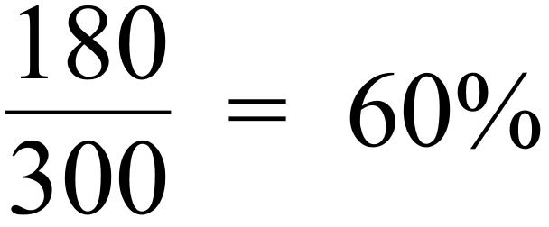
(ii) 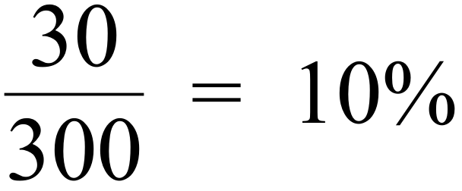
(iii) 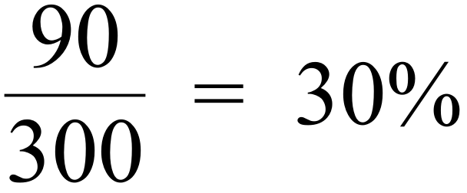
(b) Age
(c)
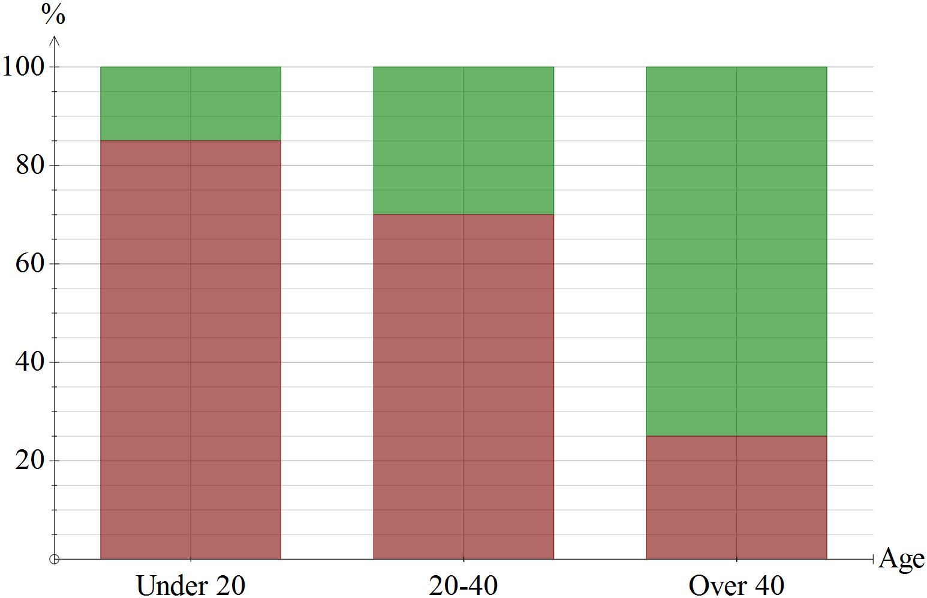

(d) There is an association between age and
interest in the cup.

2. (a) x = 55, y = 40, z = 17, m = 10 &
p = 15
(b) (i) 55% (ii) 35%
(iii) 75% (iv) 60%
(c) Sex of student
(d)
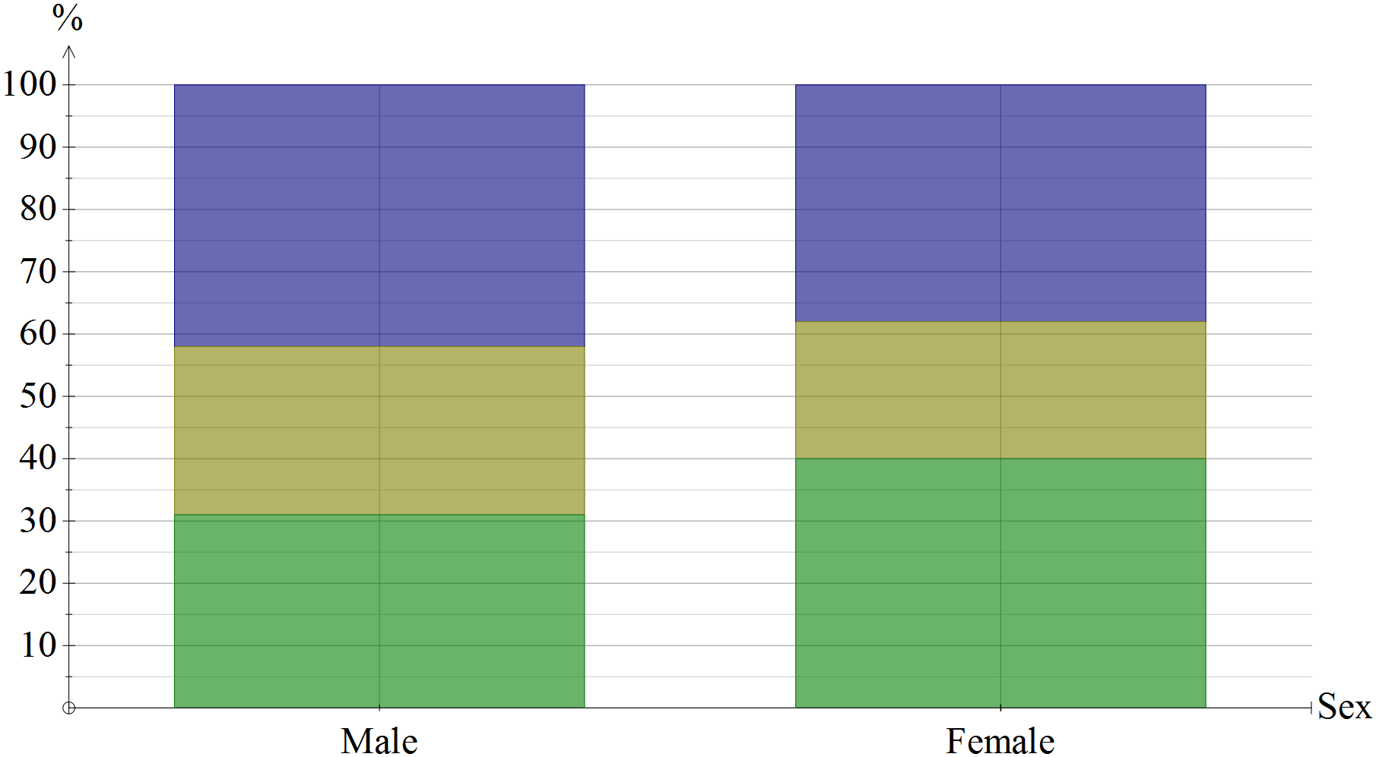

(e) No significant difference between the sexes,
so no association.

3. (a) (i) 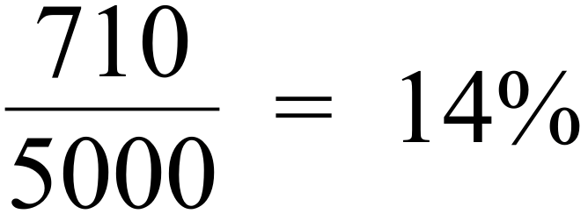
(ii) 86%
(iii) 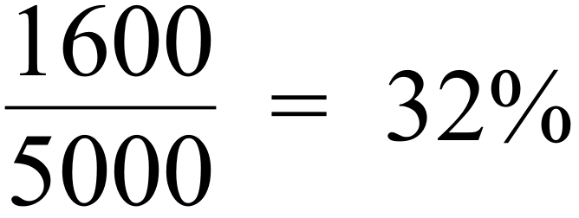
(iv) 1.8%
(v) 75%
(b) Parents smoking habits

(c)
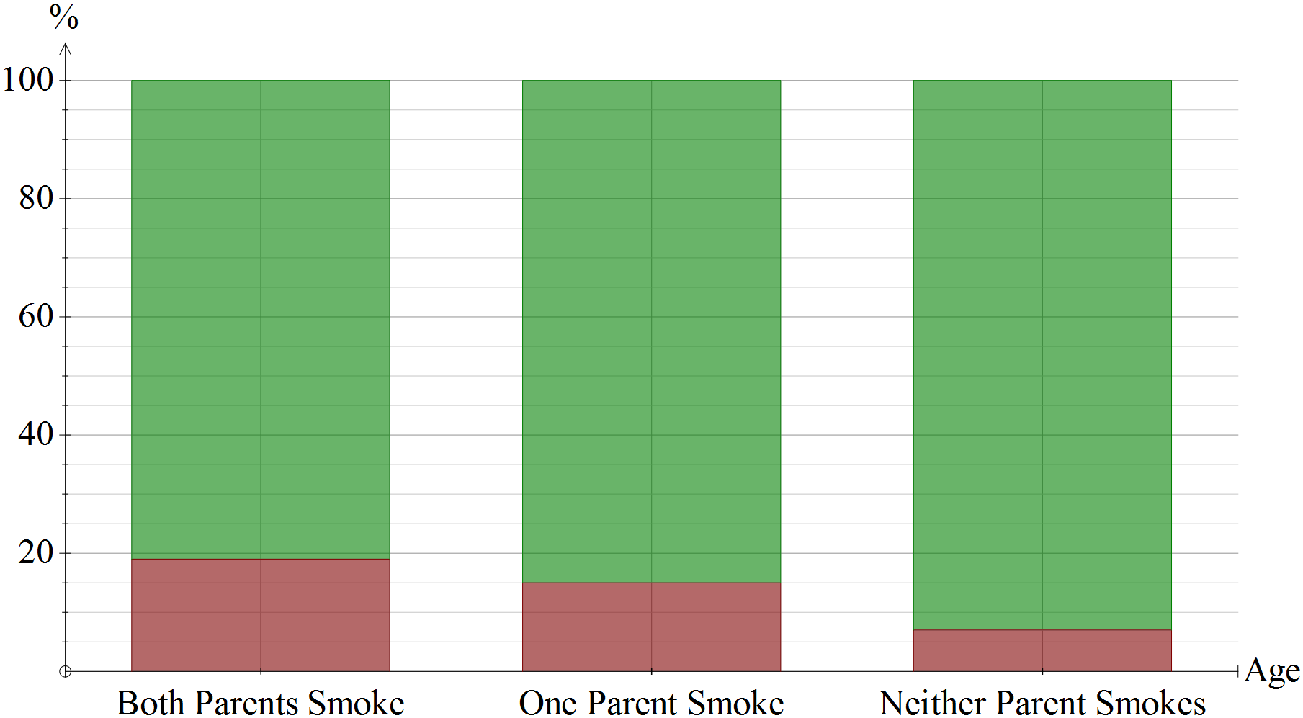

(d) It seems that “Neither Parent Smokes” is
associated with a significantly lower % of
students smoking.

4. (a) 256 (b) (i) 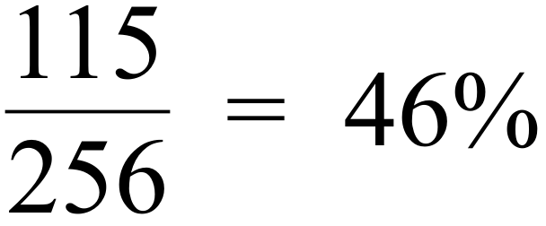 (ii) 0%
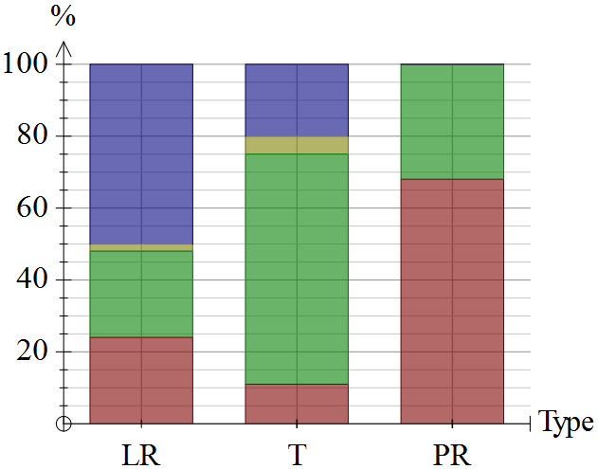 (iii) 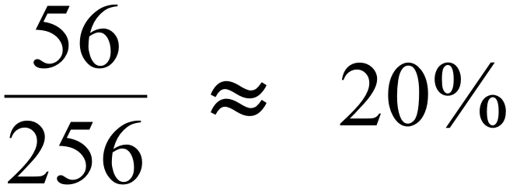 (c) Residents, Tourists, Rangers (d)

(e) There seems to be a strong relationship
between the type of person surveyed and
their opinion. Particularly on their opinion
on catching and relocating.

5. (a)
99 | 17
1 | 83
100 | 100

(b) Year 11 classes
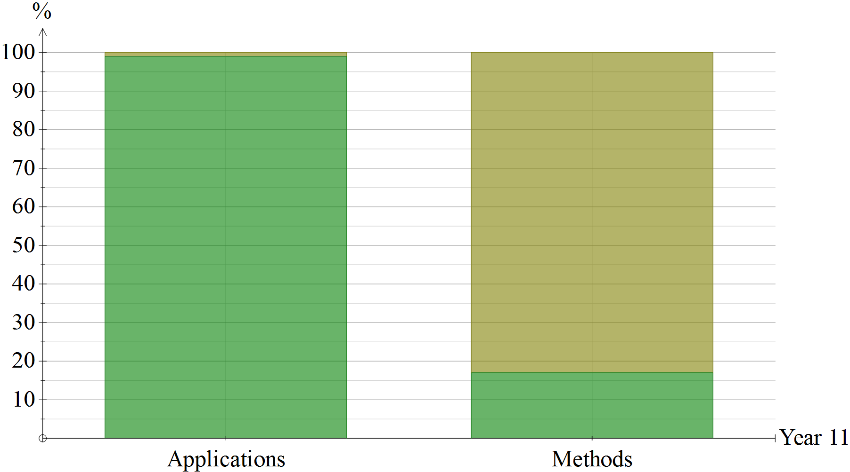 (c) `

(d) It seems there is a strong association
between subjects at Year 11 and choices
at Yr 12.

6. (a) scatter–plot

(b) strong positive linear relationship
(c) = 33.625, = 33.5 cm
(f) From h = 40, draw vertical line to meet line
of best fit and bounce off line horizontally
to meet vertical axis.
w 41
7.

(a) Scattergraph
(b) Moderately strong positive linear
relationship
(c) = 70.1 , = 73.2
(d) Plot (
(e) Line of best fit passes through (71, 74)
(f) Approximately 96
8. (a)

1 for each point

(d) line of best fit

(b)
(c) A fairly strong negative linear relationship
between T and N.
(e) From line, estimated value of T = 65

9. (a)
× (10.75, 10.25)
(d)
(e)
(−1 per error)
(b) 10.75
(c) 10.25
(d) See graph in part (a).
(e) See graph in part (a).
(f) Positive linear relationship.
(g) Rank of 9.

10. (a)
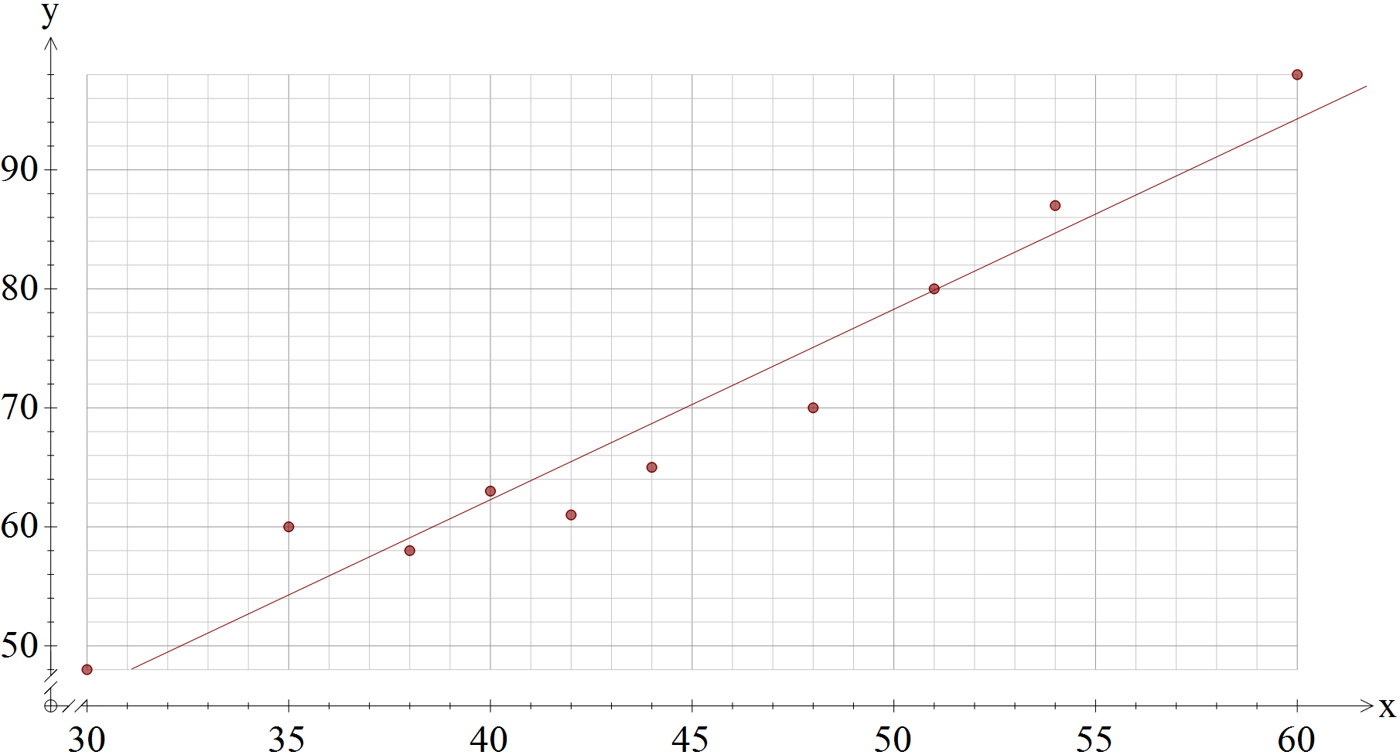

(b) See Diagram (Line of Best Fit)
(c) Approximately 82% recovery (from
graph)
(d) Bill could be mistaken
There is no cause and effect between
% recovery and paddock time.
OR
There seems to be a relationship,
but this is outside the data range.

11. (a)
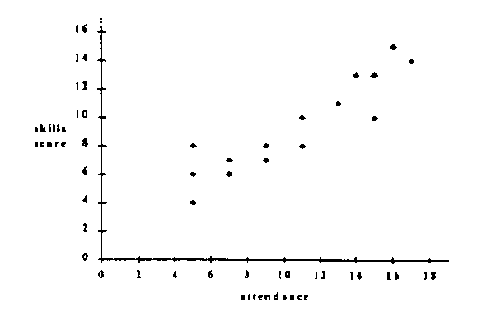

(b) Yes. there would appear to be a strong,
positive linear relationship. i.e. as the
numbers of attendances increase you would
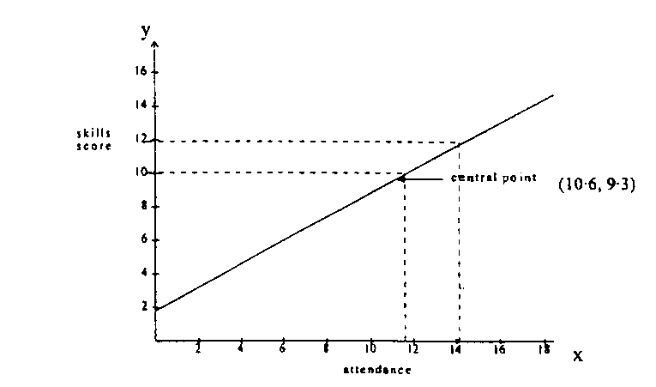
expect the skills score to also increase.

(c) (i) Approx. 10.
(ii) Approx. 14.

Chapter 3: Number Patterns

1 (a) (i) 2 048 ✓
(ii) 8 ✓
(b) 13 ✓✓
(c) 8 ✓✓
2. (a) 2, 3, 5
(b) 1, 4, 16, 25, 36
(c) 4, 25
(d) (i) 11
(ii) 15
(iii)
(iv) 6, 15, 24, 33, 42, 51

3. (a) w + d = 17
2w + d = 33
∴ w = 16 and d = 1 ✓
(b)
Wins | Draws | Losses | Points
20 | 0 | 0 | 40 X
19 | 0 | 1 | 38 X
1 | 6 | 13 | 8 ✓
2 | 4 | 14 | 8 ✓
3 | 2 | 15 | 8 ✓
4 | 0 | 16 | 8 ✓

4. (a) 1 7 21 35 35 21 7 1
(b)

(c)

(d) Pentatope numbers on the 5th
diagonal

5. (a) (i) Red
(ii) 62
(iii)
(b) A draw.
Blue = 60 points and Gold = 60 points
∴ Blue = 100% and
Gold = 100%

6.

7. (a) Price increases by a constant $15.
(b) Next Price = $85
(c) Price = 10 + (15 × Position in
Range)
(d) Price = 10 + (15 × 10) = $160
(e) Rule is not always true.

8. (a) x = 1, 1 + 1 + 11 = 13 = 13 × 1
prime
x = 2, 4 + 2 + 11 = 17 = 17 × 1
prime
x = 3, 9 + 3 + 11 = 23 = 23 × 1
prime
(b) x = 10, 100 + 11 + 11 = 121 = 11 × 11
not prime

9. (a) 121
(b) 21 + 12 = 33, 31 + 13 = 44, 51 + 15
= 66
(c) T = 121
Any two digit number with the sum of its
digits equal to 11; eg 83 + 38 = 121

10. (a) False. 6 is an even number but 4 is not a
factor of 6.
(b) (1, 4)
(c) (1, 4)

11. (a) A shown table or method.
33, 36
(b) A shown table or method.
24, 44
(c) 122, 124, 126, 128, 132, 135
(−1 per error)

12. (a)
No. of  friends | 2 | 3 | 4 | 5 | 10 | 6 | n
Total no.  of cards | 2 | 6 | 12 | 20 | 90 | 30 | n(n − 1)

(b) The total number of cards = n(n − 1) .
= even number × odd number
Since, even number × odd number will
always give an even number,
the total number of cards will always be an even number.
Therefore, the conjecture must be true.
13. (a) 1 + 3 = 22
1 + 3 + 5 = x2 x = 1 + 3 + 5 + 7 = y2 ∴ y = 4
1 + 3 + 5 + 7 + 9 = z2 ∴ z ₌ ₅
1 + 3 + 5 + ...................19 + 21
= h2 ∴ h = 11

(b) 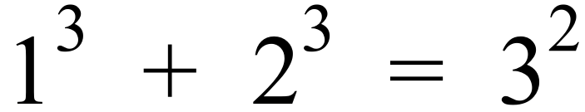
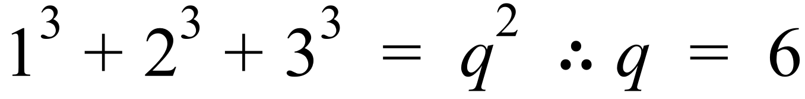
∴ t = 6
(c) (i) 1 + 3 + 5 + .......+ ( 1 + 2n )
= ( n + 1 )²
(ii) 1³ + 2³ + 3³ + ...... + ( n + 1 )³
= ( 1 + 2 + 3 + ..... + ( n + 1 ) )²

14. (a) HCF is 5
(b) a = 1 b = 64 c = 16
HCF = 16
(c) 243 − 3 × 63 = 54 (Given)
63 − 1 × 54 = 9
54 − 6 × 9 = 0
Hence, the HCF is 9

15. (a)
4 | 5 | 8 | 4 | 7 | 2 | 2 | 9 | 2 | 8 | 8 | 7 | 7 | 8 | 8 | 4
× | × | × | × | × | × | × | × | × | × | × | × | × | × | × | ×
2 | 1 | 2 | 1 | 2 | 1 | 2 | 1 | 2 | 1 | 2 | 1 | 2 | 1 | 2 | 1
Products are
8 | 5 | 16 | 4 | 14 | 2 | 4 | 9 | 4 | 8 | 16 | 7 | 14 | 8 | 16 | 4

T = 94 which is not divisible by 10
Hence, this is not a valid number.
(b)
k | 6 | 2 | 1 | 4 | 8 | 8 | 4 | 3 | 2 | 5 | 6 | 7 | 8 | 1 | 9
× | × | × | × | × | × | × | × | × | × | × | × | × | × | × | ×
2 | 1 | 2 | 1 | 2 | 1 | 2 | 1 | 2 | 1 | 2 | 1 | 2 | 1 | 2 | 1
Products are
2k | 6 | 4 | 1 | 8 | 8 | 16 | 4 | 6 | 2 | 10 | 6 | 144 | 8 | 2 | 9

T = 77 + 2k
This means T will be an odd number which
cannot be divisible by 10.
Hence, this number can never be a valid
number.

16. (a) 10, 15, 21
(b) 2T₅₀ = 50 + 50² = 2550
⇒ T₅₀ = 1275
(c) 2T_{n} = n + n² ⇒ T_{n} = ( n + n²)
(d) If 212 is a triangular number, then
( n + n²) = 424.
n = −21.09 or 20.09 (which are not whole
numbers)
Hence, 212 cannot be a triangular
number

Chapter 4: Bivariate Statistics(ii)

1. High correlation does not imply causality. A third factor, the depth of the recession, was probably responsible for both trends.
2. ΣR should be equal to 0.
Since residuals were all postitive, he has made an error in his calculation of either the regression equation, or the residuals.
3. (x$^{–}$,y$^{–}$) always lies on regression line, and since rxy = 1, so does (3,4).
Enter (3,4) and (4,5) into calculator
⇒ a = 1, b = 1
∴ y$^{ˆ}$ = 1 + x

4. y$^{ˆ}$ = a + 2x
Since (x$^{–}$,y$^{–}$) lies on line
∴ 7 = a + 2(3)
∴ 7 = a + 6
∴ a = 1
Equation is y$^{ˆ}$ = 1 + 2x

5. r ≈ 0·0063 ≈ 0.
Calculation is OK.

Data seems fitted by a parabola.
Hence, there probably is some relationship, however
the low value of r shows little or
no linear relationship.

6. (a) –0·95, 0·02, 0·9.
(b)

‘
7. (a) Diagram shows y decreasing as x is
increasing. Hence B.
(b) –0·7

8. a = 4 – 4 = 0
b = 5 – 5·25 = –0·25
c = 7 – 6·5 = 0·5
a + b + c + d + 0 = 0
∴ d = –0·25
9 – e = 0
∴ e = 9
Calculate line of prediction equation using any two of: (1,4) , (2, 5·25) , (3, 6·5) , (5 , 9)
From calc. : y$^{ˆ}$ = 2·75 + 1·25x
and when x = 4, y$^{ˆ}$ = 7·75
∴ f = 7·75 but g – f = d
∴ g – 7·75 = –0·25
∴ g = 7·5
a | b | c | d | e | f | g
0 | –0·25 | 0·5 | –0·25 | 9 | 7·75 | 7·5

9. (a) –0.9
(b) Strong and Negative
(c) (ii)
(d) A high value of r does not mean a
cause / effect relationship.
Hence comment is not appropriate.
(e) A random distribution of positive and
negative values.
i.e. no pattern should be evident.
(f) The residuals are squared, then those
squares are added. The total is
different for each line. The line having
the smallest total is the "least squares"
line.

10. (a) 1.5 km West and 5.5 km North of her
home.
(b) It doesn't fit the pattern of the other
sightings. It is the only one West. (c) (i) r_{xy}
(ii) r_{xy} = 0.98 ∴ Path is almost perfectly linear
(d) y = 0.75 + 1.7x
(e) x = 6 gives y = 11 from calculator
She was 5.5 km North.
(f) When x = 30, the position given by the
regression equation is y = 52.
This is very close to ( 30, 50 ).
So probably, yes.

11. (i) Only (8, –14·5) satisfies equation.
∴ It is the only point which lies on
line.
∴ It is probably (x$^{–}$,y$^{–}$).
(ii) (8,81) is much further from the line
than (0,0). It is probably the outlier.
[A sketch will clarify these calculations.]

12. (a) r ≈ 0·988
(b) High correlation does not imply
causality.
Relationship could be merely
coincidence.

13. (a) a = 0·5 + 0·5 = 1
b = 0
c = 0·9
(b) –0·2 loss means a gain of 0·2 kg.
(c) Put in Cumulative Loss values first (x),
to predict Week when this loss will
occur (y).
y = 0·49 + 5·63x
So if x = 5, y = 28·7
ie. Norma should lose 5kg after
≈ 29 weeks.

14. b = 4, (0,5) ∴ a = 5.
∴ Regression equation is: y$^{ˆ}$ = 5 + 4x
∴ If x = 4, y$^{ˆ}$ = 21

15. (a) y intercept = 20
It represents the hire charge, regardless of
distance travelled.
(b) Slope = 0·1
It represents a rate of $0·1 per km
travelled.
(c) r = 1,
since perfect linear relationship.
(d) y = 20 + 0·1x , x ≥ 0
(e) If x = 700, y = 90, ∴ Cost is $90

16. (a)
(b)

(c) T = 11.4 + 14.5n
(d) T = 156.4 minutes
(e) Time for 10 frames – Time for 9 frames = 15 min
(f) Total number of frames required
= 18 + 10 = 28
When n = 28, T =418 min
(g) Average time per frame = 418/28
= 14.9 minutes
(h) Average time per frame
= gradient of line of best fit

17. (a) r _{pc} = 0.72
(b) The only point far from the others
is G.
(c) r _{pc} = 0.96
(d) r _{pc} much closer to 1 than
previously.
This is because the points now fit more
closely to a line.
(e) C = 6.2 P + 266.6
(f) 514.5
(g) Reliable due to high r and
interpolation.
(h) No pattern.
It was appropriate to fit a line.
(i) High correlation does not mean
"cause and effect".
18. (a) r_{tw} = 0.99
(b) w = 0.7 t + 3
(c) 6.55 or 6.5 if w=0.7t + 3 used.
(d) Reliable. High r and interpolation.
(e) Reliable, since residuals are random.
(f) Not supported. High r does not mean
cause/effect.
(g) No pattern.
19. (a) r = 0.973
(b)
(c) Even though a line can fit reasonably well,
a curve would fit much better.
(d) y = 3.14 x²
(e) 200.96
(f) Area
20. (a) 60
(b) 7
(c) (i) 40
(ii) 2.19
(d)
(e)
(f) Points: (0, 8.74) and (, ) or
others
(g) 6.4 ≈ 6 days
(h) (i) −0.42
(ii) Not reliable, as correlation
coefficient weak.

21. (a) 0.995
(b) p = 2.869 and q = 70.351
(c) Line is a suitable model to use.
(d) F = 2.7(42) + 71 = 184.4
(e) 42 → 190.86
(f) Male since correlation coefficients are 0.995
compared with 0.95
22. (a) Quarter 4 – slope is different from then
on.
(b) Fit a line through either set.
Fixed charge is vert. intercept, and is
non zero.
(c) $13
(d) 2800 units will cost (2800 x 0.13) + 13
= $377 ( or direct from calculator)
N.B.If students enter all eight data
points, answers are (c )
$ 14.02 and (d) $ 345.50, and could
get part marks.

23. (a) (i) 2.95 %
(ii) 0.82%
(b)

(c) 2.95% x 30 g = 0.885 g
(d) 0.214
(e)
(f) 450 kj
(g) Not reliable as r_{xy} is weak.
(h) (i) 7
(ii) increase, but still low at .277
24. (a) r = 0.996
(b)
(c) 41.89 mm
(d) Reliable as strong correlation
and interpolation
(e)
= 1.618
26 26(1.618) 42

25. (a) 0.965
(b) Lost 0.5 kg
(c)
(d) (i) 1.617 kg
(ii) 4.211
(e) (i) Reliable as interpolation &
strong r value
(ii) Unreliable as extrapolation
(f) −0.965
(g)
(h) Not valid as r does not imply cause − effect
relationship
26. (a) Reasonable to have fitted a line.
(b) Pattern indicates it was not appropriate to
fit a line.
(c) Since all residuals are zero, the line was a
perfect fit.
(d) Since the sum of the residuals is not zero,
there must be some mistake in the
calculations.
27. (a) r_{nc} = 0.424
(b) r _{nc} = 1
(c) c = 80 n + 550
(d) c = 1350
Reliable, because r is strong, and
interpolation.
(e) (i) Airfare = $550
(ii) Cost per night = $80

28. (a) represents income over 8 weeks.
(b) (i) y = 5.859 x + 109.7
(ii) r_{xy} = 0.9964
(c) Because r is close to 1, points are close to
the line used to make the rediction.
(d) This supports reliability of prediction
because there is no pattern in the
residuals.
(e) (i) y = 5.859( 120 ) + 109.7
y 813 lettuces
Value $ 976
(ii) r is high, no residual pattern
price is interpolation
Reliability is high.
(f) Horizontal residuals are squared, rather than
vertical residuals.
(g) A high value of r does not mean a
cause/effect relationship.

29. (a) r _{ts} = 0.99796
(b) s = 0.248 t – 0.704 [ –1 for x,y]
(c) Unreliable, since they would be
extrapolations.
(d) 4.7512 ≈ 4.8 metres per minute.
Reliable, since interpolation and
high r.
(e) Since there is no pattern, the linear model is
the correct model and it supports the notion
that the prediction in (d) is reliable.

30. (a) y = 8x – 3
(b) r = 0.9255
(c) = 29 Not reliable; extrapolation
(d)

(e) Since there is a clear pattern, it was
probably not appropriate to fit a line
(f) A = 1, B = −1, C = 1, D = 1

31. (a) –0.707
(b) (i)
(ii) 0.9
(c) –1.4(3) = – 4.2
(d) Increase r to a value closer to –1 as have
removed the outlier.
(e)

32. (a) (i) r_{xy} = – 0.63
(ii) y = – 2.19x + 15.03
(b) (i) ( 1, 30 )
(ii) 4.97
(iii) Reliable, since r is strong and
we are interpolating.
(c) A pattern would be obvious.
(d) Linear → 4.97
Quadratic → 0.12 ( 2.4 )² – 2 ( 2.4 ) + 10
= 5.89
Difference is 0.92 bigger.

Chapter 5: Eulerian, Hamiltonian and Shortest Path

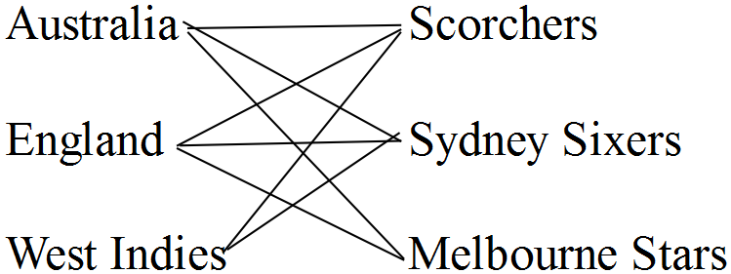1. (a)

(b) Not a complete bipartite graph.
West Indies do not link to
Melbourne Stars.

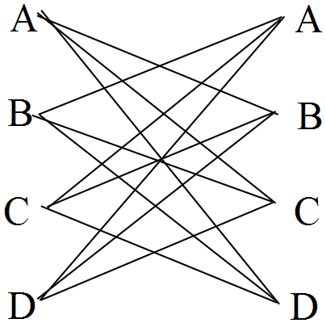2. (a)

(b) Not complete.
A doesn’t join to A etc
(c) 6. (Half the links shown)
(d)

 | A | B | C | D
A | 0 | 1 | 1 | 1
B | 1 | 0 | 1 | 1
C | 1 | 1 | 0 | 1
D | 1 | 1 | 1 | 0

3 (a) Thursday and Friday.
(b) Clinton only available 1 day of
the week.
(c) Wednesday has 4 parents available.
(d) Barbara's proportion = $\frac{3}{11}$
Barbara receives $\frac{3}{11}$ x $\frac{220}{1}$ = $60

4. (a) All are planar. No crossings.
(b) (iii) is an Eulerian circuit.
0 odd vertices.
(c) (i), (iii) Visit each vertex once only.
(d) V + F – E = 2 in each case.
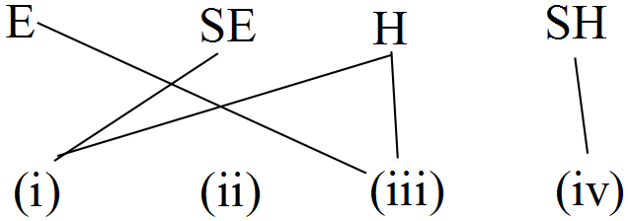 (e)

5. (a) A path starting at a vertex and passing along
each edge only once, and finishing at a
different vertex.
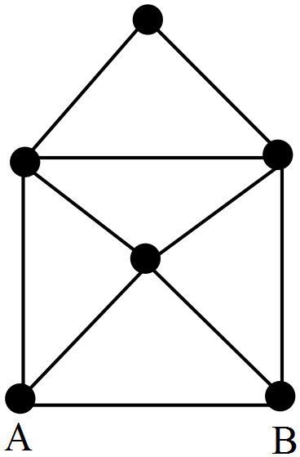 (b) (i)

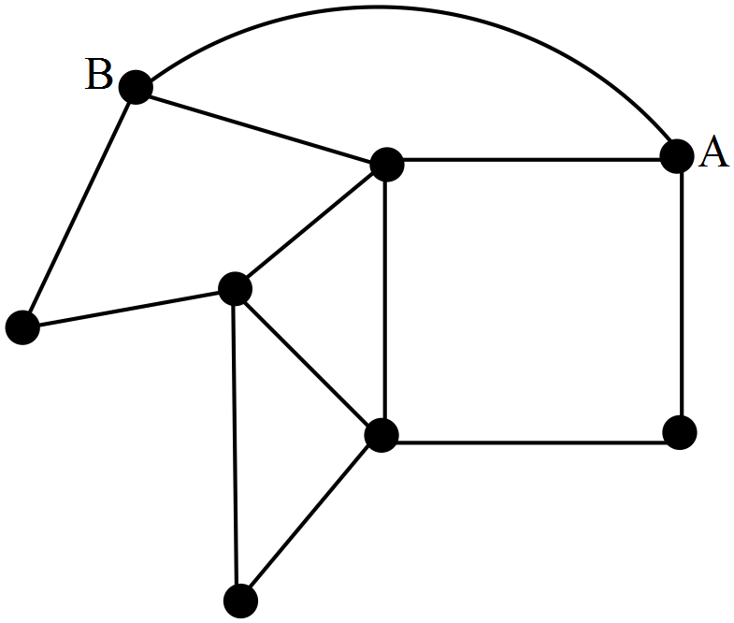 (ii)

(iii) 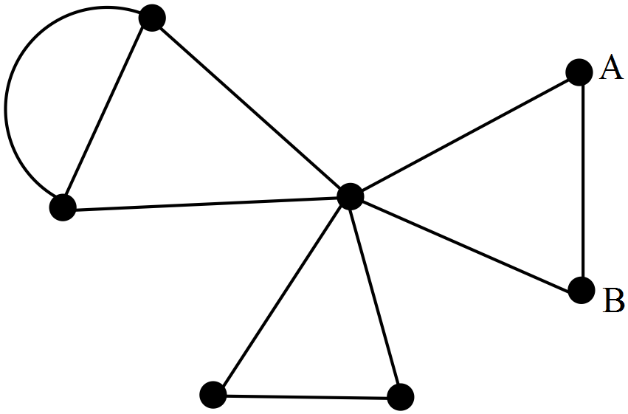

(c) the other odd vertex is the finishing point
(d) (i) (ii)
(e) V + F – E = 2
(f)
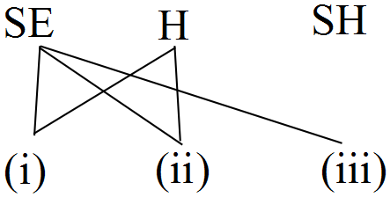

(g) A three stage route or
adjacency matrix

6. (a) A path starting at any vertex, passing along
all edges exactly once, and finishing at the
same vertex.
(b) Start anywhere, finish there
(c) Start anywhere, finish there
(d) All
(e) V + F – E = 2 for all networks.
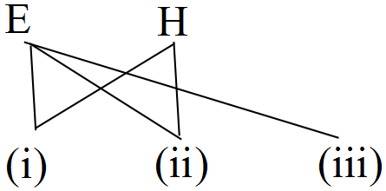 (f)

(g) 4 stage route

7. (b) More than 2 odd vertices.
(c) 3 gives 2 odd vertices.
8.

(a) Diagram Length = 26
(b) The next shortest is 28.
Shorter by 2.
(c) Five throws.
9. (a) C — WH — K — B — P —
Dalwallinu
103 km.
(b) Shortest path through Yerecoin
‘ is 118 km.
In 90 minutes they can travel 135 km
∴ they should be there on time.
(c) 6 odd vertices, so not possible.
(d) 182 km

10. (a) 468 km, INN – ARR – WIN
(b) (468 + 109 + 50 + 38 + 61 + 152 +
14 + 168) x $1.20 = $1272

11. (a)
Shortest route is as shown.
Length is 237 km.

(b)
[Hint: treat as 0, and start from there]
Shortest route is as shown.
Length is 155 + 103 = 258
Cheapest path is marked. Cost is $72.

12.

(a) Cheapest path is marked.
Cost is $72.
(b) Hamiltonian
(c) $98
BT – G – YT – DT – BT – UT

13. (a) 7
(b) 27 m
(c) $ 3.50 + ( 27)(0.95) = $ 29.15
∴ No
(d) $ 3.50 + ( 45)(0.95) = $ 46.25
14. (a)

Quickest route is marked.
(b)

(c) 10 — 5
(d) 15 minutes at 10km/h
= $\frac{15}{60}$ x 10 = 2·5 km.

15. (a) Not all this table is required

Base  Town | Total travelling distance
Manjimup | 2(120 + 186 + 159 + 208) = 1346
Walpole | 2(120 + 66 + 119 + 168) = 946
Denmark | 2(53 + 66 + 102 + 186) = 814
Mt Barker | 2(49 + 159 + 102 + 168) = 956
Albany | 2(49 + 53 + 208 + 119) = 858
Use Denmark. Minimum travelling distance is
814 km. ✓✓✓✓

(b)
Leave Manjimup to Mt Barker. ✓

16. (a) (i) ABFK 23 (ii)ADEFK 32
(b)

DEFK = 20 while DGK = 15
∴ difference of 5 mins
(c) (i) AGDEHFKCBA is one
(ii) 74 minutes
(d) (ii)

17. (a) 119 km
(b) (i) 234 km
(ii) 386 km

18. (a)

ABJGDE 113 mins
(b) ABJCDE 138 mins

Chapter 6: Recurrence

1. (a) a = 17, b = 45, c = 5n + 2
(b) (i) 5
(ii) 7
(c) e = 9n + 4
f = 13n + 6
(d) d = (5n + 2) – (3n + 1) = 2n + 1
(e)
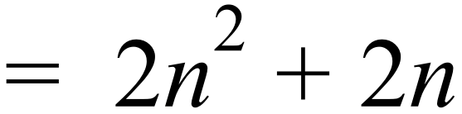
(f) (i) n = 2 ⇒ 2n + 1 = 5
n = 5 ⇒ 2n + 1 = 11
n = 15 ⇒ 2n + 1 = 31
∴ verified
(ii) n = 16 ⇒ 2n + 1 = 33
n = 31 ⇒ 2n +1 = 63
n = 49 ⇒ 2n + 1 = 99
∴ verified.

2. (a) 2, 4, 16, 256, ….
(b) 2, 6, 15, 24, …..

3. (a) Arithmetic
(b) Geometric
(c) 5, 12, 26

4. (a) width = 5, length = 7
(b) 10, 12
(c) n, n + 2
(d) (i) 35
(ii) 120
(iii) n( n + 2 )
(e) n( n + 2 ) = 143 → ∴ n = 11
5. (a) 4 x 5 rectangle of dots
(b) T₆ = 42
(c) Neither

6. (a) (i) 5, 17, 41, 89 (ii) 5, 11.4, 23.41, 47.13
(iii) 89, 41, 17, 5
(b) None, since none is an A.P.
( No common differences)

7. (a)
(b) (i)
(ii) Start from , add to get
from one term to the next.

8. (a)
(b) 280 km
(c) Line with y intercept of 100, and
gradient of 60

9. (a) 1, 3, 6, 10
(b)
(c)

10. Use linear regression or calculator sequence routine.
Calculator gives the regression equation as
Tn = –1 + 3n
∴ a = T1 = 2 ; d = 3

11. (a) 2, 6, 12, 20, 30.
(b) 2, 6, 12, 20, 30
(c) Tn = n(n+1)
∴ T10 = 10(11) = 110
2nd sequence is easier to calculate
` `manually– not dependent on previous
term. Calculator produces lists for
either.

12. (a) Tn = 23–4n
∴ T1 = 23–4 = 19
T2 = 23–4(2) = 15
T3 = 23–4(3) = 11
‘ ∴ Formula is correct.
(b) T10 = 23–4(10) = –17
(c) Tn+1 = Tn–4 , T1 = 19

13. (a) t1 = 20 t2 = 10 t3 =5 t4 = 2·5
(b) tn = arn–1
tn = 20($\frac{1}{2}$)n–1
(c) t10 = 20($\frac{1}{2}$)9
= $\frac{20}{512}$ = $\frac{5}{128}$
= 0·0390625
(d) Using the general rule manually is much
easier than using the recursive
definition because only one calculation
is required. Calculator produces lists
for either.

14. (a) (i) Geometric [a = 75, r = 0·8]
(ii) No "d" or "r"
(iii) Arithmetic
[a = 100, d = –1·5]
(b) (i) T7 = 75(0·8)6 = 19·66
(ii) By differences, T7 = 21
(iii) T7 = 100 + 6(–1·5) = 91

15. (a) (i) 10 ,20, 40, 80, 160
(ii) 10, 22, 46, 94, 190
(iii) 10, 25, 55, 115, 235
(b) (iii) is growing fastest.
(c) (i) Geometric
(ii) Neither
(iii) Neither

16. (a) (i) Not possible, since $\sqrt{–8}$ is not real.
(ii)
(iii)
(iv)
(v)

Comments: Tn 1 for all starting values
except those which are negative.
(b) After many presses, calculator
will show 1.

17. (a) (i) T1 = 6
(ii) T2 = 3
(iii) T3 = 1$\frac{1}{2}$
(b) = r ∴ r = = $\frac{3}{6}$ = $\frac{1}{2}$
(c) T6 = ar5 = 6.($\frac{1}{2}$)5 = $\frac{6}{32}$
Tn = arn–1 = 6.(0·5)n–1

18. (a) (i) d > 0 (iii) d < 0
(b) (ii) 0 < r < 1 (iv) –1 < r < 0
(c) (i) r = 1 (ii) d = 0

19. (a) T10 = $\frac{49}{21}$ = 2·333
(b) T100 = $\frac{499}{201}$ , T1000 = $\frac{4999}{2001}$
≈ 2·483 ≈ 2·498
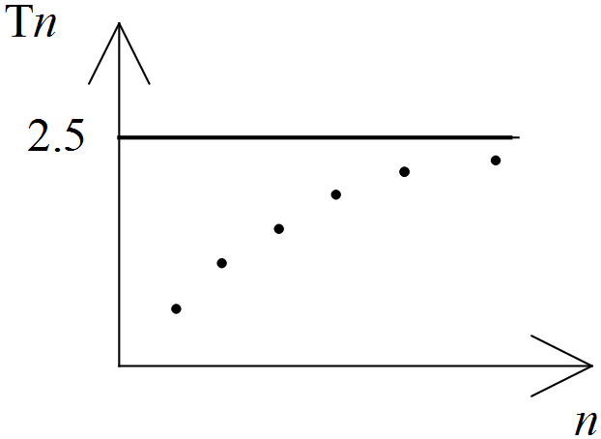 (c)

(d) The points approach the line
Tn = 2·5.

20. (a), (b)

 | Rec Df | G Rule | T1
A | 2 | β | 3
B | 1 | α | 3
C | 3 | ω | 3
D | 4 | γ | 3
for each entry

21. (a) 0
(c) – 40
(d) 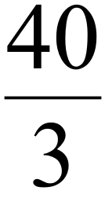
(e) 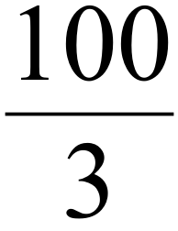

22. 75

23. (a) 3/8
(b) (i) – 8 (ii) 2.5

24. – 2, 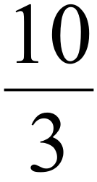

25. (a) 10
(b) –10, 16, 8.2
(c) 10

26. (a) –15
(b) 2, – 4.8, – 8.88
(c) – 15
(d) steady state

27. (a) 10, 7, 5.5
(b) 4.000000011
(c) 4
(d) 4

28. (a) (i)
(ii)
(iii) (iv)
(b) No as there is no common
difference.

29. (a) T₂ = 6
T₃ = 9
T₄ = 13
(b)
(c) Backwards, sequence is 13, 9, 6, 4, 3, 3
∴ smallest term is 3
30. (a) x = 4, y = 2, z = 3
(b) x = 5, y = –2, z = 1

Chapter 7 Applications of Sequences

1. (a) T40 = 45
(b) S40 = 1 020 trees
2. (a) hn = hn–1+2 , h1 = 2
(b) h = 2w
(c) Gradient is 2.
Gradient – common difference.
(d) h = 2 x 6·02 x 1023
= 12·04 x 1023
= 1·204 x 1024.

3. (a) After 6th raise = T7
T7 = a + 6d
= 8 000 + 6 000
= 14 000
Salary is $14 000
(b) (i) 6 raises = 6 x 1200
= $7 200
Ben would be earning $7 200 more
than his starting salary.
(ii) Andrew has a salary of $14 000
Ben has a salary of $a + 7 200
For these to be equal: a = $6 800

4. T_{n} = 0.6 T_{n–1} with T₁ = 600
or Tn = arn–1
n | Tn
10  8  9 | 6·05  16·80  10·07

Kate stops after 8 swings.

5.

PIZZA | 1 | 2 | 3 | 4
SECTIONS | 1 | 2 | 4 | 6
CUTS | 0 | 1 | 2 | 3

(a) Pizza 5 has 4 cuts ∴ 8 sections.
(b) Pizza 6 has 5 cuts ∴ 10 sections.
(c) Pizza n has n–1 cuts
∴ 2(n–1) sections.

6. (a) T₁₀ = ar9
=1.29 = 512
(b) (i) T11 = 1024
T12 = 2048
∴ He could have an eleventh bet,
but not a twelfth.
(ii) His last bet would be $1024.
(c) Use trial and error:
S5 = 31, S6 = 63, S7 = 127, S8 = 255
(i) He could lose 7 consecutive bets.
(ii) He would have 200 – 127
= $73 left.
(d) (i) $1
(ii) T10 – S9 = 512 –511 = $1

7. (a) L ₁ − L ₀ = 190 − 100 = 90
(b) L ₂ − L ₁ = 0.1 ( 90 ) = 9
(c) L ₃ − L ₂ = 0.1 ( 9 ) = 0.9
(d)

(e) From graph, limit is 200

8. (a)
n | 1 | 2 | 3 | 4 | 5
T_{n} | 2.4 | 2.88 | 3.46 | 4.15 | 4.98

(b) (i) T8 = ( 2.4 )( 1.2 )⁷ = 8.6
or by constant multiplying T8 = 8.6
or table in calculator.
(ii) T8 –T7 = 8.6 – 7.2 = 1.4 minutes
(c)
n | Tn
5 | 5
8 | 8.6
10 | 12.4
12 | 17.8
11 | 14.9
- 11 in the group.
(d) Tn+1 = (1.2 ) Tn, T1 = 2.4

9. (a) Points lie on a line.
(b) Number of people is not a continuous
quantity.
i.e. You cannot have a fraction of
a person.
(c) y = a + bx
y = 200 + 12x
(direct from calculator or intuitively obvious.)
(d) 1000 = 200 + 12x
800 = 12x
66.6 = x
∴66 people
(or direct from calculator)
(e) y = 200 + 12 ( 64 )
= 968 ( or direct from calculator )
(f) y = 200 + 12 ( 80 )
= 1160 ( or direct from calculator )
Fiona’s parents need 1160 – 500
= $ 660.
(g) T_{n+1} = T_{n} + 12, T₁ = 150

10. (a) T5 = a + 4d or
From calculator
2500 = 100 + 4d
Enter ( 1, 100 ), ( 5, 2500)
2400 = 4d
d = 600
(b) T3 = a + 2d or T3 = 1300 (direct)
= 100 + 2 ( 600 )= 1300
(c) (i) (α) Day 11 = Week 2
700m (β) Day 13 = Week 3
1300 m
(ii) Total = 6( 100 ) + 6( 700 )
+ 6( 1300 ) + 6( 1900 ) + 6 ( 2500 )
= 6( 100 + 700 + ......+ 2500) = 39 000 m
11. (a)

(b)
x | 1 | 2 | 3 | 4
y | 5 | 8 | 11 | 14
∴ y = 3x + 2
(c) If x = 13 , y = 3(13) + 2 = 41
(d) If y = 77 , 77 = 3x + 2 x = 25

12. Rates form this sequence of 7 terms.
20, 35, 40, 45, 50, 55, 60
Cost = 80 + 140 + 160 + 180
+ 200 + 220 + 240
= $1220

13. (a) 52 = 42 + 32
∴ Pythagoras' Theorem applies.
(b) 6, 8, 10 and 9, 12, 15 etc.
(c) 142 ≠ 102 + 122
∴ Kevin is not correct.

14. (a) 22 = n, from calculator list
If he continues the routine for 22 days,
he will then be practising
8 hours per day.
(b) S10 = 1500 minutes = 25 hours.

15. (a) Losing 20% means keeping 80%.
Hence r = 0.8 ✓
(b) 19 200 (0.8) = 15 360 ✓✓
(c) 30 000 (0.8) ^{p} ✓✓
(d) C ✓

16 (a) (i) 1.15 million L
(ii) 1.3225 million L
(iii) 2 011 000 L
(iv) 1.15 ^{n} million L
(b) 1.15 ^{n} = 3 → n = 7.8
∴ Year 2008
(c) (i)
(ii) y = 1.9
∴Production is 1.9 million
(d)
 | 2004 | 2005 | 2006 | 2007
Dark Ale | 1.9 | 2.01 | 2.31 | 2.66
Pale Ale | 1.7 | 2.6 | 3.5 | 4.6
For the next 30 years, production of pale
ale is greater.
(e)
 | 2033 | 2034 | 2035 | 2036
Dark Ale | 100.69 | 115.8 | 133.17 | 153.15
Pale Ale | 103.4 | 109.9 | 116.6 | 123.5
After 2033, dark ale sales are larger
(f) (i) p = – 0.1n + 1.2
(ii) p = 0.8 ∴ 800 000L
(iii) gradient = – 0.1
∴ 100 000 L per year.
(g) p = 600 000 in 2006
∴ 2006 is last year
17. (a) Value after 2 years=1800 [1 – 0·2]2
= $1 152
(b) Value after n years= 1800 [1– 0·2]n
= 1800 (0·8)n

18. (a)
(b) 20311, 20314, 20317, 20320,
20323, 20326
(c) (i) Tn = 20 308 + 3n
(ii) Tn = 20 311 + n
(d) 20371

19. (a) Linear – B
Exponential – A
(b) A
(c) (i) C

20. (a) n = a.rt , where t is the number of
days since there was 1 pad.
ie. n = 1x2t
(b) (i) n = 1x2 = 2
(ii) n = 1x216 = 65536
(c) 100% increase.
(d) Yesterday.

21. (a) Profits are a, ar, ar2 , ar3 , …
and r = 0·9
ie. Profits are a, 0·9a, 0·92 a, 0·93 a
∴ 0·93a = 250 000
a =
= 342 936
≈ $343 000
Sensible answers here would be
$340 000 or $350 000
(b) (i) In theory, profits will dwindle to
almost 0.
(ii) In practise, restructuring would
occur long before.

22. (a) Original Value: V0 = 25 000
After 1 year: V1 = 25 000 (0·78)
= 19 500
After 2 years: V2 = 19 500(0·90)1
= 17 550
After 3 years: V3 = 19 500 (0·90)2
= 15 795
Vn = 19 500 (0·90)n–1
(b) Cost = consumption x price
= (0·85) x (1·15)
= 0·9775
= 2·25% reduction

23. (a) a = 20 000
T4 = ar3 = 10 000
∴ 20 000r3 = 10 000
r3 = 0·5
r ≈ 0·79
The rate of depreciation is
≈ 21% p.a.
(b) V = art
V = 20 000(0·79)t
(c) If V = 5 000
5000 = 20 000(0·97)t
6 ≈ t
∴ It will take about 6 years.
This also can be obtained from a calculator table using the recursive formula V _{n+1} = 0.97V_{n}, V₀ = 20 000
24. (a) % increase = 8%
(b) Population after 4 months ≈ 4081
(c) From calculator table, viral attack occurred
after approximately 30 months.
(d) The remaining 20% = 6 000 caterpillars
∴ Q _{n+1} =1.08 Q_{n} with Q₀ = 6000 ∴ P _{n+1} = 1.08 P_{n} with P₀ = 3000 ∴ Q is double P for any given
equivalent time period.

25. (a) 2015 ∴ n = 2
C ≈ 20 800
(b) Since r = 1·05 = 105%
Populations are increasing by 5%
(c) H _{n+1} = 1.04 H_{n} with H₀ = 25 000
(d) n C H
4 21 879 29 246
6 24 121 31 633
7 25 327 32 898

C will exceed 25 000 when 6 < t < 7
ie. in the year 2019.

26. (a) The average increase per year =
= 300
(b) = = 0.76
∴ r = 0.993
∴ 0.7 % decrease
(c) a = 38 000, r = 1.01
(d) When n = 80, P = 38 000 ( 1.01 ) ⁸⁰
≈ 84 200 or from recursive table.

27. (a) r = $\frac{553}{500}$ = 1·106
or r = $\frac{605}{553}$ = 1·094
r ≈ 1·1
or r = $\frac{662}{605}$ = 1·094
∴ Growth rate = 10% p.a.
or r = $\frac{730}{662}$ = 1·103
(b) P _{n+1} = 1.1 P_{n} with P₀ = 500
(c) For year 7, P≈ 970
For year 10, P ≈ 1300
But since population is 4732, gold was probably discovered between years 7
and 10.

28. (a)
8 | 21
9 | 34

(b) (i) Approaches 1.618
(ii) Approaches 0.618
(c) Difference of 1.
(d) 1.618
(e) As n gets larger:

29. P_{n+1} = 0.99P_{n} – 50 000 P₀ = 2 000 000
Calculator table gives P₅ ≈ 1 657 000

30. (a) (i) 16( 1.08 )¹ = 17.28°
(ii) 16 ( 1.08 ) ⁸ = 29.61°
(b) (i) 16 ( 1.08 ) – 1 = 16.28°
(ii) 16.28( 1.08 ) – 1 = 16.58°
(c) 1.08 k – 1
(d) T _{n+1} = T _{n} ( 1.08 ) – 1 where T₁ = 16
n | T _{n}
42 | 94.62
43 | 101.19
If 1 < n < 2, 1st hour
If 42 < n < 43,
∴ during the 42nd hour.

Chapter 8: Financial Mathematics

1. (a)
Year | Amount at  Beginning  of Year | Interest | Amount at  End of  Year
1 | $400 | $32 | $432
2 | $832 | $66.56 | $898.56
3 | $1298.56 | $103.88 | $1402.44
4 | $1802.44 | $144.20 | $1946.64
5 | $2346.64 | $187.73 | $2534.37
(b) P = 1.08, Q = 400
(c) P = 1 + interest rate ,
Q = investment
(d) $2346.64
(e) $2534.37
(f) $4254.65
(g) $6258.19

2. (a)
 | A | B | C
Year | Opening  Balance | Balance +  Interest | Amount after  Repayment
1 | 4000 | 4000(1.2) | 4000(1.2)– 1000
2 | 3800 | 3800(1.2) | 3800(1.2)– 1000
3 | 3560 | 3560(1.2) | 3560(1.2)– 1000
4 | 3272 | 3272(1.2) | 3272(1.2)– 1000
(b) 20% p.a.
(c) $ 1000
(d) Q = 1.2, G = – 1000
(e)
9 | 700.18 | 700.18(1.2)=840.22 | 0
(f) 4000.R.9 = 4840.22
∴ R = 13.45 % p.a.
3. (a) $ 225
(b) $ 975
(c) $ 400
(d) a _{n+1} = 1.005 ( a _{n} ) – 400 where
a ₁ = 4 000.
(e) At the end of month 11, the loan
balance will become 0.
(f) The final repayment is $113.35
( as seen from table ) together
with the interest for month 11.
The amount is $ 13.92

4. (a) Don’t need any money to drive
the car away.
(b) Less financed so less interest.
(c) a = 74.23, b = 172, c = 7325.63,
d = 7325.63
(d) Total = 62 x 172 + 133.23
= $10797.23
(e) Total interest = 10797.23 − 7990
= $2807.23
(f) 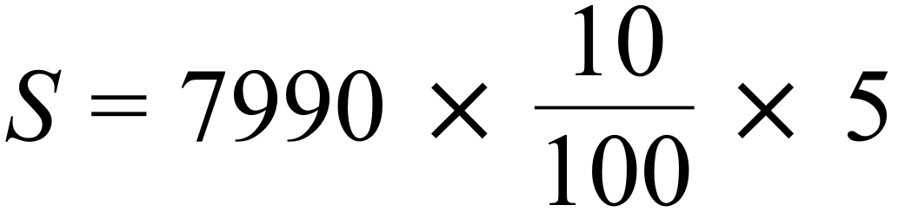
= $3995

5. (a) % = 0.6667 %
(b) (i) 32.22
(ii) 4 665.56
(iii) 87.44
(iv) 88.02
(c) ( 27 x 200 ) + 88.02 = 5 488.02
(d) 488.02
(e) Slightly more.
(f) = $ 208.33

6. (a) A = 47.75
B = 9097.75
C = 62.51
(b) (21 x 500) + 62.51 – 10 000
= $562.51
(c) x = 1485.82
(d) (18 x 400) + 303.72 + 3 000
= $10 503.72
(e) Less interest and paid off quicker
(f) Maybe difficult to save $1 000

7. (a) a = 199 198
b = 199 198
c = 995.99
(b) (i) Weekly rent = 80(1.03)4
= $90.04
(ii)
(c) (i) 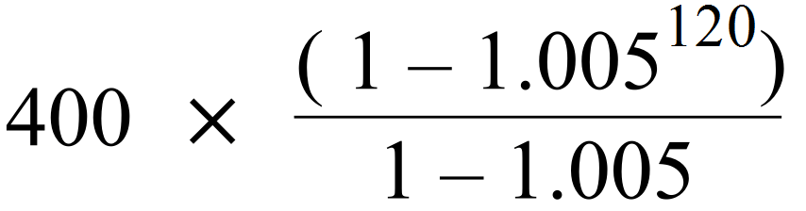
= $65 500
Or by recursion $65 500
(ii) No. As inflation would have
increased the value of the
house.

8. (a) a = 1 990, b = 395 990,
c = 395 990
(b) Reduce to zero
(c) (i) Make the payment $2 000
(ii) Make the payment less
than $2 000
9. (a)

MONTH | AMOUNT  OWING | INTEREST | AMOUNT +  INTEREST –  REPAYMENT
1 | 8000 | 106.67 | 7606.67
2 | 7606.67 | 101.42 | 7208.09
3 | 7208.09 | 96.11 | 6804.20

(b) $ 6804.20
(c) Interest paid = 106.67 + 101.42 + 96.11 = $ 304.20

10. (a) A₁ = 300 000
A₂ = 300 000, A₃ = 300 000
(b) No, as never gets smaller.
(c) Month 5. The interest increased.
(d) Interest rate =
= 0.7083% per month
(e)
8 | 296 803.69 | 2 102.36 | 2 500 | 296 406.05

(f) $ 3196.31

11. (a) Cash Price was $ 2 000 + $ 14 000
= $ 16 000
(b) Repayments were $ 1 200
per month.
(c) x 100% = 0.67 %
per month
(d) m = 63.52
n = 8 392.39
p = 223.56
(e) R = = 4.1%
(f) 4 only

12. 1895 £1:10 ≈ $3
In 2015, t = 120
Value = 3(1·10)¹²⁰
or by recursion in a table
≈ $278 000

13. From recursive mode or spreadsheet
A = 10 737 418.23
∴ (ii) by $9 737 418.23
14. (a) 1.3, 1.3 x 1.02, 1.3 x 1.02², …..
∴ x = 8.22 i.e. during 9th week
(b) From calculator table, sum is
$5 851.07
(c)
∴ x = $73 138.33
15. (a) A = P(1+r)n
= 1000(1+$\frac{0·1}{12}$)12
= $1104·71
(b) A = 1000 (1 + $\frac{0·1}{525 600}$)$^{525 600}$
If 1 year = $1105·17 = 365 days
Difference ≈ 46 cents= 365 x 24 hours
= 365 x 24 x 60 minutes
= 525 600 minutes

16. 14% p.a. monthly e = (1+$\frac{0·14}{12}$)12 – 1
= 0·1493
= 14·93% compounded annually
< 15% compounded annually
R and U is better.

17. (a) 8·05 x 80 = $644 per month.
(b) $644 x 12 x 30 = $231 840
(c) Interest= 231 840 – 80 000
= $151 840
Principal = $80 000
Time = 30 years
Rate = $\frac{100.I}{P.T}$
= $\frac{100.151 840}{80 000.30.12}$
= 6·327% p.a.
= 0·527% per month.

18. (a) His performance is given by the sum of
his profits:
Interest: A = 200 000 (1 + $\frac{·09}{12}$)24
= 200 000 (1·0075)24
= $239 282·71
 Interest = $39 282·71 —1

Real Estate: Profit = $20 000 —2
Yacht: Loss = $50 000 —3
Sum = $9,282·71
= $9 300 (nearest $100).
(b) I = P.r.t
 9300 = 500 000.r.2
 r = $\frac{9300}{1 000 000}$ = ·0093
Rate is 0·93% p.a.

19. (a) A = Amount owing at beginning of month
B = interest for the month
C = Amount + interest
D = Amount owing after
monthly repayment
(b) $300
(c) p = 19,893·96
q = 19,593·96
r = 19,593·96
s = 195·94

20. (a) (1·03)4 = (1 + i)1
1·1255 = 1 + I
0·1255 = i
 Equivalent rate is 12·55% p.a.
(b)
Year | Amount owing | Interest for  the year | Balance
1  2 | 20 000  15 510 | 2 510  1 947 | 15 510  10 457

(c) A = P(1 + r)n
= 7500 (1·1)3
= $9 982·50
The inheritance is not quite enough to pay
off the $10 457 owing.

21. (a) A = 300 000 ( 1 + ) 24
= 358 924.06
(b) SI = (300 000)( 0.15 )(2) = 90 000
 Selling Price = $ 390 000
(c) Profit = 90 000 – 58 924.06
= $ 31 075.94
(d) ( 1 + )12 – 1= 0.0938
Effective Rate of 9.38 % p.a.
( 1 + )365 – 1 = 0.0887
Effective Rate of 8.87 % p.a.
 8.5% p.a. compounded daily was the
better rate for borrowing money.

22. (a) A = P(1+r)t
= 100 (1·1)2
= 121
So $100 grows to $121.
(b) (i) If r = 3%, predicted doubling time
is $\frac{72}{3}$ = 24 years.
A = 100 (1·03)24 = 203·28
If r = 4%, predicted doubling time
is $\frac{72}{4}$ = 18 years.
A = 100 (1·04)18 = 202·58
Comment: Slightly more than
double after these times.
(ii) If r = 8%, predicted doubling time
= $\frac{72}{8}$ = 9 years.
A = 100(1·08)9 = $199·90
If r = 9%, predicted doubling time
= $\frac{72}{9}$ = 8 years.
A = 100(1·09)8 = $199·26
Comment: slightly less than double
after these times.

(iii) If r = 24%, predicted doubling
time = $\frac{72}{24}$ = 3 years.
A = 100 (1·24)3 = $190·66
If r = 36%, predicted doubling
time = $\frac{72}{36}$ = 2 years.
A = 100 (1·36)2 = $184·96
Comment: Increasingly less than
double after these times.
(iv) Rule seems very useful for small
to medium rates, but less
so for high rates.

23. (a) Amount 1 is compound.
Interest changes from year to year.
(b) Easiest to look at 1st years interest
on $1000.
A = P(1+r)t
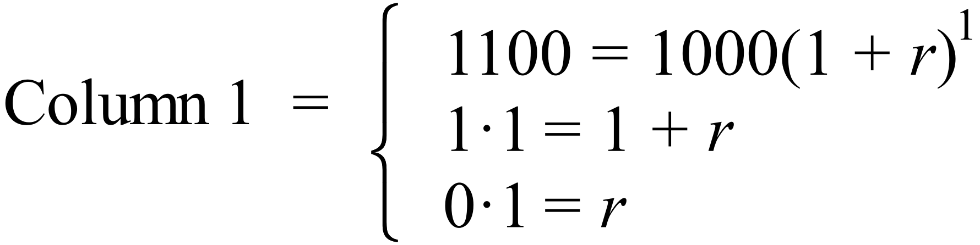
 r = 10% p.a. compounded annually
or
I = P.R.T.
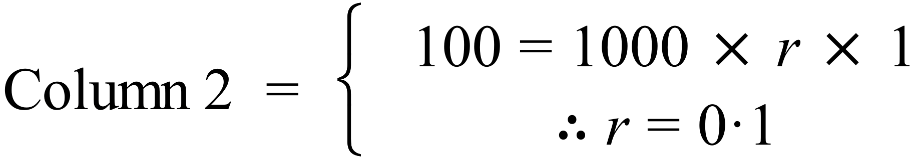 = 10% p.a. simple interest per annum.
(c) A = P(1+r)n
A = 1000(1·1)100Column 1
= 13 780 612·34
I = P.R.T.
= (1000)(0·1)(100)
= $10 000 Column 2
 Amount = 1 000 + 10 000
= $11 000

24. (a) 11 600 – Deposit = 24 ( 400 )
Deposit = 2 000
(b)
OPENING  BALANCE | DEPOSIT | INTEREST AT  END OF MONTH | CLOSING  BALANCE
0 | 400 | 3 | 403
403 | 400 | 6.02 | 409.02
409.02 | 400
Amount = $ 809.02
(c) By extending the table:
A = $ 3 285.27
(d) A = 9 600 ( 1.09 )²
= 11 405.76
Interest = $ 1 805.76 which is considerably
more than the annuity result.

25. (a) A = P(1 + i)n
= 30 000 (1 + $\frac{·06}{4}$)40
= 30 000 (1·015)40
= $54,420·55
(b) A = P(1 + $\frac{r}{400}$ )4y

26. (a) 0.75% per month = 9 % p.a
(b) Only interest is being repaid. (c) (i) Decrease (ii) Decrease
(d) (i) Increase (ii) Increase

27. (a) $40 100
(b) $45 200
(c) 400 weeks (d) 30 000 x 1.2 = $36 000
(e) 30 000 x 1.2 ² = $43 200
(f) Direct from calculator = 3.8 years
(g) After 3.75 years, Dan has
40 000 + 5 200(3.75) = $59 500
Kate has 30 000(1.2)^{3.75} = $59 436
(h) A : Starting value of Dan's "investment" B : Equal value ( see (g) ) C : Maximum block value D : Investments again of equal value.

(i) $74 650
(j) 5% p.a.
(k)
 | n | Dan | Kate
Time | 4 | 60 800 | 62 208
 | 5 | 66 000 | 74 650
 | 6 | 71 200 | 70 917
 | 7 | 76 400 | 67 372
D = ( 6, 71 000 )
Chapter 9: Time Series

1. (a) Error
(b) Seasonal Index
(c) Trend

2. (a) We need the 3PMA for times 3,4,5.
ie. $\frac{6+5+7}{3}$ = 6.
(b) Period is 3 months.
(c) Next x looks to be ≈ 10.

3. (a)

(b) Trend is negative (decreasing)
(c) Probably about 4·5.
(d) (i) trend continues downwards
(ii) seasonal component regular

4. (a) Upward or Positive or Increasing.
(b) There seems to be 2 seasons, winter and
summer. Winter gives higher $ than summer.
Period of 1 year.
(c) 2PMA most appropriate since 2 seasons.
(d) Sales of do–nuts is most appropriate – more sales
in winter than summer and increasing overall
trend. (since population is increasing).

5. (a) $\frac{90 + 103 + 112}{3}$ = $\frac{305}{3}$ = 101·67
(b) $\frac{100 + 90 + 103 + 112}{4}$ = $\frac{405}{4}$ = 101·25
(c) a is more appropriate since there are
clearly 3 seasons in the data.
(d) Next term looks like being ≈ 124.

6. (a) Four seasons in the cycle.
(b) a = 23.25 b = 32
(c) S.I. for Autumn = (0.773 + 0.792 + 0.808)/3
= 0.791
(d) y = 20.75 + 0.5x
(e) Autumn 2016 = Time Period 14
∴ y = 27.75
Predicted Value = Trend x Seasonal Index
= 27.75 x ( 0.791 ) = 22
(f) Seasonally Adjusted figures for Autumn 2013
= 17/ ( 0.791 ) = 21.5

7. (a)
(b) Period = 4 quarters = 1 year.
(c) $\frac{\frac{1}{2} (30) + 45 + 55 + 35 + \frac{1}{2} (33)}{4}$
= 41·625
55 – 41·625 = 13·375
(d) on graph
(e) 2nd quarter 2013 ∴ t = 14
From the line graph, TREND ≈ 55
2nd quarter: (1.09 + 1.09 + 1.11) /3
= 1.10
∴ When t = 14, Hours
∴ 55 x 1.10 = 60.5
(f) From calculator, H = 38·4 + 1·1 t
When t = 14, H = 54
(g) "High Season" is season 3.
SI3 = (1.33 + 1.31 + 1.29)/3 = 1.31
Predicted Hours = TREND x SI3
80 = TREND x 1.31
61.1 = TREND
61.1 = 38·4 + 1·1t
22.7 = 1·1t
t = 20 or 21 quarters ie. in 2014.

8.

QUARTER | SALES ( $ ) SEASONALLY ADJ.
JANUARY | 15000/0.7 = 21 428
APRIL | 18000/ 1.3 = 13846
JULY | 12000/1.1 = 10909
OCTOBER | 19000/0.9 = 21111
X = 90% The team leader for January should get the bonus.

9. (a) $\frac{p + 5855 + 5837}{3}$ = 5833
∴ p = 5807
$\frac{5806 + 5882 + 5876}{3}$ = q
∴ 5854·7 = q
(b)

(c) From the graph, m ≈ 5925
(d) If t = 12, m = 5817·3 + 8·88(12)
m = 5923·9 (1dp)
(e) (i) line upward slope ∴increasing
(ii) equation has gradient of 8·88
∴ increasing
(f) m = 5923·9 = $\frac{5890 + 5922 + W13}{3}$
∴ W13 = 5959·7
No of workers = 5,959,700

10. (a) Increasing. Positive gradient.
(b) Seasonally Adjusted = 33000 /1.5
= 22000
(c) Sales = (5 + 9 ( 10 )) x SC
= 95 000 x 1.5
= 142 500
(d) 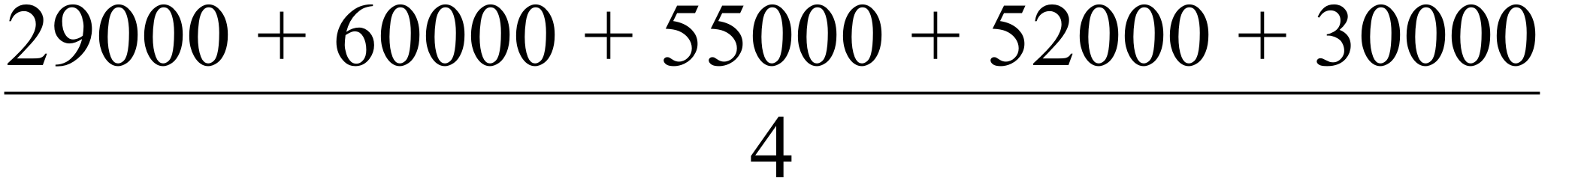
= = 56 500
11. (a) = 192.375
A = 191.75
B = 200.25
C = 95%
D = 98.7%
(b) y = 1.2(16) + 189.3
= 19.2 + 189.3
= 208.5
∴ Sales = 208.5 x 1.003 = $209.1 million
(c) Seas. Adj. Sales = 200/0.994
= 201.2 ≈ $ 201 million
(d) Increasing .
Trend line has positive gradient.

12. (a) 4 point cycle
(b) ( 756 + 792 + 801 + 0.5( 773 + 824 ))
= 786.875
(c) Trend = 1003.7
Seasonal index = 1.005
∴ Future value = 1008.7 x $ 10 000
= $ 10 087 000
(d) Seasonally adjusted value = 756/1.005
= $7 522 000
(e) Yes, since goes against the trend.
(f) 10 000 000 x 0.99 ³ ≈ $ 9 700 000

13. (a) a = 48
(b) (i) 1 week
(ii) Positive
(iii) Smooth the data, as efficiently as
possible.
(c) Seasonal Index Tuesday
= (60.4 +63.0 +78.0)/3 = 67.1%
(d) Tuesday of week 4 : Day = 23
Predict y when x = 23 ⇒ = 70.71
∴ Predicted Sales= x Seasonal Index Tuesday
= 70.71 x 0.671 = 47.4

14. (a) (i) Decreasing trend
(ii) High in March, low in August
(b) yearly cycle
(c)
(d) = $1.78 m
∴ Sales = 1.78 x 1.01 = $1.80 m
(e) = $2.74 m
∴ Sales = 2.74 x 1.01 = $2.77 m
(f) More as SAF = Sales /1.01
(g) Max occurs in June/July

15. (a)
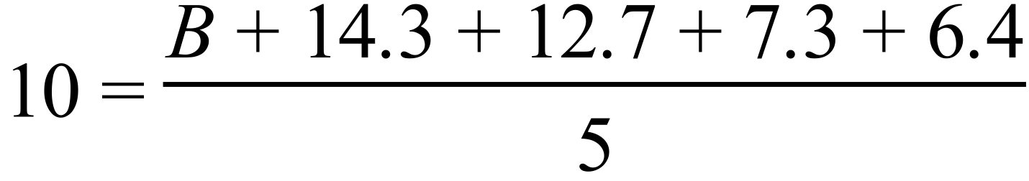
∴ B = 9.3
(b) (12.7/10 + 12.8/9.4 + 12.1/9.2) /3
= 1.32
(c) y = 0.03(35) + 8.81 = 9.86
∴ Predicted Sales = 9.86 x1.32
= 13.02
∴ $1302
(d) (i) Correlation coefficient between t and y
(ii) Extrapolation into the future
(iii) The regularity of the sc.

Chapter 10: Minimal Spanning Tree

1. (a) 171m
(b)

2.

Minimum connecting tree is shown.
Minimum connecting distance is
27 + 17 + 12 + 33 = 89 km
∴ Cost = 89 000 x 100 = $8·9 million
∴ The offer would be accepted.

3. (a) 1000 + 1500 + 1200 + 900 + 1100
+ 2000 + 1300 + 1400
= $10 400
(b) Minimal Spanning Tree is required.

AB = 1000, BC = 1200, CE = 1100,
MH
E

B
D
C

A
CD = 900, D–MH = 1300
∴ Cost = $ 5 500
(c)
B(0)
MH(34)
E
(20)
D(21)
C
(12)
A(10)
Shortest Path is B–C–D–MH, or B–E–MH,
a distance of 34 m.

4. (a)
Co–op |  | 9 |  | – |  | 12 |  | 13
CCH |  | 8 |  | 12 |  | – |  | 11
P |  | 10 |  | 13 |  | 11 |  | –
(b) 27 x 100m
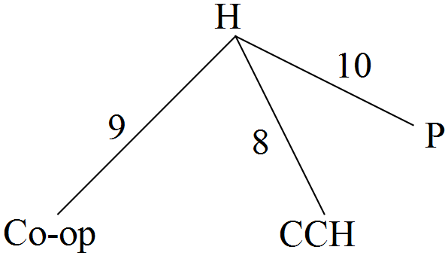 (c)

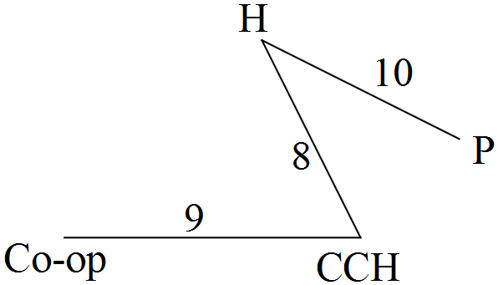 (d)

Next best is 3 km

5.

BC = 17 (by Pythagoras)
(a) Spanning Trees are
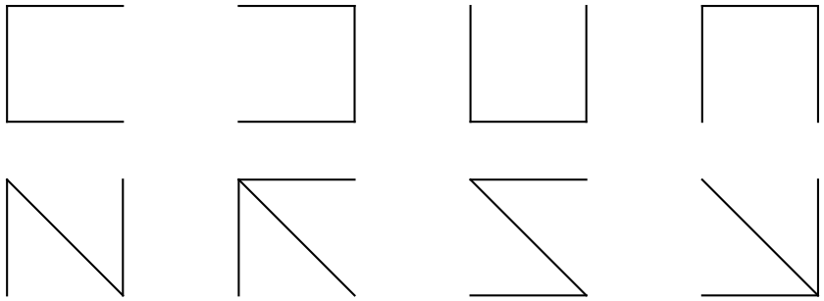

each
(b) Minimal Spanning Tree =
or
Length = 31.
6. (a)

(b) Minimum cost is $41 000.

(c)

(d) F was left unconnected.
(e) 30 ≤ F < 41

7. S not connected.( Not spanning )
PQR is a cycle. ( Not a tree.)
8. (a) Minimum Distance = 58 m
(b) Shortest Path = ABCE
Length = 31m Time = = 620 mins.
Since this is less than 12 hours,
he survives.
(c) Length of tree = 60 m.
Extra expense = 2x3 = $6

9. (a)

(b)

(c) Minimum connecting distance
= 38 + 40 + 28 + 32 = 138km.

10. (a), (b)

(c) Spanning Tree is correct.
(d) AE, AB, BD, BC
∴ minimal cost of 3 + 5 + 3 + 6
= 17 ∴ $17 000
[AE, ED, DB, BC is an equivalent spanning tree.]

11. (a) 297 via Roy Hill and Nullagine.
(b)

(c)

12. (a) x = 90, y = 10, k = 74 ✓✓✓
(b) = 1 hour 44 minutes ✓ 
(c) (i) ✓✓✓ for either of the diagrams
below
(ii) 104 ✓
(iii) BD was another alternative ✓       
13.
✓
(a) Length = 87 km. ✓
(b) (i) KHEC. 47 km. ✓✓
(ii) x 60 minutes
= 35.25 minutes. ✓✓✓
(iii) 54 km. ✓✓

14. (a)
(b) 150 km
(c) (i) 85 km (ii)

15. (a) FB & EC
(b) (i) Any tree containing AB
e.g.
(ii) 4 x $3 000 + $2 000
= $14 000

(c) (i) $1 500
(ii) Not unique
(d) $14 000 + $2 000 = $16 000
16. (a)

(b)

(c) 41 m

17. (a) 5 & 6, 5 & 2, 5 & 0, 6 & 1, 6 & 7, 7 & 4,
1 & 4, 1 & 2, 2 & 3, 3 & 4, 3 & 0, 7 & 0
∴ 3, 5, 7, 11, 13 correct
(b)

∴ Length = 11
18. (a) (ii) Minimal spanning tree needs the
smallest connection
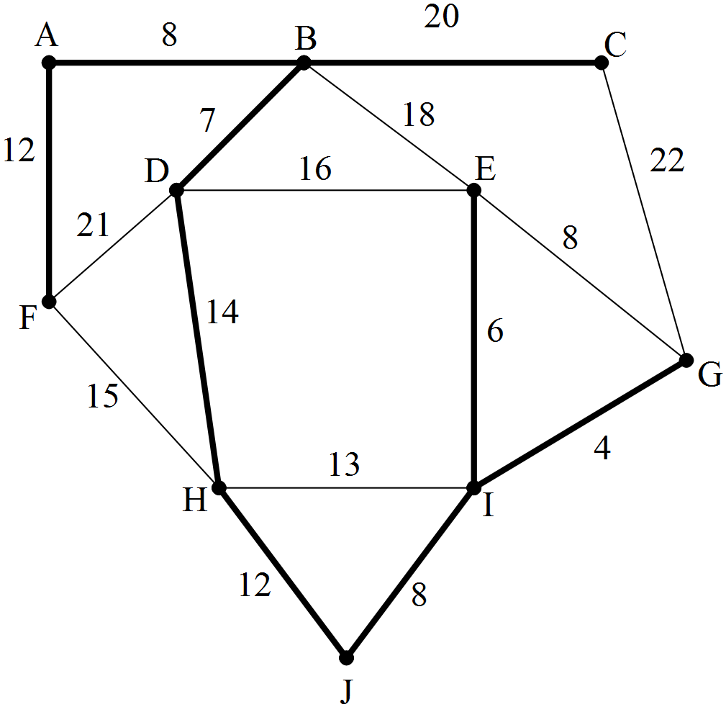 (b) (i)

(ii) 91 km
(iii) 9
(c)
Number of  Vertices | Number of  Paths
2 | 1
3 | 2
10 | 9
∴ n − 1 paths
19. (a)

F
C
E
C
D
B
A

(b)
Minimum cost is $41 000.

(c)

(d) F was left unconnected.
(e) 30 ≤ F < 41

Chapter 11: Maximal Flow

1.
ABD 9
ACD 6
AECD 3
AEFD 4
Max. Flow = 22 = minimum cut

2. (a) Flow from source totals 15.
∴ Max. flow cannot be 18.
(b)
ADF 6
ACDF 2
ACEF 3
ABCEF 1
ABEF 2
14
∴ Maximum flow is 14 units.

3. (a) (i) Source is A
(ii) Sink is E
(b) Because only 17 leaves the source.
(c)

AFE 5
AGFE 2
AGE 1
ACDE 5
ABCDE 4
17
∴ Maximum Flow is 17.
Other possible solutions exist.
4. (a)
ABEG 3
ACBEG 3
ACEG 3
ACDFG 3
ADFG 1
13
∴ MF is 1300 vehicles per hour.
(b)
OR

(c) (i) Maximum flow will remain at 1300
[EG is 2 less, FG is 2 more]
(ii) No,
there was only 2 units of flow
available on path ADFG.

5. (a) ABCG = 50
ADG = 50
AEFG = 50
∴ Maximum flow = 150
(b) BD can be removed
B
C
E
C
D
F
A

6. (a) Amount leaving source = 12
Amount entering sink = 12
(b) Max. Flow = 12
(c) BC, DC were unused.
(d) Upgrade CF by 6
would increase the flow ACF by 4,
and the flow ADCF by 2.
7. (a) Source is A
Sink is B

(b)

(c) CD has no effect .
(d) No effect,
since AEFB can take no more.

8. (a)
ACE 90
ACGE 10
AFGE 50
ABDE 100
250
Maximum flow is 250.
(b) AC by 60.
(c) 310
[an extra 40 will flow through ACDE,
and an extra 20 will flow through ACGE]

9. (a) Source is A. Sink is E. ✓✓
(b) ADE = 6
ACE = 11
ADFE = 4
Maximum Flow = 21 ✓✓
(c) Increase DF or DE by 5

10. (a) 33 ✓✓
(b) 26 ✓✓

11. (a) Flow from source = 3 + 5 + 7 + 9 = 24
∴ Flow into sink ≠ 28 and is a max.
of 24. ✓
(b) ABCD 3
ACD 5
AFD 7
AEFD 4
19
Max. Flow = 19 ✓

5
9
0
7
0
4
5
9
6
1
4
9
2
1
3
6
5
0
E
F
D
C
B
A
5 0

(c)

✓

12. (a) 30
(b) 20
(c) 18

13. (a) Source is A. Sink is E. ✓
(b) Maximal flow is 18 ✓✓
(c) ✓✓

(d) None ✓
(e) DE by 1 or CE by 1 ✓✓ 

14. (a)

(b) Source A, Sink C
(c) ABC = 7
ABEC = 5
AFC = 6
ADC = 10
Total = 28
(d) Change AD to 20

15. (a) Y = 4 X = 10 Z = 2 K = 0
W = 19
(b) 42
(c) Correct
(d) 32

16. (a) 30
(b) (i) P
(ii) NP
(iii) P

17. (a) ACEF 8
ADF 3
ABF 5
Max flow = 16
(b)

NB: Other answers possible for (a) and (b).
(c) (i) Increase of 1
(ii) No change
(iii) No change

18. (a) ABGH 3
ACDH 3
ADFH 4
- Max flow = 1 000 vehicles per hour
(b)

(c) (i)

(ii) 600 extra vehicles

Chapter 12: Project Networks

1. (a) E follows C, not C and B.
(b) ACE
(c) 60 minutes
(d) Delay of 2 minutes.
(e) Not recommended, because there is no
saving in the overall completion time.

2. (a) (i)

(ii) ABCD
(iii) 17 weeks
(iv) 7 weeks slack time.
(v) Reduce by 2; any more would be unnecessary because FH = 15.
Hence, pay 2 ( $ 500 ) = $ 1 000
is worthwhile.
(b) (i) 200 units
(ii) Reject, since no unused flow
(c) (i) 60 + 50 + 70 + 105 + 105 +
105 + 105 + 105 + 25 = 730
(ii)

(iii) M – C – T5 – COS – T4 – R
60 + 50 + 105 + 105 + 25
= 345
3. (a) Critical path is CDGH
Minimum completion time
is 53 hours.
(b) x = 4

4. (a)
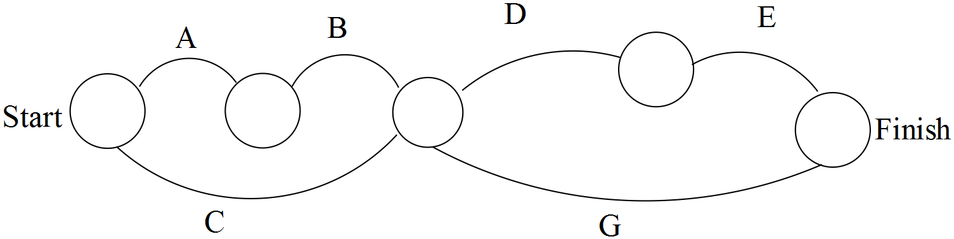

(b) 52 hours
(c) 72 hours.
5. (a) CGJ
(b) 11 days
(c) Because it would not affect the minimum
completion time.
(d) 1 day.

6. (a) DG
(b) 12 days
(c) (i) x = 11
(ii) y < 10
7. (a) 14
(b) BCDEM or BCDGM
(c) Delayed by 2
(d) Reduction required ≥ 1.4
DG is total of 1.6, or DB, or DE,
or DM

8. (a) A and H
(b) 16
(c) (i) 1 (ii) 15
(d) $10 000 since critical path is
now BH
(e) No change

9. (a) ABCEKM 26

(b) 8 weeks

(c) 9 weeks delay
(d) (i)

(ii) ABCEHM 25 weeks.
10. (a) 11
(b) 7
(c) 18 weeks
(d) < 8 weeks
(e) G > 5 weeks

11. (a) (i)

(ii) H, I
(b) ABCFGIJ
(c) 26 weeks
(d) Increase of 1 week
(e) H increases to be more than 5
or G or I reduced by more than 1
only two used

12. (a)
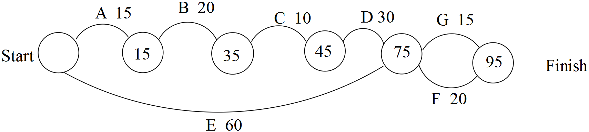

(b) 95 minutes. Path is ABCDF
(c) 15 minutes slack in activity E.
∴ Weeding starts 15 minutes late.

13. (a), (c)
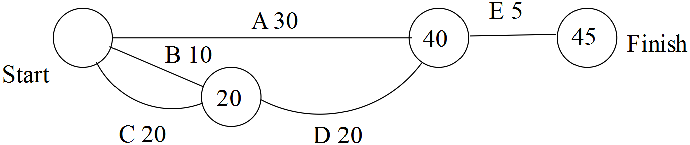

(b) Service the engine must start first,
10 mins. before cleaning the outside
of the car, and preparing the picnic.
(d) Least total time = 45 mins.
(e) If only 2 people then
Extra 10 mins required.

14. (a)

(b) Minimum completion time = 35
∴ Time to complete process
= 35 + 20 = 55 minutes.
(c) (i) Since there are 9 minutes of slack time
in E, a 5 min delay in parking has no
effect.
(ii) If F is delayed by 5 minutes, the total
delay is 5 minutes, since F is on the
critical path.

15. (a)
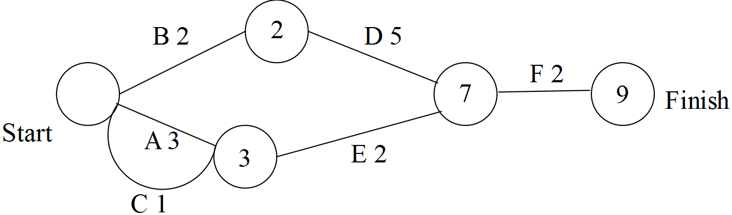

(b) 9 days
(c) B D F
(d) Activities A, C, E will have least impact
on completion time since they are
not on the critical path.
(e) If D is delayed by 5 days, the project is
delayed by 5 days.

16. (a) Earliest finishing at t = 31.
(b) B G I.
(c) 20
(d)

(e) 2 min. delay overall.
(f) 5 min. delay overall.
(g) 6 min. of slack time in Activity F.

17. (a) 9 days
(b) r =1 s = 6 p = A q = C,D,B
(c) BEFG
(d) No change to minimum time.

18. (a) 24 days
(b) C
(c) d – 16 b – 12 a – 2
19. (a)

(b) Min Time is 25 mins.
(c) Critical Path is ABCEFG
(d) (i) 9·25
(ii) Latest time for D is t = 11,
ie 9·11
(iii) 8 minutes slack time for D
∴ 10 minute delay is a delay of
2 mins overall∴ Finish at 9·27.

20. (a)

(b) Min time = 48 mins.
(c) A B C D E G H
(d) t = 19

Chapter 14 Task Allocation

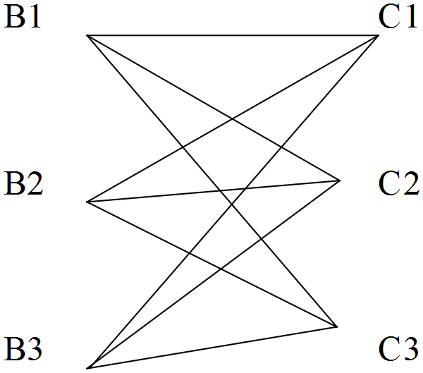1. (a)

(b) B1C1, B2C2, B3C3
Cost = 16.6
B1C1, B2C3, B3C2
Cost = 16.3
B1C2, B2C1, B3C3
Cost = 16.8
B1C2, B2C3, B3C1
Cost = 15.8
B1C3, B2C1, B3C2
Cost = 16.9
B1C3, B2C2, B3C1
Cost = 16.2
(c)
4.8 | 8.5 | 2.9
4.6 | 8.1 | 3.2
5.2 | 8.3 | 3.7
Subtract the minimum value in each
row.

1.9 | 5.6 | 0.0
1.4 | 4.9 | 0.0
1.5 | 4.6 | 0.0
Subtract the minimum value in each column.
3 lines are required to cover all the zeros.
0.0
0.0
0.0
These are the key zeros.
2.9
4.6
8.3
These are the allocations.
Value is 4.6 + 8.3 + 2.9 = 15.8
Minimum cost is $15 800 as in (b)

2.
85 | 60 | 60 | 75
30 | 90 | 50 | 60
120 | 90 | 80 | 100
40 | 100 | 90 | 110
Subtract the minimum value in each row.
25 | 0 | 0 | 15
0 | 60 | 20 | 30
40 | 10 | 0 | 20
0 | 60 | 50 | 70
Subtract the minimum value in each
column.
25 | 0 | 0 | 0
0 | 60 | 20 | 15
40 | 10 | 0 | 5
0 | 60 | 50 | 55
3 lines are required to cover all the zeros, but we require 4. The smallest uncovered number is 15. Subtract 15 from all uncovered elements, and add 15 to all elements that are covered by two lines.
40 | 0 | 0 | 0
0 | 45 | 5 | 0
55 | 10 | 0 | 5
0 | 45 | 35 | 40
Now 4 lines will cover all zeros and these are the key zeros.
0
0
0
0
These are the allocations.

60
60
80
40

Minimum is 240 km

3. (a)
Make all entries negative, then add
220 to all entries to make them all
nonnegative., then insert a column of
zeros for a dummy card.
80 | 160 | 20 | 90
60 | 150 | 0 | 70
90 | 140 | 30 | 90
90 | 160 | 40 | 90
60 | 180 | 30 | 70
(b)
The matrix must be square ie 5 x 5 hence
a column of zeros must be inserted
as a dummy card.

80 | 160 | 20 | 90 | 0
60 | 150 | 0 | 70 | 0
90 | 140 | 30 | 90 | 0
90 | 160 | 40 | 90 | 0
60 | 180 | 30 | 70 | 0

Subtract the minimum value in each
column.

20 | 20 | 20 | 20 | 0
0 | 10 | 0 | 0 | 0
30 | 0 | 30 | 20 | 0
30 | 20 | 40 | 20 | 0
0 | 40 | 30 | 0 | 0
4 lines are required to cover all the zeros, but we require 5. The smallest uncovered
number is 20. Subtract 20 from all
uncovered elements, and add 20 to all elements that are covered by two lines.
0 | 0 | 0 | 0 | 0
0 | 10 | 0 | 0 | 20
30 | 0 | 30 | 20 | 20
10 | 0 | 20 | 0 | 0
0 | 40 | 30 | 0 | 20
Now 5 lines will cover all zeros and
these are the key zeros.
 |  |  |  | 0
 |  | 0
 | 0
0 |  |  | 0

These are the allocations.
0
220
80
130
160
Value is 160 + 130 + 80 + 220 = 590
Maximum amount for Harry is $590
(c) Bidder 1 missed out.

4. Make all entries negative, then add 24
to all entries to make them all
nonnegative.
0 | 6 | 22 | 17 | 20 | 12
0 | 6 | 22 | 17 | 20 | 12
4 | 7 | 13 | 14 | 2 | 3
9 | 14 | 12 | 9 | 7 | 1
16 | 19 | 11 | 13 | 15 | 8
21 | 20 | 10 | 8 | 14 | 11
Subtract the minimum value in each row.
0 | 6 | 22 | 17 | 20 | 12
0 | 6 | 22 | 17 | 20 | 12
2 | 5 | 11 | 12 | 0 | 1
8 | 13 | 11 | 8 | 6 | 0
8 | 11 | 3 | 5 | 7 | 0
13 | 12 | 2 | 0 | 6 | 3
Subtract the minimum value in each
column.
0 | 1 | 20 | 17 | 20 | 12
0 | 1 | 20 | 17 | 20 | 12
2 | 0 | 9 | 12 | 0 | 1
8 | 8 | 9 | 8 | 6 | 0
8 | 6 | 1 | 5 | 7 | 0
13 | 7 | 0 | 0 | 6 | 3

4 lines are required to cover all the zeros, but we require 6. The smallest uncovered number
is 1. Subtract 1 from all uncovered elements, and add 1 to all elements that are covered by two lines.
0 | 0 | 19 | 16 | 19 | 12
0 | 0 | 19 | 16 | 19 | 12
3 | 0 | 9 | 12 | 0 | 2
8 | 7 | 8 | 7 | 5 | 0
8 | 5 | 0 | 4 | 6 | 0
14 | 7 | 0 | 0 | 6 | 4

Now 6 lines will cover all zeros and these are the key zeros.
0
0
0
0
0
0

These are the allocations with a maximum rating of 116.
24
18
22
23
13
16

